CAFÉ BY THE BAY: INTEGRATION OF A WEB-BASED
POINT-OF-SALES SYSTEM

A Capstone Project presented to the College of Computer Studies
Laguna State Polytechnic University
Los Baños Campus
Los Baños, Laguna

In Partial Fulfillment of the Requirement for the Degree
Bachelor of Science in Information Technology
Specialized in Service Management Program

MARIA RAQUEL GRACE A. TUISA
SHERLYN I. BANASIHAN
JENELYN C. SIERVO

JONALYN JOY B. LABAYNE, MIT
JUNE 2026
APPROVAL SHEET

The Capstone Project entitled “CAFÉ BY THE BAY: INTEGRATION OF A WEB-BASED POINT-OF-SALES SYSTEM” prepared and submitted by Jenelyn C. Siervo, Maria Raquel Grace A. Tuisa, and Sherlyn I. Banasihan in partial fulfillment of the requirements for the degree Bachelor of Science in Information Technology specialized in Service Management Program is hereby recommended for approval and acceptance.

JONALYN JOY B. LABAYNE, MIT
Adviser
Approved and Accepted by the Committee on Oral Examination with a grade of _____.

ROWAN N. ELOMINA, PhD  Member | CAROLINA R. JOVAL, MAEd  Member
MYRA V. PAICAGLINO, MPA  Member | JEFFERSON L. LERIOS, DIT  Member

Accepted in partial fulfillment of the requirements for the degree of Bachelor of Science in Information Technology specialized in Service Management Program.

LOYD S. ECHALAR
Associate Dean, College of Computer Studies

OFELIA B. MANINGAS, Ed. D. | _________________
Chairperson, Research and Development Office | Date Signed

RESEARCH CONTRIBUTION NO.

ACKNOWLEDGEMENT

The journey of pursuing the degree Bachelor of Science in Information Technology has been made possible through the invaluable support, encouragement, and guidance of remarkable individuals who stood by them throughout their academic endeavor. The successful completion of this capstone project would not have been possible without their contributions.
To Almighty God, for His guidance, protection, knowledge, and wisdom.
To the University President, Dr. Mario R. Briones, and the Campus Director, Engr. Manuel Luis R. Alvarez, for their great leadership.
To their dearest Associate Dean, Loyd S. Echalar, DIT for his kind words and encouragement.
To their adviser, Ms. Jonalyn Joy B. Labayne, for her guidance, encouragement, and support.
To their research coordinator, Jefferson L. Lerios, DIT and the members of the approval committee, namely, Dr. Rowan N. Elomina, Ms. Carolina R. Joval, and Ms. Myra V. Paicaglino who took proper interest in their project work and guided them throughout its completion by providing the necessary insights for developing a good system.
This capstone project stands as a testament not only to their hard work but also to the collective support of all the people who have been with them every step of the way.
The Researchers
DEDICATION
This successful study is sincerely dedicated to their parents, family, and loved ones, whose unwavering love, support, and encouragement has been their greatest source of inspiration and motivation. Without them, the completion of this thesis would not have been possible.
To Mr. Roque and Mrs. Rosemarie Tuisa for their patience, faith, and guidance, which greatly contributed to the well-being of the researchers in completing this project.
To Mr. Rene and Mrs. Edna Manlangit for their unwavering support, especially through their financial assistance, which greatly contributed to the success of this project.
To Mr. Ryan and Mrs. Maricel Norris for their constant guidance and support, which served as the researcher’s source of encouragement in completing this project.
Their unwavering love, support, patience and encouraging words have been the foundation that helped to complete this study. The researchers are grateful to their classmates, friends, siblings, and loved ones who cheered them up in times of hardships and difficulties.
The researchers would also like to extend their sincere gratitude to
Mr. Wilson B. Suyat, whose consideration, help, and support greatly guided them throughout this study.
M.R.G.A.T
J.C.S
S.I.B
ABSTRACT
Manual transaction processing, inventory mismanagement, and the absence of real-time data continue to pose challenges for small cafés and academic business facilities that affects the operational efficiency and decision-making. Despite efforts to improve these processes, many existing systems lack integrated solutions that combine sales tracking, inventory monitoring, and data-driven forecasting. Therefore, this study addresses these gaps by developing a web-based Point-of-Sales (POS) system with integrated inventory management specifically designed for Café by the Bay. While previous studies have shown that digital systems greatly enhance business operations, most of it have not incorporated predictive analytics designed to small-scale café environments. The study integrates a K-Nearest Neighbor (KNN) forecasting module to support sales prediction and inventory planning. Using the Agile Scrum methodology for system development, the platform was evaluated through ISO 25010 software quality standards and the Technology Acceptance Model (TAM). Results from system testing showed that all modules met the required quality attributes, demonstrating the system’s efficiency, usability, reliability, and strong user acceptance. This study provides evidence that the developed system is a practical and innovative solution that strengthens the café’s operational accuracy, enhances their data-driven decision-making, and improves the overall business performance within training-based café environments.

Keywords: point-of-sales (POS), Inventory Management, ISO 25010, TAM, Agile Scrum, KNN Algorithm, Forecasting, Retail Business

TABLE OF CONTENTS
Preliminaries |  |  |  | Page
Title Page  Approval Sheet  Acknowledgement  Dedication  Abstract  Table of Contents  List of Figures  List of Tables  Definition of Terms |  |  |  | i
 |  |  |  | ii
 |  |  |  | iii
 |  |  |  | iv
 |  |  |  | v
 |  |  |  | vi
 |  |  |  | viii
 |  |  |  | ix
 |  |  |  | xi
 | CHAPTER
 | I | INTRODUCTION
 |  | Project Context |  | 1
 |  | Project Objectives |  | 3
 |  | Project Purpose |  | 4
 |  | Scope and Limitation of the Study |  | 6
 | II | REVIEW OF RELATED LITERATURE, STUDIES, AND SYSTEMS
 |  | Related Literature and Studies |  | 12
 |  | Synthesis of the Study |  | 34
 |  | Literature Matrix |  | 35
 |  | Conceptual Framework |  | 41
 | III | METHODOLOGY
 |  | Project Design |  | 42
 |  |  | Context Diagram | 42
 |  | Project Development |  | 43
 |  |  | Agile Scrum | 43
 |  |  | Data Source and Dataset Description | 44
 |  |  | KNN Algorithm Selection and Rationale | 44
 |  |  | Product Backlog | 48
 |  |  | Sprint Planning & Sprint Backlog | 50
 |  |  | Flowchart | 53
 |  |  | Use Case Diagram | 55
 |  | Materials |  | 56
 |  |  | Software | 56
 |  |  | Hardware | 59
 |  | Business Model |  | 61
 |  | Project Testing and Evaluation |  | 61
 |  |  | Software Testing | 62
 |  |  | Unit Testing | 62
 |  |  | Integration Testing | 63
 |  |  | System Testing | 63
 |  |  | Acceptance Testing | 64
 |  | Evaluation Procedure |  | 65
 |  |  | ISO 25010 Software Quality Model | 65
 |  |  | Technology Acceptance Model (TAM) | 66
 |  | Sampling Design |  | 67
 |  | Population of the Study |  | 67
 |  | Data Collection Instrument |  | 68
 |  | Statistical Treatment |  | 69
 |  | Ethical Consideration |  | 72
 | IV | RESULTS AND DISCUSSIONS
 |  | Results by Objectives |  | 73
 |  | Result of Unit Testing |  | 80
 |  | Result of Integration Testing |  | 89
 |  | Result of System Testing |  | 92
 |  | Result of ISO 25010 Software Quality Evaluation |  | 96
 |  | Result of Technology Acceptance Model (TAM) Evaluation |  | 107
 |  | Result of Acceptance Testing |  | 113
 | V | SUMMARY, CONCLUSSIONS, AND RECOMMENDATIONS
 |  | Summary |  | 114
 |  | Conclusions |  | 116
 |  | Recommendations |  | 118
 | REFERENCES |  |  | 122
 | APPENDICES
 |  | Appendix A. Letter of Approval |  | 128
 |  | Appendix B. Relevant Source Code |  | 130
 |  | Appendix C. Evaluation Tool & Statistical Computation |  | 136
 |  | Appendix D. Sample Input / Output |  | 145
 |  | Appendix E. User’s Guide |  | 150
 |  | Appendix F. Curriculum Vitae |  | 153
 |  | Appendix G. Publishable Paper (IEEE format) |  | 157
 |  | Appendix H. Plagiarism Result |  | 165

LIST OF FIGURES
No. | Title | Page
1 | Conceptual Framework | 41
2 | Context Diagram | 42
3 | Agile Scrum | 43
4 | Manual Process Flowchart | 53
5 | System Flowchart | 54
6 | Use Case Diagram | 55
7 | Business Model | 61
8 | Software Testing | 62
9 | Unit Testing | 62
10 | Integration Testing | 63
11 | System Testing | 63
12 | Acceptance Testing | 64
13 | Quality Characteristic of ISO 25010 | 65
14 | Technology Acceptance Model (TAM) | 66
15 | Order Management Interface for Staff | 73
15.1 | Payment Option and Process Feature | 74
15.2 | Generated Printable Receipt Feature | 75
16 | Inventory Management Interface for Staff | 76
17 | Forecasting Feature for Administrator | 77
18 | Inventory Management Interface for Administrator | 94
19 | Sales Report | 95

LIST OF TABLES
No. | Title | Page
1 | Literature Matrix | 35
2 | Product Backlog (Admin) | 49
3 | Product Backlog (Staff) | 49
4 | Sprint Planning (Admin) | 51
5 | Sprint Planning (Staff) | 52
6 | Hardware Requirements | 60
7 | Minimum Requirements for PC and Laptop | 60
8 | Respondents of the Research Study (ISO) | 67
9 | Respondents of the Research Study (TAM) | 68
10 | Likert Scale for ISO 25010 | 71
11 | Likert Scale for TAM | 71
12 | Unit Testing for Account Management Module | 80
13 | Unit Testing for Inventory Management Module | 81
14 | Unit Testing for Order Module | 82
15 | Unit Testing for Supplier Module | 83
16 | Unit Testing for Product Module | 84
17 | Unit Testing for Notification and Alert Module | 85
18 | Unit Testing for Transaction Module | 86
19 | Unit Testing for Reports Module | 87
20 | Unit Testing for Analytics Module | 88
21 | Integration Testing Results | 90
22 | Browser Compatibility Testing Results | 93
23 | Results of ISO 25010 Functional Suitability Evaluation | 97
24 | Results of ISO 25010 Performance Efficiency Evaluation | 98
25 | Results of ISO 25010 System Compatibility Evaluation | 99
26 | Results of ISO 25010 Interaction Capability Evaluation | 100
27 | Results of ISO 25010 Reliability Evaluation | 101
28 | Results of ISO 25010 Security Evaluation | 102
29 | Results of ISO 25010 Maintainability Evaluation | 103
30 | Results of ISO 25010 Flexibility Evaluation | 104
31 | Results of ISO 25010 Safety Evaluation | 105
32 | Results of System Quality Evaluation (ISO 25010) | 106
33 | Results of Perceived Usefulness | 107
34 | Results of Perceived Ease of Use | 108
35 | Results of Attitude Towards Using the System | 109
36 | Results of Intention to Use the System | 110
37 | Results of the Technology Acceptance Model (TAM) Evaluation | 111

DEFINITION OF TERMS

Admin | A user role within the point-of-sales users having higher privileges. An Admin manages staff accounts, sales review, inventory updates, and edits system information.
Conceptual Framework | Is a comprehensive figure that is used to understand the structure of the study and guide the development. It serves as a roadmap to visualize the structure of the project by providing outlines that connects different ideas, concepts, and modules of the system.
Database | The location where data is structured so that POS information such as sales information, employee accounts, and inventory information is securely stored and retrieved.
Inventory | A set of products or items that the café has. The POS may be used to track quantities of items in the inventory and the availability of items, updating after three transactions.
Point-of-Sale (POS) | A collection of hardware and software used by a business to effect sales transactions; to record purchases, compute totals, beautify of method, update inventory levels, and generate receipts.
Receipt | A printed or digital proof of purchase generated by the POS after each completed transaction. It shows details such as items purchased, prices, total amount, and date of purchase.
Sales Monitoring | The process of observing sales activities occurring in real time in the POS system, for performance evaluation and strong decision-making.
Sales Report | It is an output of the POS showing the sales information for a certain period. The report allows the business to monitor income and ascertain trends.
Staff | A user role secondary to Admin in the POS Users that operate the system around business transactions. Staff can take customer orders, record sales, and generate receipts with limited access, unlike Admin.
System Settings | Options for configuring the POS that are made available to the admin for customizing the system. This settings may involve security options and operational preferences.
Transaction | A sale via the POS with details including items being sold, quantity, price, amount total, and payment mode.
User Authentication | The process of verifying the identity of a user (either admin or staff) by checking for valid login credentials before granting access to the POS system.
Web-based System | Refers to a software system that runs on a web server. Users access web-based systems through a web browser using an internet connection.

CHAPTER I
INTRODUCTION
Project Context
Laguna State Polytechnic University–Los Baños Campus (LSPU-LBC) is a state university in Los Baños, Laguna, and part of the broader LSPU system, committed to providing quality higher education and technical training. Through its various colleges, LSPU-LBC equips students with the theoretical knowledge and practical skills needed for their careers. The College of Hospitality Management and Tourism (CHMT) plays an important role in preparing future professionals in the hospitality and tourism industries by promoting experiential learning and maintaining strong industry partnerships (Laguna State Polytechnic University, 2024).
Café by the Bay is more than just a café; it is a strategic initiative by the College of Hospitality Management and Tourism (CHMT) at Laguna State Polytechnic University–Los Baños Campus (LSPU-LBC) that blends business practice with academic learning. Officially launched on October 18, 2023, at the CHMT Guest House, Café by the Bay serves as both an Income-Generating Project (IGP) and a laboratory training facility for Bachelor of Science in Hospitality Management (BSHM) and Bachelor of Science in Tourism Management (BSTM) students (LSPU, 2023). This facility allows students to gain hands-on experience in food service, customer relations, and business operations, which reflects the CHMT’s commitment to experiential learning under its "Learning by Doing: Five-Year Development Project for Functional Facilities and Laboratories for CHMT Students Towards a Sustainable and Industry-Driven Learning Program" (LSPU, 2023).
The integration of real-world business initiatives within the academic environment has been recognized globally as a powerful approach to enhance education, diversify institutional income, and strengthen partnerships between academic institutions and industry (Deloitte, n.d.). Research supports the idea that university-business collaborations stimulate economic growth, build a more skilled workforce, and create valuable applied-learning opportunities (University of Minnesota, 2023). Practical exposure, such as that provided by Café by the Bay, enables students to translate theoretical knowledge into professional skills, develop positive work attitudes, and build customer service competencies essential to the hospitality and tourism sectors. Studies further show that hands-on training significantly boosts students' knowledge, skills, attitude, and personality, leading to stronger professional performance and better decision-making abilities to meet the industry's evolving challenges (Felicen et al., 2014; Arago et al., 2019). Facilities like Café by the Bay thus play a critical role in bridging the gap between academic preparation and industry readiness.
Practical training facilities, including Café by the Bay, encounter several challenges even when designed to simulate real-world operations. Hands-on training for students has not eliminated operational difficulties, particularly in the areas of sales tracking, inventory management, and data-driven decision-making. Manual processes have sometimes resulted in inefficiencies such as stock mismanagement, slow transactions, and a lack of real-time financial understanding.
To address these operational issues, the researchers integrate a point-of-sale (POS) system with an inventory management platform specifically designed for Café by the Bay. The system addresses the prevalent issues of manual errors, stock discrepancies, and inefficient resource management by incorporating streamlined order processing, real-time sales monitoring, stock control, and streamlined financial reporting. This approach not only enhances operational efficiency but also provides a user-friendly interface tailored to the dynamic needs of café management that offers a comprehensive solution to elevate both business performance and customer service. The study contributes to the growing body of research on the integration of digital technologies in small business operations that shows how point-of-sale (POS) and inventory systems can support industry-standard practices while serving as a valuable training ground for hospitality and tourism management students.
Project Objectives
The general objective of this capstone project is to design, develop, and implement a web-based point-of-sales system with the integration of inventory management for Café by the Bay that would improve business operation, financial control, and actual student learning. Specifically, this project aims the following:
1. To develop a web-based point-of-sales system integrated with inventory management designed to the needs of Café by the Bay to streamline sales transactions and improve order management.
2. To develop a web-based system that automates stock monitoring, generates sales reports, and inventory stock levels alerts.
3. To evaluate the efficiency and effectiveness of the developed system using ISO 25010 and Technology Acceptance Model (TAM).
Project Purpose
The goal of this study is to develop a web-based point-of-sale (POS) system integrated with inventory management to simplify business processes and generate comprehensive sales reports. This project aligns with several Sustainable Development Goals (SDGs). It supports SDG 4: Quality Education by exposing CHMT students to technology that is used and relevant in the industry, giving them practical experience in business operations, customer service, and accounting.
It also addresses SDG 8: Decent Work and Economic Growth by enhancing the training environment for students through a functional digital platform at the College of Hospitality Management and Tourism, Laguna State Polytechnic University – Los Baños Campus. In support of SDG 9: Industry, Innovation, and Infrastructure, the system introduces digital transformation to university business operations, which modernizes the traditional hospitality training and prepares students to meet evolving industry needs. It also contributes to SDG 12: Responsible Consumption and Production by improving stock management, reducing food waste, and promoting the efficient use of resources through the inventory system that encourages sustainable practices. SDG 17: Partnerships for the Goals, by fostering collaboration between academic institutions, industry partners, and local stakeholders, providing students with access to expertise, internship opportunities, mentorship, and technological resources to strengthen their readiness for the hospitality and tourism sector. The project benefits the following:
Administrator. This project helps the administrators or the management of the Café by the Bay as it streamlines business transactions, inventory tracking, and sales reports. It allows the management to easily monitor student staff, gain better control over stock levels, pricing, and revenue reports. It aids in making informed decisions through accurate and timely data.
Staff. This project benefits the shop’s staff, who are students of College of International Hospitality Management and Tourism (CIHMT), especially cashiers and staff that handles the inventory, as it simplifies the overall workflow. The integrated POS system allows faster and more accurate order processing that minimizes manual tasks and reduces the chances of errors during transactions. With a user-friendly interface, staff can easily navigate the system, which helps save time and improves productivity. Additionally, accurate inventory tracking eliminates the confusion regarding stock availability which helps the staff to respond more efficiently to customer inquiries and avoid service disruptions.
Customers. Customers benefit from a smoother and more efficient service experience. Waiting time is minimized and errors in orders are reduced, which leads to increased customer satisfaction and trust in the café’s service. Customers are more likely to return, as transactions become quicker and more accurate, leading to customer loyalty and positive feedback.
Academic Institution. This study is beneficial to academic institutions as it demonstrates how information technology can be used to address practical business problems. It promotes creativity and project-based learning and can be used as a case study or reference for IT-related courses. The project also contributes to the institution’s mission of producing competent and industry-ready graduates by promoting hands-on experience in system development and practical research application.
System Developers/IT Students. This study benefits the system developers and IT students by providing them with valuable experience in real-world application development. By studying or working on this project, they can better understand how to design and implement a fully functional web-based point-of-sale and inventory management system tailored to the needs of small businesses like cafés. It offers a practical learning platform for integrating various system components into a single solution.
Future Researchers. This project benefits future researchers by providing a guide or serving as a reference for studies related to web-based point-of-sale (POS) systems with inventory management. This study can serve as a foundation for further improvements or system development as future researchers may enhance the system by integrating additional features depending on the evolving needs of small businesses like cafés.
Scope and Limitation of the Study
This study focuses on the development of a web-based Point-of-Sales (POS) system with the integration of inventory management, designed to support and improve business processes of the Café by the Bay. The goal of the system is to improve the daily tasks and workflows by enabling administrator to monitor sales, manage staff accounts, track inventory and product availability, and oversee the overall business performance through a centralized platform. Through this system, the staff can efficiently process customer orders, monitor inventory stock levels, and send transaction related reports to the administrator for administrative review. The project intends to simplify operations, reduce errors, increase accuracy, and support data-driven decision-making for managing the café by switching from manual process to a digital platform. The web system consists of different modules and features as stated below.
Account Management Module
This module is responsible for user authentication and deals with account-related functions. All users, including staff and the administrator, must be registered and able to log in. The administrator must log in and out, and has permission to access product information, inventory, user account management and permissions, sales reports, and other admin panel features.
Inventory Management Module
In this module, both the administrator and staff can track stock levels to monitor product availability and determine whether items are still in stock or restocking is needed. The administrator has the ability to add items, edit details such as names, categories, prices, and quantities, and hide items that are no longer needed or available.
Order Module
This module is responsible for managing all customer orders and sales transactions within the system. It allows staff to efficiently create, update, and track orders, which ensures the accuracy and faster processing of order. The module also supports the generation and printing of receipts, which provides customers with proper documentation of their purchases.
Supplier Module
This module manages supplier information and records. It allows the administrator to add, edit, and update supplier details for better coordination in purchasing and inventory restocking. The module ensures that all data related to the supplier is organized and easy to access for monitoring and future transactions.
Product Module
This module focuses on managing product details and categories. The administrator can add new products, edit existing product details such as name, price, category, and description, and hide or disable products that are no longer available. It ensures that all items in the system menu are updated and properly categorized.
Notification & Alert Module
This module provides all important automated notifications and alerts within the system. It is responsible to keep the administrator and staff updated on important tasks which may need immediate attention. It automatically notifies the administrator and staff about low inventory stock levels as well as receivable purchase orders to prevent stockouts, delays, or missed transactions. It notifies the staff about customer pending orders from pay-later transactions as well as the overdue ones, payments received from email reminder, and the processed billing-orders. By providing real-time and categorized notifications, the module ensures timely responses and improves operational efficiency across the system. It notifies the administrator and staff about low inventory stock levels which ensures timely responses and prevents issues from occurring such as stockouts, delays, or missed transactions.
Transaction Module
This module focuses on point-of-sale (POS) operations. Staff can simply process customer orders while the system automatically calculates the total amount. It supports payment via cash and Gcash, and transactions are automatically stored after generating receipts. It also supports Pay Later option for selected customers who prefer to settle their payments at a later time. This ensures fast and reliable transaction processing.
Reports Module
This module provides information on various areas of the business by generating different types of reports, automatically. The administrator can view sales reports based on daily, weekly, monthly, or custom timeframes. It also offers insights to stock movement and transaction records, as well as the evaluation of product performance by identifying best-selling and under-selling products. All of these features are for managerial and administrative purposes to help in the assessment of overall performance and making data-driven decisions for business operations. Reports can also be exported in various formats for documentation and keeping of records.
Analytics Module
This module is responsible for analyzing sales and inventory data to generate insights that support the decision-making. It uses the K-Nearest Neighbors (KNN) algorithm to forecast future sales and evaluate prediction accuracy. The module provides Forecast Accuracy Metrics using MAE, RMSE, and Bias to measure the model performance. This algorithm enables the administrator to track sales patterns, assess the system’s forecasting reliability, and optimize its business and inventory strategies based on data-driven insights provided by this module.
The limitations of the system are related to its technical scope, deployment environment, and operational requirements within the café setting. Although the developed web-base POS and inventory management system introduces significant improvements to the café’s daily business operations, it remains bounded by several constraints, which may affect its usage in real-world environment. These limitations must be considered when implementing and maintaining the system in an actual café environment. The identified limitations are as follows:
- Platform Support. The system was developed exclusively for desktop and laptop computers. It does not include support for mobile devices such as tablets or smartphones, as the system’s interface and functionalities were designed specifically for larger screens and standard desktop workflows. This limitation may reduce accessibility for users who prefer using mobile devices. As a result, the system cannot be used conveniently outside the café premises.
2. Internet Connectivity Dependence. As a web-based application, the system relies heavily on a stable internet access for real-time data synchronization, order processing, and inventory updates. Limited or unstable connectivity may affect the system’s responsiveness and overall performance for both staff and administrators. This can cause delays in transactions and data updates during peak hours. In some cases, system functions may become temporarily unavailable.
3. Device Availability. There might be limited backup devices or terminals available at the café to use. The lack of alternative equipment could cause operations to be temporarily disrupted in case the primary device fails. This situation may lead to downtime and slower service operations. Employees may have difficulty continuing tasks without available devices.
4. User Access and Training. Proper user orientation and training are required for both administrators and student staff to ensure the efficient and accurate use of the system. Since the café’s staff often changes every semester, continuous training is necessary to maintain a consistent proficiency and avoid operational errors. Without proper training, users might commit mistakes while using the system. Additional time and effort are needed to train new staff members.
5. Staff Turnover. The frequent turnover of student staff has an impact on the consistency of system use and could lead to different levels of user familiarity. New users may take time to adjust to the system, which may temporarily affect efficiency of workflow. This may result in slower system usage during adjustment periods.
CHAPTER II
THEORETICAL FRAMEWORK OF THE PROJECT
Review of Related Literature, Studies, and Systems
The literature review provides a broad understanding of the importance of integrating point-of-sales (POS) with inventory system to business operations.
Point-of-Sales (POS) with Inventory Integration
Small retail businesses like cafes and restaurants indeed need a very strong online-offline compatible point-of-sales (POS) system to keep their operations continuously alive, as Hu et al. (2018) stated. System availability can be maximized when complementary technologies such as blockchain or edge computing are integrated into POS systems, that allows them to be functional even there is no internet service. In such cases, resiliency in these systems becomes very important for small businesses, to think that most of them do not have reliable connectivity.
In the case study of Hidayati et al. (2023) revealed that the implementation of the POS system significantly improved operational efficiency and financial management within the coffee shop businesses using SWOT analysis. The study identified several strengths of the system, such as enhanced stock visibility, faster customer transactions, and reliable financial reporting. Such results are proven on the study of Dewi et al. (2021) that enhances operational efficiency at InHome Café by developing a web-based POS system that focused using Agile methodology. As the cafe used the traditional manual and paper-based method in managing transactions, it often caused mistakes in recording data that made it hard to generate reports efficiently and monitor inventory. The findings showed that the implementation of the POS system significantly improved the café's ability to handle sales transactions efficiently, which makes the café experience smoother operations, reduced manual processes, and more accurate data management. The system’s flexibility allowed it to adapt quickly to the dynamic needs of the café that contributes to better service delivery and a more streamlined customer interaction process.
Modern day point-of-sale systems can also be referred to as the tools used to execute the financial transactions of a restaurant. Alt (2021) sees this as platforms used to query sales tracking during the busy management periods in a restaurant, such as inventory management and analytics, which is complemented with friendly web interfaces for easier data input and analysis. Gill (2021) also supports putting the inventory management system into the POS since real-time input of data reduces waste, adds profitability, and boosts customer satisfaction with the better decision-making of restaurants through the information. Similarly, Sihombing (2024), highlights that real-time inventory tracking not only reduces waste but also ensures the availability of product for customers, which demonstrates the importance of timely and accurate inventory sales data.
The study of Villanueva (2023) on the development of a web-based POS and inventory management system for Yannie Computer Store, revealed that the system significantly improved the operational efficiency, particularly in transaction processing and inventory management. The integration of Flutter framework allowed for the creation of a cross-platform system that provided a responsive user interface, while RFID technology enabled the real-time tracking of inventory, which reduces errors and losses associated with manual process address challenges related to tracking client returns, managing stock transfers between branches, and improving sales and inventory monitoring. The study employed Multi-Motive Information Systems Continuance Model and Unified Theory of Acceptance and Use of Technology (UTAUT) to evaluate user acceptance and system usability. The study employed a developmental research approach where interviews, observations, and document analysis are used to gather user requirements. The system was then developed, tested, and evaluated based on performance and usability metrics that revealed the system’s user-friendly interface, which resulted in high user satisfaction. The system was evaluated based on performance and usability metrics that confirms its operational effectiveness in managing sales transactions and inventory control. The MySQL database ensured secure and efficient data storage and retrieval.
In the study of Polasik et al. (2013) that focused on the time efficiency of various payment methods at physical Points-of-Sales (POS) in Poland revealed significant differences in transaction times across payment methods, highlighting the ease of using offline contactless card payments which is deemed faster, achieving an average time of 25.71 seconds that makes it even quicker than cash transaction. The researchers aimed to compare traditional payment systems (cash and conventional cards) with innovative payment solutions such as (NFC and remote mobile payments). The comparison of contactless cards, RFID stickers, and mobile payments to understand which payment methods were most efficient in terms of transaction time, ultimately affecting customer satisfaction and operational performance in retail environments.
Beyond just this requirement of web-based systems, another possible need is illustrated by Melvin et al. (2023), who developed a POS system that applied the Rapid Application Development (RAD) model in the automotive components industry. The system used in the study integrated inventory and sales data that leads to optimized business processes and greater system usability. In a similar study of Susanto and Fenriana (2024), Market Basket Analysis and the Apriori algorithm were employed in a web-based POS system to understand customer purchasing behaviors for strategic sales efforts. The study focused on addressing operational inefficiencies typically encountered in coffee shop businesses, such as delayed transaction processing, inaccurate sales recording, and poor inventory management.
Andarwati et al. (2020) emphasized the importance of integrating robust POS systems in small business operations to streamline processes and improve service delivery. To evaluate the functionality and effectiveness of POS systems used by Small and Medium Enterprises (SMEs) in East Java, Indonesia, Black Box Testing was utilized to evaluate the system’s functionalities without examining internal code structures. This testing method focused on verifying the login processes, inventory management, transaction handling, and data backup features. All scenarios produced expected outcomes, indicating that the system operated reliably and provided a user-friendly interface. The study also applied the PIECES methodology—Performance, Information, Economy, Control, Efficiency, and Service—to measure the overall effectiveness of the system. Data were collected from 183 SME respondents through questionnaires using a Likert scale. The results showed that the POS system was largely effective across all six aspects. Notably, 50.8% of respondents rated the system’s performance as effective, 47.5% found the information reporting adequate, and 60.1% rated the system’s service capabilities high, which highlights improvements in customer satisfaction and transaction speed. Overall, the study concluded that the POS system significantly enhanced operational efficiency, supported accurate and timely decision-making, and provided substantial benefits in terms of cost-effectiveness and control features for SMEs.
In the study of AAPPL et al. (2024) shows that inventory and POS systems significantly improves business operations, enhances financial performance, and simplifies inventory processes for Bida Mart. The researchers employed a survey to gather data from Bida Mart personnel regarding their perceptions of the proposed system’s functionality, usability, and its potential impact on business processes. Descriptive statistics were used to analyze the survey results. The system was developed using JavaScript and SQL, following established software development and accounting standards, to address the inefficiencies caused by manual inventory tracking and record-keeping in Bida Mart. The study focused on developing a system that enhances real-time inventory management, decision-making, and operational efficiency. The findings indicated that the proposed Inventory and POS system could provide real-time data visibility, allowing users to monitor stock levels effectively, identify slow-moving products, and optimize inventory management.
Similarly, Chicano and Huervana (2009) address the challenges faced by a specialty restaurant in Iloilo City that relied on manual billing and unmonitored stock systems, by developing a computerized Point-of-Sale (POS) and stock monitoring system to enhance operational efficiency and customer satisfaction.​ The researchers conducted interviews with the restaurant's owner and managers to identify the limitations of the existing manual system. The new system streamlined sales transactions, provided real-time inventory tracking, and improved data accuracy. These enhancements led to better decision-making and increased customer satisfaction, which significantly improved the restaurant's operations. It facilitated efficient sales management, accurate inventory control, and enhanced overall service quality.
Dela Cruz et al. (2019) developed an inventory management with POS system using the .NET framework that focuses on functionalities such as sales data storage, transaction processing, receipt generation, and data export capabilities. To evaluate the system's effectiveness, questionnaires were administered to both users and the business owner, assessing various aspects based on the ISO 25010 software quality model.​ This is to address the inefficiencies associated with manual inventory and sales processes in businesses. The evaluation revealed that the system achieved the highest rating in Functional Suitability, indicating that it met the users' needs effectively. The automated system facilitated quick transactions, reduced manual paperwork, and provided secure data storage. Features like login security, sales data export to Excel or PDF, and real-time inventory monitoring contributed to improved business operations.​ The researchers concluded that implementing an automated inventory management system with POS capabilities significantly enhances business processes by streamlining sales transactions, securing data, and reducing manual workload. The system's user-friendly interface and real-time monitoring features support efficient decision-making and operational control.​
Inventory System
An intelligent web-based integrated inventory system developed by Madamidola (2017) is meant to connect several stores whereby real-time synchronization and automated determination of reorder levels can take place. The system utilized Java Remote Method Invocation (RMI) with a secure socket layer (SSL), implemented using My Structured Query Language (MySQL), Database Management System, Hypertext Markup Language (HTML), JavaScript, Hypertext Preprocessor (PHP) and Xampp (Apache) for centralizing data among different stores. This approach to inventory management has moved away from isolated single-store systems toward a distributed model for better coordination in the reduction of stockouts. In line with scalability and real-time monitoring, this serves as a working framework considered for enterprises managing inventories from different locations.
In study the of Tanaman et al. (2023) tackled the inefficiencies that traditional inventory systems had for a small Philippine business with four branches and a mobile store. PHP, MySQL, HTML5, Bootstrap, and JavaScript were used to address the inventory challenges of a small enterprise in Pagadian City, Philippines. The study followed the Waterfall Method of system development and aimed to streamline inventory tracking and reporting. The implementation of real-time reporting features revealed significant improvements in inventory accuracy, process efficiency, and decision-making. Evaluations from both IT experts and end-users indicated high levels of satisfaction across software quality dimensions, including usability (4.73), reliability (4.63), and performance efficiency (4.60). These results validate the efficiency of web-based inventory systems in enhancing operational control for small to medium-sized enterprises.
The case study conducted by Alifadillah and Supriatna (2023) in a coffee shop located at Sukabumi, Indonesia, shows how a web application solves the problems of inventory management gaps. The findings of the case have a mixed method-interview, observation, and system testing, proving that the errors and delays involved in the operation mainly result from manual processes. The web-based system developed will track the inventory in real time, reducing manual-recording errors by automatically updating stocks, thus improving operational efficiency. Positive ratings from users were received on usability and time benefits as an indicator of the usefulness of the system to small-scale food and beverage businesses. Limitations were noted by the authors, such as the absence of predictive analytics for stock forecasting and no mobile-based interface to give more flexibility.
In the study of Oladele et al. (2021), highlights that data-driven inventory systems can address the limitations of traditional manual methods by providing accurate, timely, and strategic information for operational and business planning by developing of an inventory management system with the incorporation of association rule mining, particularly the Apriori algorithm. The web-based application used AngularJS for the front-end interface, PHP for backend, NoSQL database to manage the inventory records, and HTML and CSS for a responsive and user-friendly interface. The system identifies frequent item combinations and supports smarter inventory decisions. This study addressed common inventory issues such as stock mismanagement and inefficient data tracking by applying data mining techniques to transaction datasets. The system was able to suggest product bundles based on purchasing patterns through association rule mining that aids in stock optimization and promotional strategies. The integration of these techniques not only streamlined the inventory tracking but also improved decision-making related to product placement and sales forecasting.
Sales Reporting
Sales reporting is an essential aspect of data gathering, analysis, and presentation in sales processes. It tells the business about sales trends, customer behavioral trends, and whether their sales strategies are working (Salesforce, 2024). It is very crucial to improve the business processes by providing important real-time snapshots around sales performance, inventory status, and customer trends. In a study of Jan et al. (2023) that proposed a business management software designed for resolving sales reporting and inventory management problems, outlined the numerous advantages of shifting from conventional manual reporting mechanisms to a more flexible, effective, and easy-to-use Interface even for those with basic computer literacy. The system integrates the functionalities of seller account management, product listing, sales report preparations, and account handling. The new system was able to significantly cut down the time and paperwork involved in POS management that benefited the operational efficiency of the small stores and shops.
Similarly, Cote (2015), examined implementing POS and inventory management systems into small businesses with a case study of Wildwood Inc., a garden center, and nursery. Cote proposed a three-step process that involves preliminary process analysis, evaluation of the systems, and final action recommendations. The research stresses the advantages of being able to provide benefits such as real-time inventory updates, fast checkout process, and improved data-driven decision-making, which are all aspects that contribute to growth, profit margins, and customer satisfaction directly. Another related study by Hartzel and Wood (2017), focused on how real-time availability of POS data affects the accuracy of demand forecasting. According to the study, the realization of the forecast was increased in accuracy by 11.2% upon the integration of the real-time POS data compared to those old methodologies that have been based solely on order history. Also, they recognized that the advantages are more pronounced for products with a low frequency and variance of orders. They emphasize the trade-off between in-stock availability and working capital tied up, which substantiates the role of the POS reporting in production scheduling and inventory management.
In the study of Rajan, Sulthana, and Sowndhariya (2022) that emphasized replacing traditional manual processes with a digital solution to streamline operations., revealed that the implementation of the mPOS system enabled real-time sales data capture and inventory updates. The system's reporting feature allowed for the generation of detailed sales reports, providing insights into sales trends and inventory levels. This capability supported informed decision-making regarding stock replenishment and sales strategies.​ Similar study of Bashini and Akilan (2022) revealed that sales reporting capabilities allowed for the generation of detailed reports, which provides insights into sales trends and inventory movements. This real-time data access supported informed decision-making and improved overall business operations.​ Additionally, development of POS with inventory management systems not only streamlined sales transactions but also provided valuable sales reporting features, which enhances the efficiency and accuracy of business operations in the hospitality industry.
In study of German, V. K., Gerardo, B., & Tanguilig, B. (2016), where they combine mobile POS capabilities with cloud-based inventory management employed with data synchronization techniques, indicated that sales reporting features enabled business owners to generate detailed reports, providing insights into sales trends and inventory levels. This capability facilitated informed decision-making and efficient resource management.​ The integration of mobile POS with cloud computing allowed for real-time sales data collection and inventory tracking as the system significantly improved the operational efficiency of micro and small enterprises by automating sales transactions and inventory management. with the sales reporting functionality played a crucial role in enhancing business operations by providing timely and accurate data.​ By developing a web-based POS and inventory system, businesses can achieve real-time inventory visibility, faster transaction processing, secure data management, and detailed sales reporting. Its user-friendly and scalable design ensures adaptability to business growth and evolving technology needs. Ultimately, the study offers a practical and cost-effective solution to streamline operations, enhance decision-making, and improve competitiveness in today’s digital economy.
The study of Lewis et. al. (2021) explored the integration of mobile POS technology in small, underserved retail stores in Baltimore City. The aim was to evaluate whether mobile tablet applications (POST) could effectively track sales data for specific food and beverage items in a region where electronic record-keeping was scarce. Four corner store owners participated in the study, with each store being equipped with a POST system to record the sales of 14 items over 11 days. The feasibility was evaluated based on factors like ease of use, integration into daily operations, and the ability of store owners to manage the system independently. Results showed that the system allowed owners to use the system. The study highlighted that such systems can improve sales tracking accuracy, offer real-time insights into inventory and sales, and make it easier to assess the impact of nutrition programs or promotional activities. This suggests that mobile POS technology could be a useful tool for small retailers in urban food deserts, enhancing business efficiency and potentially supporting community-based health interventions by providing reliable sales data.
K-Nearest Neighbor (KNN) Algorithm
The K-Nearest Neighbor (KNN) algorithm is one of the simplest and most common machine learning techniques used for making predictions and classifications. It works by comparing new data to existing data and finding the most similar ones. In a Point of Sale (POS) system, KNN can be used to analyze sales data, predict customer behavior, and help in inventory management. For example, by using KNN, a café’s POS system can identify which products are often bought together or what items are most popular at certain times. This helps improve decision-making, sales forecasting, and customer service by allowing businesses to use data more effectively.
According to Miha Djami, Utami, and Paramitha (2023), the KNN algorithm performed very well in predicting product sales at PT Kotamas Bali, reaching an accuracy of 99% with high F1-scores for all product types. On the other hand, the Naïve Bayes algorithm only achieved 54% accuracy and often failed to classify data correctly. This shows that KNN is more reliable for analyzing product performance and supporting stock management decisions. Similarly, their ROC curve analysis showed that KNN had a high AUC score of 99%, which means it classified the data almost perfectly. The authors also pointed out that choosing the right algorithm and cleaning the data properly can really affect the results. Overall, their study proves that KNN is a strong and practical method for predicting product sales accurately.
In the study by Nasution, Rambe, Putra, Dafa, and Syahputra (2025), the KNN algorithm was used to predict drug sales at the Pratama Haji Medan-Pancing Clinic. They used data mining techniques and sales records to estimate the number of drugs needed in the clinic. The system reached an accuracy of 88.9%, proving that KNN works well for this type of task. Moreover, it helped reduce manual work and made stock management faster and more organized. This finding supports the idea that KNN can also be used in other fields like POS systems, where predicting and managing inventory properly is important for business operations.
Likewise, Kurniawan, Rayuwati, and Zulfa (2024) applied KNN to predict laptop sales at the MVP Computer Mawar Store in Takengon. Their study showed that the success of KNN depends a lot on having complete and structured sales data since it helps the model find accurate patterns. They also explained that choosing the right k value is very important because a small k might cause overfitting, while a large k could make the model too simple. Their results showed that KNN achieved high accuracy, precision, and recall, proving that it can effectively classify future sales by brand. In addition, the study noted that factors like promotions, seasons, and events could affect results, so combining KNN with more data sources could improve predictions. This shows that KNN can be a useful tool for small business owners in making better inventory and sales decisions.
In another study, Danny, Muhidin, and Jamal (2024) used the KNN algorithm to predict which products at PT LG Innotek Indonesia would sell well. They analyzed sales data from 2020 to 2023 and categorized items as “Selling” or “Not Selling.” The model achieved 94.74% accuracy and only 5.26% error, which means KNN performed effectively when data was properly cleaned and processed. They also found that KNN works well with non-linear data and gives stable results that help with inventory management. This supports the idea that KNN is not only easy to use but also reliable for sales forecasting and product planning.
Similarly, Suchacka, Skolimowska, and Potempa (2015) studied how KNN could predict whether online shoppers would make a purchase or just browse. Using data from an online bookstore, they analyzed 22 features like time on page, pages visited, and items added to the cart. Their experiment showed that using 11 nearest neighbors gave the highest accuracy of 99.85% and correctly predicted 87.5% of buying sessions. These results prove that KNN can effectively classify user behavior and help online stores identify potential buyers. The authors also mentioned that future studies could try different distance measures and feature selection methods to make KNN even better for e-commerce applications.
Meanwhile, Zhang, Wang, and Huang (2023) developed a KNN-based consensus algorithm that classifies transactions by priority, making sure important ones are processed faster in Blockchain-as-a-Service systems. Their model used transaction details like type, account, and category to predict priority levels accurately. They also applied optimization techniques such as clipping and compression to reduce training size while keeping accuracy high. Compared to the traditional FIFO method, their approach improved transaction handling and reduced SLA violations. The study also stressed that choosing the best k value through cross-validation helps prevent overfitting and ensures consistent results. Overall, they proved that integrating KNN with modern technologies can improve both speed and efficiency in transaction management.
Zhang, Li, Zong, Zhu, and Wang (2018) worked on improving KNN by introducing the kTree and kTree* methods. These new models select the best k for each test sample automatically, which helps reduce computation time and improve accuracy. They tested their approach on 20 datasets from the UCI Repository, including both small and large datasets, and found that kTree improved accuracy by up to 5% compared to standard KNN. It also ran much faster than adaptive methods like GS-kNN and S-kNN that analyze all training samples. Similarly, it outperformed LC-kNN while using fewer data points, which shows that adaptive k selection makes KNN more efficient. Their findings highlight that improving classical algorithms like KNN through small changes can lead to big performance gains in real-world applications.
Nitin Bhatia and Vandana claim that nearest neighbor (NN) methods categorize data according to its closest known points, with the fundamental k-nearest neighbor (kNN) approach being straightforward and efficient for big datasets. However, they pointed out that kNN can be memory-intensive and slow, which led to the creation of improved techniques. In the meantime, other techniques reduce the size of the data by removing redundant points, and weighted kNN assigns different importance to neighbors based on distance. However, neighbor searches can be accelerated by using clustering techniques and tree structures like k-d trees and ball trees. They contend that these advancements increase NN efficiency based on the kind of data and application, proving its usefulness in domains like face and pattern recognition.
On the other hand, a feature selection method based on the KNN approach that concentrates on high-dimensional data without requiring labeled information was proposed by Xianchang Wang, Lishi Zhang, and Yonggang Ma. When tested on datasets like iris, diabetes, and breast cancer, they discovered that their unsupervised approach performs similarly to conventional labeled methods, indicating its efficacy in scenarios where data labels are unknown. In a similar vein, Random KNN was developed by Shengqiao Li, E. James Harner, and Donald A. Adjeroh for feature selection in big data, especially when there are many features but few samples, like in gene expression studies. According to their research, Random KNN is a better tool for complex biological problems because it is faster, more stable, and more resilient against noisy or unbalanced data than Random Forests. Their research indicates that Random KNN is faster, more stable, and more robust against noisy or unbalanced data compared to Random Forests, making it a suitable tool for complex biological and medical datasets.
Sequential feature selection (SFS), which finds the most important features and increases accuracy and computational efficiency, was used by Rajkumar Govindarajan and associates to improve KNN for diabetes prediction. With an accuracy of 84.41%, they claimed that characteristics like blood pressure, glucose level, skin thickness, age, and body mass index greatly enhanced predictive performance. However, Zhao et al. (2025) stressed the significance of feature selection in high-dimensional datasets, like genomic data, where redundant or irrelevant features can raise computational costs and decrease classification accuracy. Zhao et al. claim that traditional KNN models frequently perform poorly in these situations, which prompted the creation of GA-based methods that integrate classifiers like KNN, SVM, and logistic regression as well as enhanced KNN variants (EK-NN). They developed the GEK-NN model, which combines Genetic Algorithms for feature selection, Evidence Theory-based KNN for classification, and Elastic Net regularization, to overcome constraints like computational intensity and hyperparameter sensitivity. Their results highlight the robustness and generalizability of GEK-NN by showing that it consistently chooses compact feature subsets while retaining high predictive accuracy across both high-dimensional gene expression datasets and low-dimensional UCI datasets.
Technology Acceptance Model (TAM) in System Implementation
User adoption of information systems is key to technology success. The Technology Acceptance Model (TAM) explains this powerfully, with an emphasis on such crucial determinants as perceived usefulness and ease of use.
The fast growth of Information and Communication Technology (ICT) has transformed many industries, most notably education, through massive e-learning system adoption. Knowing why users accept such systems is important to making such systems successful. Fred Davis's (1987) Technology Acceptance Model (TAM) is one theoretical model employed to study this phenomenon. TAM has determined perceived usefulness (PU) and perceived ease of use (PEOU) as key determinants of user attitudes and system use. Davis's actual research, with 112 users on two systems, found that PU was 50% more predictive than PEOU of actual system use, and the model accounted for 36% of the variance in user behavior. These results provided the basis for a user-oriented approach to technology design and assessment, highlighting that systems need to be seen as useful and easy to use to gain widespread acceptance.
Expanding Davis's initial model, Napitupulu, Ibrahim, and Purwandari (2018) used TAM to assess an e-learning application at University XYZ. With a purposive sample of 73 respondents, they recorded 69.12% agreement on usefulness, 69.80% on ease of use, and 72.69% total system acceptance. These findings confirm TAM's basic propositions and imply that PU and PEOU have a considerable influence on sustained user involvement. The authors contend that enhancing these two factors results in greater future use of e-learning sites, and they suggest extending TAM to encompass more variables for more insight into the adoption of educational technology.
Extending TAM further, Ibrahim et al. (2017) added variables like instructor traits, computer self-efficacy, and course design to their research at Tunku Abdul Rahman University College (TARUC). With Structural Equation Modeling (SEM) on data from 95 undergraduates, they reported that computer self-efficacy had a very strong positive influence on PEOU (path coefficient = 0.75, p < 0.001), and PEOU had a strong influence on intention to use (path coefficient = 0.57, p < 0.001). Perceived usefulness and instructor characteristics were unexpectedly not significant and were dropped from the final model. The research underscores the significance of students' technology confidence as compared to conventional educational functions, pointing towards a change in determinants driving technology acceptance in contemporary learning settings
In the same context, Khorasani and Zeyun (2014) used TAM to analyze 150 Universiti Sains Malaysia students with regard to the adoption of web-based learning. Using the SPSS for correlation and multiple regression analysis, their findings supported that PU and PEOU were effective mediators of behavioral intention. Most importantly, self-efficacy was a better predictor of intention to use than PU or PEOU. Authors concluded that self-efficacy, induced by system design and training, is critical for successful adoption. They support institutional activity in enhancing student engagement by building confidence and offering easy-to-use systems that clearly show good academic outcomes.
Outside of education, Verma, Bhattacharyya, and Kumar (2018) used an extended TAM to investigate big data analytics system adoption. Among 150 users, their study indicated system features had strong direct and indirect effects on PU, attitude, and adoption. Mediation effects were detected, which showed intricate relationships among technical features, user perceptions, and attitudes. These results reinforce the importance of properly designed systems to shape managerial attitudes and foster adoption, positing that perception by the user is as vital in corporate analytics as it is in education.
Venkatesh and Bala (2008) took the TAM model forward by proposing TAM3, which incorporates external variables such as training and incentives to predict IT adoption. Their work underscores the importance of manager interventions prior to and after system implementation, suggesting measures that improve both PU and PEOU. Through its concentration on organizational dynamics and behavior, TAM3 fills the gap between theory and practice and reveals how contextual and institutional variables play a crucial role in determining user acceptance.
Although TAM offers a strong base for system adoption understanding, it is far more effective when complemented by contextual variables such as self-efficacy, system attributes, and organizational interventions. The actual results support the significance of user-centered design, technical instruction, and context adaptation to the highest adoption. Success in the implementation of technology remains dependent on both system-related and personal-level variables in both educational and business settings, showing the usefulness and continued relevance of TAM in the dynamic ICT arena.
ISO 25010 Quality Model for Software Evaluation
Software quality evaluation has become an important component of system development, particularly with the goal of achieving reliability, usability, and maintainability over the long term. With the ever-increasing development of software systems and rising user expectations, the need for standardized models to measure software quality effectively is more than ever before. Of these, the ISO/IEC 25010 standard has proved to be a more inclusive framework than the previous one, the ISO 9126 standard. The standard defines new quality characteristics including security, compatibility, and user experience as part of software evaluation, which are more demanded in modern software. This change is evidence of increasing needs for software that not only functions well but also fits into larger user demands in the areas of security and adaptability.
Adewumi, Misra, and Omoregbe (2015) also made a critical comparison of quality models that were available and looked into how these were aligned to the ISO 25010 standard. Their work is especially relevant since it points to the fact that most existing open-source software (OSS) models rely to a large extent on the outmoded ISO 9126 framework. Although most OSS models have incorporated some aspects of ISO 9126, the authors suggest that all but one model properly incorporate the enhanced, comprehensive quality attributes specified by ISO 25010. This criticism is an indication that evaluation frameworks for OSS need to be modernized to include emerging dimensions such as security and maintainability. It also refers to the overall trend in software development in which industry and academia are beginning to see the need to align quality models with international standards in order to enhance software design and long-term reliability.
Moreover, the evolution of software quality models (SQMs) has been pivotal in shaping the evaluation landscape. Gordieiev et al. (2014) traced the development of nine SQMs over four decades, from McCall’s 1977 model to the 2010 ISO 25010 standard. Their findings demonstrate a clear trend of increasing sophistication in SQMs, reflecting the expanding complexity of software systems. The authors defined models as being either basic or corporate, and determined their structure complexity and completeness. Based on this analysis, they found distinct features such as operational suitability, reliability, and safety that have undergone significant improvements to suit software needs in recent times. These observations support the case for the implementation of ISO 25010 as a more inclusive and appropriate framework, especially for systems with high complexity like Point of Sale (POS) and inventory control, where performance and reliability are critical.
Estdale and Georgiadou (2018) also investigated further the use of the ISO/IEC 25010 model, highlighting the importance of taking a service-based approach when measuring software quality. Their research builds on the classic product-centric view to take into account the performance of the software throughout its lifespan, recognizing that service quality over the long term is as important as product quality at the start. Their research also highlights commonly neglected aspects such as maintainability and user satisfaction. By recognizing these other quality dimensions, they contend that ISO/IEC 25010 can be further developed and refined to more effectively address the dynamic usage of software in practical situations. This is in keeping with increasing recognition that software quality assessment cannot just be technical details but needs to include consideration of user experience as well as extended service delivery.
In Higher Education Institutions (HEIs), where Enterprise Resource Planning (ERP) systems have become more common, system quality assurance is essential. Due to the high investment in ERP systems and their growing complexity, Peters and Aggrey (2020) offered a model grounded on ISO/IEC 25010 to assess ERP system quality. This new framework proposes a framework of eight quality factors functional suitability, reliability, usability, performance efficiency, compatibility, security, maintainability, and portability, and segments them into thirty-four sub-factors. This detailed framework presents a solid platform for choosing and deploying ERP systems in HEIs, where the factors have a direct impact on the effectiveness of the system in accomplishing institutional objectives. The authors contend that, in the future, research should investigate how these factors interrelate and, potentially, how this contributes to our broader understanding of their influence on the overall quality of ERP systems. Through connecting ISO 25010 with evaluation of ERP systems, their research closes an essential void between generic software standards and HEIs' particular requirements.
Synthesis and Relevance of the Study
The collection of both international and local research is about the findings and insights of various literature, methodology, and key findings that would address the objectives of this study. The importance of the research is in its contribution to improvement and optimization of the Café by the Bay’s business operations by involving it more into technology innovation.
The gathered literature and studies show that combining Point-of-Sales (POS) and Inventory Management System has a major positive impact on business operations, especially for small and medium enterprises (SMEs). Such automated systems solve common business problems such as slow transaction times, recording mistakes, stock shortages, and delays in sales reporting, which is mostly due to manual process.
Studies show that modern POS systems, when integrated with inventory tracking, help businesses manage their stock better, minimize waste, increase profits, and improve customer satisfaction. Modern inventory systems also allow businesses to monitor stock levels across different locations in real time, which helps in preventing stockouts and overstocking issues that can interrupt operations, increase costs, and negatively impact the customer satisfaction. The study also highlights the importance of effective sales reporting, as detailed and real-time reports help businesses make smarter choices and decisions about sales strategies, stock planning, and financial management.
Literature Matrix
Table 1. Matrix of Related Literature and Studies
Author(s) | Year | Title | Findings
Adi K., Rayuwati R., & Ira Z. | 2024 | Prediction Of Laptop Sales Using The K-Nearest Neighbor Method t the MVP Computer Mawar Store, In Takengon | KNN achieved high accuracy, precision, and recall. Highlights the importance of structured sales data and correct k-value selection for accurate sales prediction.
Alifadillah, A., & Supriatna, H. | 2023 | Web-Based Coffee Inventory Application (Case Study on One of The Coffee Shop in Sukabumi) | Based on the research conducted on the web-based coffee inventory application for a coffee shop in Sukabumi, the web-based coffee inventory application resulted in better inventory tracking, reduced errors, and improved operational efficiency. Staff found that the applications were user friendly and saved time.
Alt, R. | 2021 | Digital Transformation in the Restaurant Industry: A Strategic View on Digital Services and Platforms | The study indicates that digital transformation has opened up opportunities for both small and large restaurants, providing innovations from the customer (FoH) side to the operational (BoH). Four digital strategies emerge-flat out customer touchpoints, increased individualization through data use, increased automation through smart devices, and increased integration through cloud and platform services. In addition, while digital tools have potential, the success of the innovations depends on how far they fit into the restaurant's business model, core competencies, and market positioning.
Andarwati, M., Amrullah, F., Thamrin, E., & Muslikh, A. | 2020 | An Analysis of Point of Sales (POS) Information Systems in SMEswith The Black Box Testing and PIECES Method | The study found that POS system integration improved SME operations by streamlining processes and enhancing service delivery. Black Box Testing confirmed reliable system performance across key functions, while PIECES analysis showed effectiveness in performance, information reporting, and service, with high customer satisfaction. Overall, the system boosted efficiency, decision-making, and cost-effectiveness for SMEs.
Bo Hu, Hongfeng Xie, Yutao Ma, Jian Wang & Liang-Jie Zhang | 2018 | A Robust POS System Based on Blockchain and Edge Computing for Weak Internet Environments | This study proposed a POS system that would work offline during internet interruptions and use blockchain technology for transaction verification and reliability. The edge computing would synchronize transactions once the network was restored. The feature offers two advantages over traditional POS systems: network failure immunity and automatic adaptability without manual intervention.
Estdale & Georgiadou | 2018 | Applying the ISO/IEC 25010 Quality Models to Software Product | Emphasized the importance of adopting a service-based approach in software quality assessment, stressing that long-term service quality is as critical as initial product quality. They argue for the expansion of ISO 25010 to better address user experience.
Gill, A. | 2021 | Optimizing Restaurant Inventory Management using Real-Time Data | This research highlights the limitations of traditional restaurant inventory practices, including overstocking, stockouts, and wastage. It shows how by enhancing real-time data integration with POS systems, it will provide accurate and real-time information on inventory as a basis for decision making, thus minimizing food losses and increasing profit.
Gordieiev, Kharchenko, Fominykh, & Sklyar | 2014 | Evolution of Software Quality Models in Context of the Standard ISO 25010 | Analyzed the evolution of software quality models over four decades, identifying a clear trend towards greater sophistication. The study supports the implementation of ISO 25010 for more complex systems like Point of Sale (POS) and inventory management.
Indra N., Rezkinah R., Khairil P., Muhammad D., & Muhammad S. N. | 2025 | Application of the K-Nearest Neighbor Algorithm in the Data Mining Process to Predict Drug Sales at Pratama Haji Medan-Pancing Clinic | KNN reached 88.9% accuracy, reduced manual work, and improved inventory management, proving its applicability in predicting sales in service settings.
Madamidola, O. A, Daramola, O.A & Akintola, K .G | 2017 | Web – Based Intelligent Inventory Management  System | This study presented an intelligent web-based inventory system that applied fuzzy logic on supply and demand forecasting. The whole system was implemented in a client-server architecture, thus supporting real-time visibility across warehouses from distributed environments. Dynamic reorder points are determined, along with coordination improvements such as Java RMI and SSL in terms of optimizing operations and maintaining efficiency under competitive market conditions.
Melvin, M., Wiratama, J., Sutomo, R., & Sanjaya, S. A. | 2023 | A Web-based Point of Sales for Automotive Component Industry using Rapid Application Development model | This study created a web-based POS system using the Rapid Application Development (RAD) model, addressing inefficiencies in inventory control and sales transactions. The system achieved a System Usability Scale (SUS) score of 86.6, indicating 'very good' usability and a hope to be used in further optimizing business processes within MSMEs in the automotive sector.
Miha Djami, A. S., Utami, N. W., & Paramitha, A. A. I. I. | 2023 | The Prediction of Product Sales Level Using K-Nearest Neighbor and Naive Bayes Algorithms | KNN achieved 99% accuracy in predicting product sales, outperforming Naïve Bayes. Shows KNN is reliable for stock management and sales forecasting.
Sihombing, D. J. C. | 2024 | Innovating Restaurant Inventory Management Application Enhanc-ing Quality and Efficiency Through Extreme Programming Approach | The Extreme Programming (XP) method was employed in developing an application that addressed various challenges in restaurant inventory management-such as errors, shortages, and waste. It was found that XP improves flexibility, effective development, and product quality, thus enhancing operational performance and customer satisfaction. The application was validated with user feedback, which supports XP as an agile methodology to address the changing needs of the industry.
Susanto, J., & Fenriana, I. | 2024 | Web-Based POS with Apriori Market Basket Analysis | The effectiveness of the Apriori algorithm is demonstrated in this research to be used in a system-based point of sale web for Market Basket Analysis (MBA). The design and implementation of the system were achieved efficiently to manage sales transactions and customer data. The Apriori algorithm made associations analysis for frequently co-purchased products about cross-selling and product bundling. MBA empowers organizations to enrich marketing strategies, optimize inventory-based layouts, and enhance sales performance and satisfaction by data-driven insights.
Tanaman, M.T. et al. | 2023 | Web-based Inventory Management System | This system improved inventory management by automating data recording, processing, and report generation.
Venkatesh, V., & Bala, H. | 2008 | Technology Acceptance Model 3 and a Research Agenda on Interventions | TAM3 highlights training and incentives as key for increasing system adoption, applicable to POS and inventory systems needing user engagement and intervention for successful adoption.

Conceptual Framework
Figure 1 illustrates the development of the point-of-sales (pos) with inventory system using the Supplier – Input – Process – Output – Customer Feedback (SIPOCF) model. It is composed of five main components: Supplier, Input, Process, Output, and Customer.
The Supplier represents the primary provider of the necessary resources, materials, and data needed for the input and has an impact on the business operations, including the system owner, administrator, staff, the system database, and the forecasting analytics module. The Inputs consists of essential data that is needed for the system operations to work and support its functions, including business requirements, system configurations, staff accounts, sales transactions, inventory data, user credentials, transaction history, and sales trends. The Process section covers the core functions performed by the POS system, such as system configuration, user and account management, staff assignment, transaction handling, report generation, inventory adjustment, data storage and retrieval, as well as advanced functions such as KNN analytics and sales trend analysis. From these processes generates the Outputs that include the configured POS system, active modules, updated user accounts, sales records, inventory updates, reports, real-time data access, and the return of investment (ROI) of the business from sales. Finally, the Customers are identified as the system owner, admin, and staff, who will benefit directly utilize these outputs to manage the café’s business operations, ensure accurate transactions, monitor inventory, and support the administrator’s data-driven decision-making.
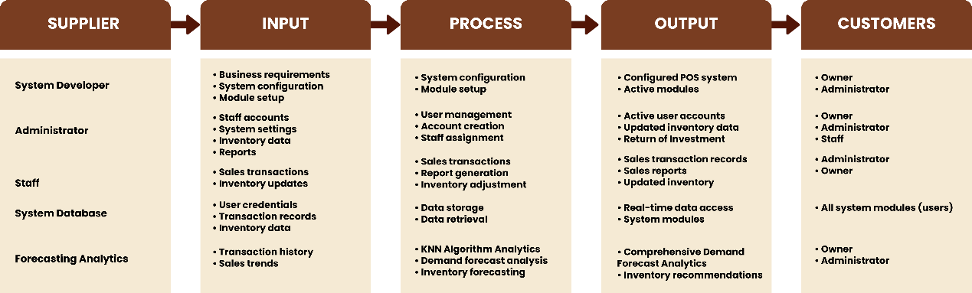
Figure 1. Conceptual Framework

CHAPTER III
METHODOLOGY
This chapter discusses the processes used to build the project, including the project design, project development, software and hardware used to develop the system, models, and other procedures.
Project Design
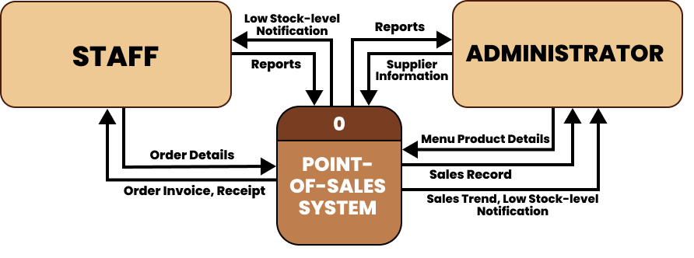
Figure 2. Context Diagram
The figure 2, context diagram, illustrates the overall interaction between the Point-of-Sales (POS) system, the staff, and the admin, whereas the system serves as the central process. The staff primarily uses the system to input customer order details by which the POS processes and displays order invoice and receipts. Staff can send reports to the system and receive low stock-level notifications to help manage inventory during business operations.
The admin interacts with the POS system on a broader management level. The system provides the admin with sales records, various reports, and sales trend analysis, along with the low stock-level notifications, to support their decision-making. The admin also provides the menu product details and supplier information, which ensures that the POS remains updated with accurate inventory and product data.
Project Development
To effectively develop and design the web-based point-of-sales system, the researchers utilize Agile Software Development Lifecycle methodology that allows iterative development, continuous feedback, and flexibility in addressing changes throughout the development process of the web-based system.
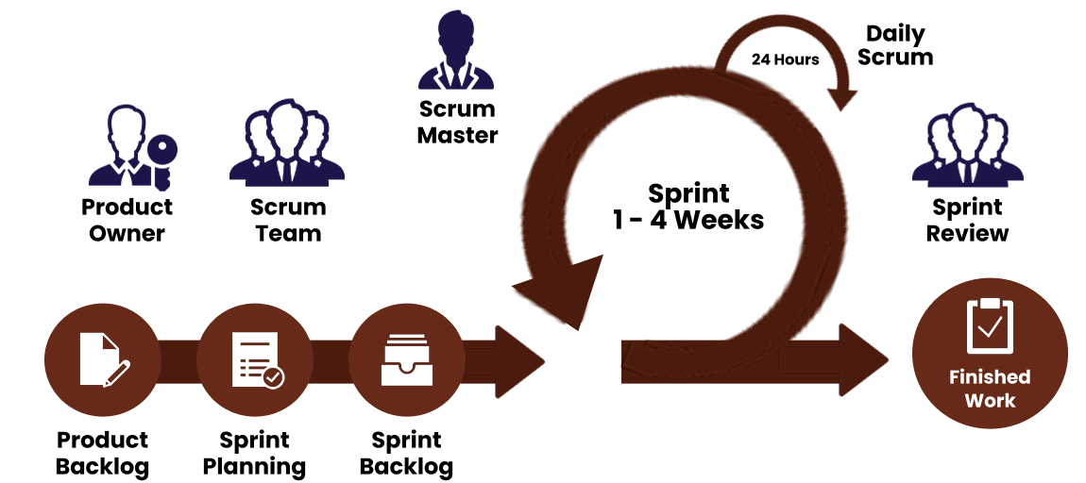
Figure 3. Agile Scrum
Figure 3 illustrates the life cycle of the system from the initial idea to the final output, which is the point-of-sale (POS) system. The researchers adopted Agile Scrum methodology by dividing the tasks into multiple phases with one to four (1-4) weeks iterations. Key procedures include product backlog, sprint planning, daily scrum, scrum review, and delivering of the finished product.
The active involvement of the team throughout the development process makes the innovation of ideas easier and increases collaboration that contributes to improved system performance.
Data Source and Dataset Description
In connection with this capstone project, sales data from Cafe by the Bay were collected to create and validate forecasting systems. The dataset, which spans from October 10, 2024 to July 10, 2025, was extracted from the café’s Microsoft Excel file where all transactions are recorded and consists of comprehensive daily sales data. Only completed transactions that is marked as status='paid' were included so that the analysis would reflect the sales that actually took place.
The dataset is split into different relational tables: sales, sale_items, menu_items, categories, and subcategories. These not only supply the target variable (daily product demand) but also offer essential descriptive information such as the product price, category, and time of day.
The data preprocessing stage included the removal of inappropriate records, daily demand aggregation at the product level, the creation of temporal and statistical features, and normalization of the values to make the dataset compatible with the K-Nearest Neighbors (KNN) algorithm.
KNN Algorithm Selection and Rationale
K-Nearest Neighbors (KNN) was selected as the forecasting algorithm for this study due to its simplicity, interpretability, and suitability for environments with limited historical data.
Unlike parametric forecasting models, KNN does not assume linearity, or fixed seasonal patterns. Instead, it predicts demand by identifying historically similar situations based on engineered features. This characteristic makes KNN useful for businesses with irregular demand or products with fluctuating sales volumes.
The key KNN parameters used are the following:
Number of Neighbors (n_neighbors): evaluated between 3 and 20
Weights: 'distance' to prioritize closer neighbors
Distance Metric: Euclidean
Cross-Validation Method: TimeSeriesSplit
The best model per product was identified using GridSearchCV, which is evaluated using negative MAE to ensure that the model minimizes absolute forecasting errors.
Feature Engineering
To improve the algorithm’s predictive accuracy, more than 40 features were engineered. These include temporal indicators, patterns from previous sales, rolling averages, volatility indicators, product attributes, and demand–recency statistics. Missing values were handled using appropriate zero-fill or backfill techniques, and all numerical features were standardized to maintain consistency.
Major feature groups included are the following:
Temporal features: day of week, month, hour, weekend, quarter
Lag features: previous 1–7 days of demand
Rolling statistics: 3-, 7-, and 14-day rolling mean and standard deviation
Product characteristics: category, subcategory, price tier
Inventory-aware metrics: days since last sale, recent trend slope
Model Training
The model training period covered the data from October 10, 2024 to April 19, 2025, while the testing period spanned from April 20, 2025 to July 10, 2025. A temporal split was used to avoid data leakage. The model was trained using TimeSeriesSplit with five folds, ensuring that the validation sets always occurred after their corresponding training windows.
After identifying the best-performing model, a bias‑correction procedure was applied. This adjustment compensates for systematic over‑ or under‑prediction, improving alignment with actual sales patterns.
Forecast Accuracy Metrics
To evaluate the forecasting performance of the model, three widely used error metrics were employed: Mean Absolute Error (MAE), Root Mean Squared Error (RMSE), and Forecast Bias. These metrics quantify the magnitude, variability, and direction of prediction errors during the testing period.
Mean Absolute Error (MAE)
MAE measures the average magnitude of errors in predictions, treating all errors equally regardless of their direction:
$$MAE=\frac{1}{n}\sum_{i=1}^{n}{|}y_{i}-{\hat{y}}_{i}|$$
where:
$y_{i}$ = actual demand for observation
${\hat{y}}_{i}$ = predicted demand for observation
$n$ = total number of observations
Lower MAE values indicate better forecast accuracy. The metric is expressed in the same units as the target variable, making it interpretable in business context. MAE is less sensitive to outliers compared to RMSE.
Root Mean Squared Error (RMSE)
RMSE provides a measure of prediction accuracy that penalizes larger errors more heavily than smaller ones:
$$RMSE=\sqrt{\frac{1}{n}\sum_{i=1}^{n}{(}y_{i}-{\hat{y}}_{i})^{2}}$$
where:
$y_{i}$ = actual demand for observation
${\hat{y}}_{i}$ = predicted demand for observation
$n$ = total number of observations
Lower RMSE values indicate better forecast accuracy. RMSE is particularly useful for identifying predictions with significant deviations from actual values, as squaring the errors amplifies the impact of outliers. RMSE is always greater than or equal to MAE for the same dataset.
Forecast Bias
Bias measures the systematic tendency of the model to over-predict or under-predict actual demand:
$$Bias=\frac{1}{n}\sum_{i=1}^{n}{(}y_{i}-{\hat{y}}_{i})$$
where:
$y_{i}$ = actual demand for observation
${\hat{y}}_{i}$ = predicted demand for observation
$n$ = total number of observations
$Bias>0$: Model consistently under-predicts (forecasts are lower than actuals)
$Bias<0$: Model consistently over-predicts (forecasts are higher than actuals)
$Bias≈0$: Model is unbiased
An unbiased model is preferred as it indicates no systematic prediction error. Positive or negative bias suggests the need for model calibration or bias correction techniques.
Product Backlog
The researchers identified the features of the system by creating a comprehensive list of requirements to be developed and begin with the project’s product backlog, with estimated time frames for completion. This backlog acts as the primary guide, collecting of client requirements, and setting the development procedures that helps the developer with planning, and ensures that the system meets administrative and staff needs. The product backlog is continuously reviewed and refined throughout the development process to accommodate changes and prioritize features based on their importance and feasibility.
Table 2. Product Backlog (Administrator)
PRIORITY | USER AS ADMIN STORY | EST.HR/DAY
1 | As an Administrator, I want to log in to the system | 2 Hours
2 | As an administrator, I want to manage product. | 4 Hours
3 | As an administrator, I want to manage staff accounts and permissions | 3 Hours
4 | As an Administrator, I want to view inventory stock levels | 5 Hours
5 | As an administrator, I want to access analytics reports | 10 Hours
Table 2 presents the product backlog for the administrator interface, which prioritizes a list of tasks that is crucial for the project’s progress. The administrator must login to the system in order to access the its modules. Once logged in, the administrator must be able to manage products such as create, read, update, and delete its information. The administrator should be able to manage staff accounts and permissions to ensure security and avoid unauthorized access to the system. The administrator also should be able to view inventory stock levels to monitor and update inventory. Lastly, administrator should access or view analytics reports to determine and analyze sales and trends. This backlog act as the initial guide by gathering client requirements and setting development procedures. It includes key admin features that contain the estimated time for the system.
Table 3. Product Backlog (Staff)
PRIORITY | USER AS STAFF STORY | EST.HR/DAY
1 | As a Staff, I want to log in to the system | 3 Hours
2 | As a Staff, I want to manage customer orders | 5 Hours
3 | As a Staff, I want to monitor stock levels | 5 Hours
4 | As a Staff, I want to send daily sales reports | 5 Hours
Table 3 shows the product backlog need to be completed for the staff functionalities. Each task describes what a staff should be able to do in the system and its estimated completion time. The backlog includes essential functions such as logging in to the system using the account provided by the administrator, manage customer orders and payment transaction, monitor inventory stock levels, and send daily sales reports in order for the administrator to monitor each staff order records. This serves as a guide for prioritizing features that will support the business’ efficient sales and inventory management.
Sprint Planning & Sprint Backlog
The identified product backlog items are used to create a sprint backlog, which details the tasks selected for completion during the sprint process. Each module follows a structured process consisting of four phases: planning, coding, user interface design and implementation, and testing with debugging.
The planning phase focuses on outlining the development strategies and setting clear objectives. Coding involves the technical implementation of system functionalities. The user interface design and implementation stage ensure that the visual components meet client requirements and enhance usability. The testing and debugging phase are essential for identifying and resolving system errors, which ensures the stability and reliability of the system. Each task includes an estimated completion time to support project tracking and resource allocation.
The sprint planning meetings are conducted to assess task priorities, distribute responsibilities among developers, and ensure alignment with project goals. This iterative approach allows for continuous improvement and timely adjustments throughout the development cycle.
Table 4. Sprint Backlog (Administrator)
PRIORITY | STORY | TASK | EST.HR/DAY
1 | As an Administrator, I want to log in to the system | Design and develop a login page for the administrator. | 2 Hours
2 | As an administrator, I want to modify the products. | Design and develop a product management interface. Implement functionalities to add, edit, and delete products. | 4 Hours
3 | As an administrator, I want to manage staff accounts and permissions. | Design and develop a user management interface. Implement functionalities to create and delete users' accounts. | 3 Hours
4 | As an Administrator, I want to view inventory stock levels. | Design and develop an inventory management interface. Implement functionalities to monitor, add, modify, and delete stocks. | 5 Hours
5 | As an administrator, I want to access analytics reports. | Design and develop an analytics interface. Implement functionalities to view, filter and delete history sales reports. | 10 Hours
Table 4 presents the sprint backlog, which specifies the upcoming system features that developers needed to complete during the sprint period. These items are selected from the product backlog and transferred into the sprint backlog to identify the scope of work for the current iteration. Each row includes a user story, specific development tasks, and its estimated completion time. The completion of analytics reports has the longest estimated time of completion of 10 hours each day of the sprint period, as it includes various functionalities and requires training of the data. While the log in interface has the shortest estimated time of two hours. This sprint focuses on key administrative functions such as login authentication, product and user management, inventory monitoring, and accessing analytics reports.
Table 5. Sprint Backlog (Staff)
PRIORITY | STORY | TASK | EST.HR/DAY
1 | As a Staff, I want to and log in to the system. | Design and develop a log in interface. | 3 Hours
2 | As a Staff, I want to manage customer orders. | Design and implement functionalities to add, modify, and delete customer orders. | 4 Hours
3 | As a Staff, I want to monitor stock levels. | Design and develop functionality to monitor stock levels. | 5 Hours
4 | As a Staff, I want to send daily sales reports. | Design and develop functionality to validate and send daily sales reports to the admin. | 5 Hours
Table 5 presents the sprint backlog for staff-related functions. This backlog outlines a prioritized set of items intended for completion before the next sprint. Each backlog item corresponds to a defined user story and its estimated completion time. The sprint focuses on key functionalities such as staff account authentication log in, management of customer order, inventory stock level monitoring, and submission of daily sales report. The completion of stock levels monitoring and sales report feature has the longest estimated time of 5 hours a day of the sprint period, while the completion of log in interface has the shortest estimated time of 3 hours. This ensures that important staff features are completed within the sprint period. The prioritization of these tasks reflects their operational importance in supporting daily business activities, this help ensure the efficient sprint execution of staff-related system functionalities.
Manual Process Flowchart
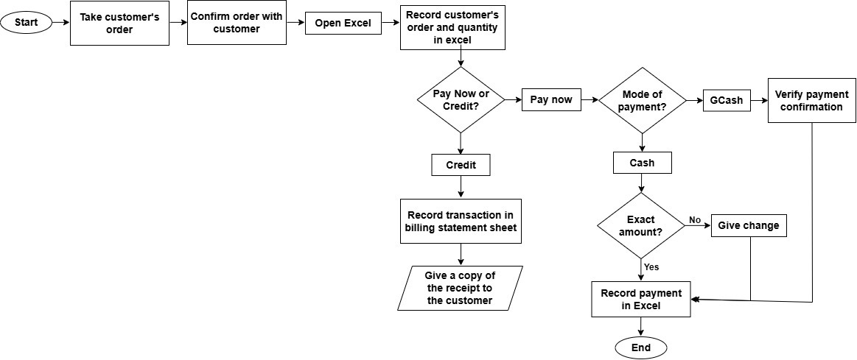
Figure 4. Manual Process Flowchart
Figure 4 shows the manual process of operation at College of the International Hospitality Management and Tourism (CIHMT) Café by the Bay. The process begins when the staff takes the customer’s order and confirms it to make sure it is correct. After confirming, the staff opens a Microsoft Excel file where their order slip is tabulated, which serves as their manual recording system, and inputs the order details and quantity. The staff then asks the customer whether they will pay right away or later, a privilege that is available only to faculty members of the Laguna State Polytechnic University campus. If the customer chooses to pay later, the transaction is recorded in the billing statement sheet, and a copy of the receipt is issued. However, regular customers are required to pay immediately after the order is processed. The staff then settles the payment through either GCash or cash. For GCash payments, the staff verify the payment confirmation, while for cash payments, they check if the amount is exact and provide change if necessary. After completing the payment process, the Café by the Bay’s staff records all the transaction in Excel.
System Flowchart
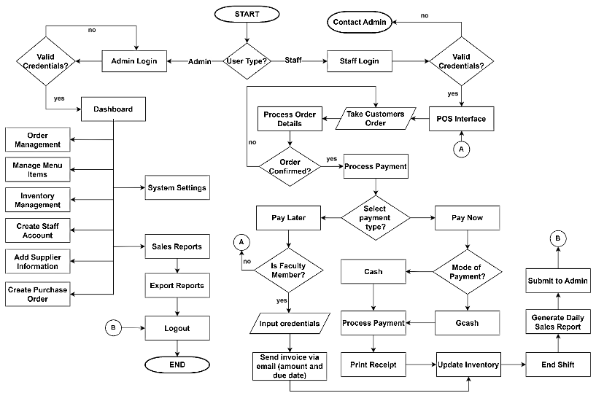
Figure 5. System Flowchart
The figure 5 illustrates the system flowchart of the system, which presents the overall operational process of the Café by the Bay Point-of-Sales (POS) system. It shows how both administrator and staff interact with the system from login to logout.
The flow starts by identifying the user type that differentiate the two main workflows. For administrator, the system validates their credentials before granting access to the dashboard and other administrative functionalities. These include the management of orders and records, menu and product items, inventory, staff accounts, supplier information, purchase orders, system settings configuration, and viewing of sales reports that allows admin to export records. These functions allow administrator to monitor and manage both the system’s core operational and analytical aspects while maintaining all records accurate.
For staff users, the system also performs a credential check, and those without valid access are presented with a display that contains the administrator’s contact information so they can request assistance or account creation. Once logged in, staff are directed to the POS interface, where they take customer orders and processes to payment transactions. The system supports both cash and GCash payments that requires staff to verify either the payment confirmation or the cash amount is correct before completing the transaction. For faculty members, the system allows a "pay later" option, which requires input of credentials to process the payment and send an invoice via email provided. The workflow also supports printing order receipts, and automatically updates inventory, generates daily sales reports, and ending shifts that ensures staff operations are efficiently managed. Both user types conclude their activities by logging out. Overall, this flowchart demonstrates a structured and efficient sequence of processes that ensures a secure access, accurate transaction handling, and organized management of the café’s daily operations.
Use Case Diagram
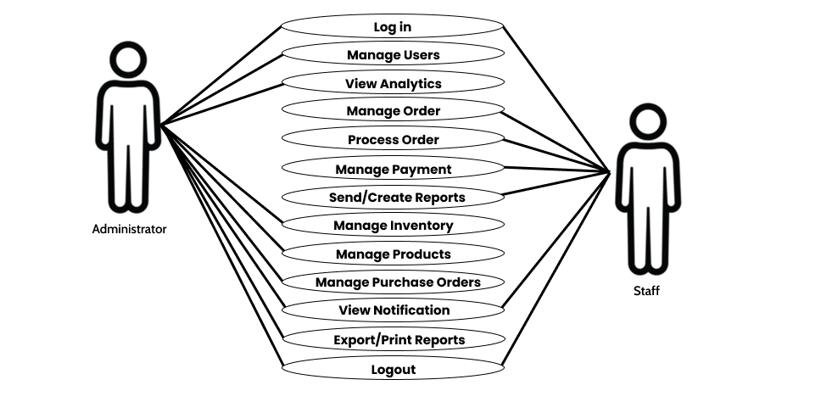
Figure 6. Use Case Diagram
Figure 5 illustrated the different functions that both the Administrator and Staff can perform in the system. It shows how each user role interacts with various features based on the level of their access to the system. Both the Administrator and Staff can perform basic operations such as logging in, viewing of notifications, and logging out.
Once the admin is logged in, they gain access to the system’s functionalities including the management of user accounts, viewing and analyzing analytics, updates inventory and products, manage purchase orders, and manage reports. The admin interface differs from the staff interface as their main role is to monitor sales and transactions processed by the staff.
The staff’s major role is to perform daily business operational tasks, such as managing and processing orders, managing payment transactions, and creating and sending all necessary reports to administrator using the system. Both roles deal with sales functions and can view inventories; however, the admin role is the only one designed to manage users accounts, access the analytical analysis of shop performance, and conduct higher-level management of the system. The diagram offers clarity to demonstrate how the system supports role-based access control, which ensure that tasks are properly allocated for the efficient and safe operation of the business.
Materials
The following tools, software, and hardware are utilized to develop a comprehensive point-of-sales system.
Software
The following software programs were productively utilized by the researchers to develop the system.
PhpMyAdmin is used by developers to specify, store, manage and organize the database of the Point of Sale with Inventory System. It stores important data such as product details, user accounts, sales transactions, and inventory records. PhpMyAdmin allows developers to update easily, run queries, and make sure that the data would be validated and synchronized in real-time.
Cascading Style Sheets (CSS) is what is used to design the visual appearance of the system for a neat, modern, user-friendly experience. Layouts, color schemes, fonts, spacing, and all other stylistic features that make the interface appealing and easy to navigate are defined here. This is in fact very important for the cleanliness, modernity, and user-friendliness of the system being used by both staff and administrators.
Hypertext Markup Language (HTML) is responsible for building the initial structure and layout of the POS user interface. It is responsible for putting all those buttons, forms, and tables and navigation menus in the framework to be displayed. Well organized content will help users understand the system in an efficient and intuitive manner.
Bootstrap is utilized as part of the system’s front-end design and user interface development. It is responsible for ensuring that the system’s interface is not only user-friendly but also adaptive, which helps in maintaining consistency across different screen sizes, making it more accessible and user-friendly for all types of users.
JavaScript has been applied to the making of the system dynamic and responsive. It renders the system more interactive to real-time updates, form validations, product searches, and all other essential user actions. This guarantees that there would be seamless and efficient end-to-end workflows during transactions and inventory management with instant responses to input from the user when using an integrated POS system.
Visual Studio Code serves as the primary integrated development environment (IDE) to create and manage the system codebase. This includes helpful features such as syntax highlighting, debugging tools, as well as various extensions that all help improve productivity. Developers would be working with Visual Studio Code using HTML, CSS, JavaScript, PHP, and other technologies necessary to develop and maintain the system.
XAMPP is used to create a local development environment for testing POS implementations before deployment. The XAMPP environment contains Apache, MySQL, PHP, and other such components to run a live server environment on a local machine, allowing developers to test features, fix their bugs, and improve them in development itself without interfering with the live version of the system.
Python. The system was created in Python, which is a multi-purpose programming language with a lot of different applications such as data analysis, machine learning, and database interaction. Various libraries are incorporated to make the system more versatile.
Pandas allows data manipulation or data handling, which makes it capable of reading data from SQL databases and performing extensive DataFrame operations. This function is very important for the analysis of historical sales data to be done properly and easily.
NumPy provides the necessary support for numerical computing through its fast and easy-to-use array structures and mathematical operations; thus, the demand forecasting algorithms are able to take the required computation done easily. This improves processing efficiency and ensures accurate handling of large numerical datasets within the system.
Scikit-learn for machine learning model implementation especially for the algorithm of K-Nearest Neighbors (KNN). It provides support for the process of data scaling, cross-validation, and hyperparameter tuning, which makes it very easy for the system to find patterns in sales data and thus provide predictions of demand that are reliable and accurate.
Mysql-connector-python library as the communication between the MySQL database and Python. It makes it possible for the data to be retrieved and updated efficiently thus, making database connectivity a crucial part of the system. This library ensures reliable data exchange and supports seamless integration between the application logic and the database.
The combination of all these libraries, the system becomes capable of handling data, running predictive models, and offering useful hints for inventory management, among others. This in turn leads one to make wise decisions and encourages the optimization of stock levels in such a way that the business can smoothly operate.
Hardware
The following computer specifications were utilized through the researchers’ personal computers with enough specification to develop the system.
Table 6. Hardware Requirements
HARDWARE | SPECIFICATION
RAM | 4GB
CPU | Intel iCore5
OS | WINDOWS 10
Table 6 shows the basic equipment required for the project to operate smoothly. At least 4GB of RAM is needed to run the software used. A quad-core CPU is recommended to handle the system’s heavy processing requirements. It is also recommended to use Windows 10 as the operating system, and one to two computers were used during the development of the web-based system. These hardware specifications help to ensure a stable system performance during development and testing.
Table 7. Minimum Requirements for PC or Laptop
MINIMUM REQUIREMENTS FOR PC OR LAPTOP SPECIFICATION | SPECIFICATION
OS | WINDOWS 10
RAM | 4GB
HARD DISK | At least 2GB free space
PROCESSOR | Intel Celeron
Table 7 presents the basic specifications required for PCs and laptops to ensure the system operates smoothly. Since some products may not be compatible with newer operating systems, it is recommended the use of Windows 10. A web browser and a stable internet connection are necessary to fully access and utilize the system’s features.
Business Model
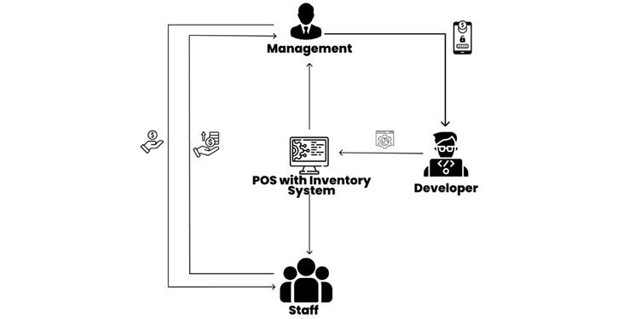
Figure 7. Business Model
Figure 7 illustrates the business model canvas of the project. The POS System serves as the core of the business framework, smoothly connecting Management, Staff, and Developers. The staff use the system to handle transactions, inventory, and customer interactions, while every recorded transaction delivers real-time data to Management for strategic decision-making.
The developers maintain and enhance the system based on feedback, ensuring it remains efficient and secure. Revenue flows through Staff transactions, managed and optimized by Management. The POS System acts as the digital backbone, linking operations, leadership, and innovation.
Project Testing and Evaluation
The researchers conducted different testing to ensure the quality and integrity of the system. Software testing, where all components of modules of the web-based system are tested to verify that it functions as required and identify bugs or errors to avoid failure before delivering the system.
Software Testing
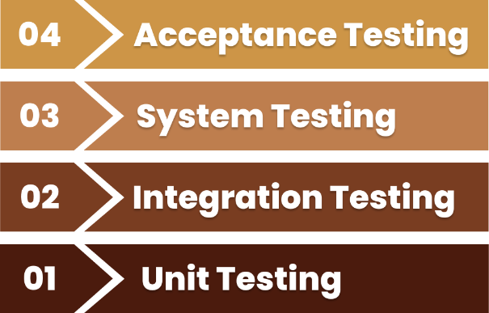
Figure 8. Software Testing
Figure 8 demonstrates the levels of software testing, where individual software units and components are tested. The objective is to verify that each component of the software functions properly to ensure that the system is free of errors, bugs, inconsistencies, and missing features, while confirming that the actual product aligns with the expected requirements. These testing aims to test each component separately to identify whether it performs as intended. This is to improve the quality, reliability, and efficiency of the final product before it is deployed.
Unit Testing
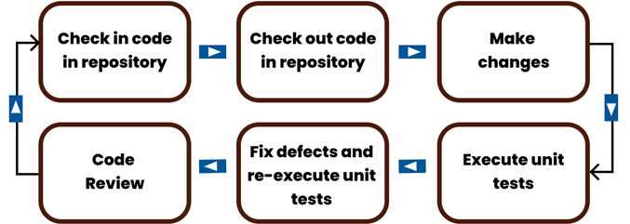
Figure 9. Unit Testing
Figure 9 shows the unit testing process for every module of the system that has been carefully reviewed according to what the developers have designed. The system tests each component focusing on its main function, including registering, selling, updating stock levels, creating a receipt, and allowing user authentication. The modules for the POS interface, inventory tracker, user login system, and reporting tool were subjected for unit testing to
Integration Testing
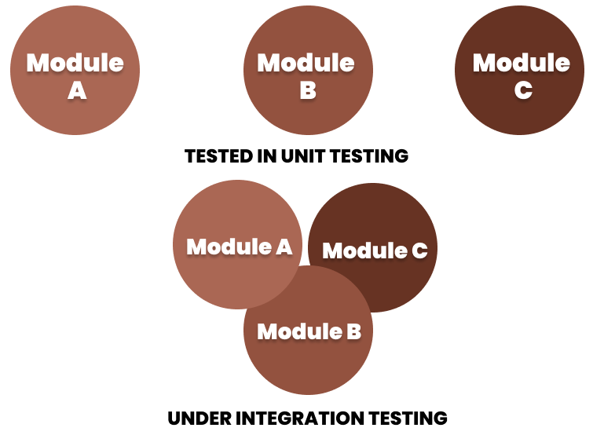
Figure 10. Integration Testing
Figure 10 is the testing activity that developers executed to ensure that more than one module integrated within the architecture of the system functioned properly together. During integration testing, it is verified whether individual components not just work but also interact correctly together. When a sale is made at the POS, it is expected that an automatic deduction of the correct quantity of items happens within the inventory module, and the updated transaction data reflected by the reporting module. Also, access rights to the system were established in some cases. Integration testing thus facilitates seamless and logical communication within all components of the system.
System Testing
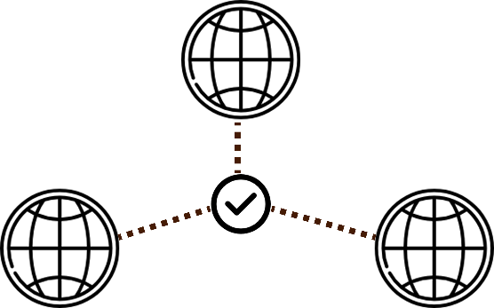
Figure 11. Browser Compatibility Testing
Figure 11 describes the compatibility testing process, where the system is tested across different browsers. This phase evaluates how consistently the system performs in different web environments to ensure that its features, interface elements, and functionalities are operating correctly regardless of the browser used.
System testers verify that all components and features of the point-of-sales (POS) system operate as intended, which ensures that users can seamlessly manage order transactions, monitor and update inventory, manage operational reports, and receives notifications and alerts regardless of the browser used to access the system.
Acceptance Testing
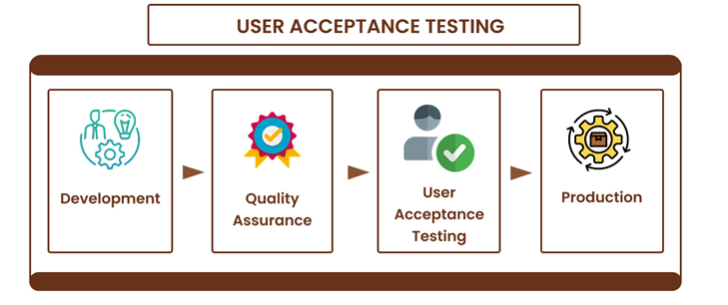
Figure 12. Acceptance Testing
Figure 12 shows the acceptance testing where it consists of measuring the developed system against the requirements approved by the user. It is considered accepted if the developers have satisfied the operational expectations of the user. This testing phase verifies the working capabilities of the system, particularly with real-time inventory updates, secure transaction processing, and role-based access controls. The system was put through its paces in real-world environments by actual users—store owners/admin and staff. The acceptance is determined when the system meets the clients' standards with regards to usability and performance.
Evaluation Procedures
The evaluation of the system was conducted using the ISO 25010 Software Quality Model and the Technology Acceptance Model (TAM). Theses standard and models were employed to guide the assessment, which focuses on the system’s performance and user experience. This evaluation aims to provide a systematic approach for measuring how well the system meets its intended objectives and fulfills user requirements.
ISO 25010 Software Quality Model
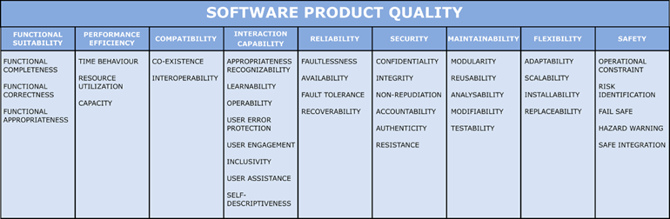
Figure 13. Quality Characteristic of ISO 25010
The system’s quality was evaluated across multiple software characteristics based on the ISO 25010 software quality model. Functional suitability examines how effectively the system performs its intended functions and meets user requirements. Reliability assesses the system’s stability and consistency during operation to ensure that it continues to function properly over time. Usability focuses on how easy is the system for users to learn, navigate, and interact with. Performance efficiency evaluates the system’s responsiveness and resource utilization, especially during peak business operations when there is a high demand for service. While security ensures that access control mechanisms and data protection measures are implemented to protect sensitive information from being exposed or exploited.
Another assessed characteristic are compatibility, maintainability, and portability that determines how well the system integrates and performs with other platforms, how easily it can be improved, and how effectively it can be deployed in different environments. All together, these characteristics provide a comprehensive understanding of the system’s overall quality according to ISO 25010.
Technology Acceptance Model (TAM)
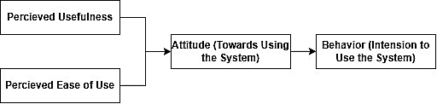
Figure 14. Technology Acceptance Model (TAM)
The Technology Acceptance Model (TAM) was employed to evaluate the system’s user satisfaction and the perceived usefulness. TAM includes four key constructs: perceived usefulness, perceived ease of use, attitude toward use, and behavioral intention to use. Integrating TAM into the survey process allows a structured assessment of how users interact with the system, how beneficial and easy to use they perceive it to be, and how these perceptions influence their attitudes and intentions of continuing to use. This approach enabled the identification of areas to improve and provided meaningful insights into user preferences, satisfaction levels, and the likelihood of long-term adoption of the system.
Sampling Design
The study utilizes purposive sampling to select respondents with different levels of involvement in the daily operations of Café by the Bay point-of-sales (POS) system. The sample includes the shop’s administrator and staff, who serves as the direct users of the system, as well as customers who act as indirect users and beneficiaries of the improved transaction process.
This method ensures that feedback is gathered from individuals with direct and indirect experience of the point-of-sale and inventory management system to avoid potential biases and, accurately represent the research population.
Population of the Study
Table 8. Respondents of the Research Project (ISO 25010)
Category of Respondents | Sample
IT expert | 4
Total | 4
To evaluate the system according to the ISO 25010 quality characteristics, four (4) IT experts have been selected to assess the system’s secure handling of collected data and to identify potential issues such as errors, bugs, and system failures. These experts have illustrated, analyzed, and assessed the feasibility of developing a web-based system, as well as evaluated the overall performance and features of the developed platform.
Table 9. Respondents of the Research Project (TAM)
CATEGORY OF RESPONDENTS | SAMPLE
Admin/Management | 5
Staff | 17
Customer | 78
Total | 100
To evaluate the system’s user acceptance based on the Technology Acceptance Model (TAM), one hundred (100) respondents, consisting of the shop’s Admin or Management, staff, and customers. These respondents analyzed and tested the system by providing insights into its effectiveness in business operations and the buying experience, ensuring that it meets the needs of daily tasks and business operations.
Data Collection Instrument
The data were collected by conducting interviews and providing survey questionnaires to the respondents after showing the actual system, which served as the basis for evaluating and improving the development of the web-based point-of-sales (POS) system for Café by the Bay.
Surveys were conducted using structured questionnaires administered via Google Forms to gather feedback on the web-based point-of-sales (POS) system, by which responses were automatically recorded and processed in Microsoft Excel for compilation, tabulation, and analysis. Two sets of questionnaires were deployed. The first set follows the ISO 25010 quality model that covers several categories such as functional suitability, performance efficiency, compatibility, usability, reliability, security, maintainability, and portability. The questionnaire utilized a five-point rating scale, classified as: One (1) – Poor, two (2) – Needs improvement, three (3) – Fair, four (4) – Good, five (5) – Excellent. This set was answered by four (4) IT experts to ensure the technical evaluation of the system’s quality attributes.
The second set of questionnaires were based on the Technology Acceptance Model (TAM) to assess categories such as Perceived Ease of Use, Perceived Usefulness, Attitude Toward Using, and Behavior of Intention to Use the System. Responses were measured on a four-point Likert scale as follows: One (1) – Strongly Disagree, two (2) – Disagree, three (3) – Agree, four (4) – Strongly Agree. This set was answered by one hundred (100) research respondents.
Statistical Treatment
The purposive sampling technique used in this study allows the researchers to gather specific respondents to evaluate the system. Collected responses from survey questionnaires using Google form were thoroughly analyzed and computed for ISO and TAM survey results.
The data collected from the ISO 25010 and Technology Acceptance Model (TAM) survey questionnaires were analyzed using descriptive statistics. The Mean was calculated in order to determine the central tendency of the respondents' ratings, along with the standard deviation to measure the variations and consistency of their responses. Through this approach, the general perceptions of the respondents are assessed.
These statistical measures provide a clear summary of user evaluation results and support the objective interpretation of the findings. The use of descriptive statistics ensures that the analysis remains appropriate for the nature of the collected data. The formula used were as follows:
- Mean
Each survey item and components was calculated to determine its central score or the average using the following formula:
Mean ($\overline{x})$ = $\frac{\sum{X}}{n}$

Where:
∑X = sum of all responses
x = individual scores or responses
n = total number of respondents
- Standard Deviation
The Standard Deviation was used to measure how spread out the respondent’s answers are around the calculated mean. A low standard deviation means most respondents gave similar ratings that shows agreement. While a high standard deviation means the responses vary more, which indicates the diverse opinions of the respondents. The formula used is as follows:
SD = $\sqrt{ \frac{{\sum{(x_{i} - \overline{x}})}^{2}}{n-1}}$

Where:
$x_{i}$ = each item responses
x̄ = mean of the responses
n = total number of respondents
Table 10. 5-Point Likert Scale for ISO 25010
Rating | Mean Range | Interpretation
5 | 4.21–5.00 | Excellent
4 | 3.41–4.20 | Good
3 | 2.61–3.40 | Fair
2 | 1.81–2.60 | Needs Improvement
1 | 1.00–1.80 | Poor

Table 10 presents the 5-point Likert scale for ISO 25010, which serves as the basis to interpret respondents’ ratings. A score of 5 (mean 4.21–5.00) indicates excellent performance, showing strong satisfaction. A rating of 4 (mean 3.41–4.20) reflects good performance with minor areas for improvement, while a score of 3 (mean 2.61–3.40) suggests fair performance, indicating acceptability but with noticeable shortcomings. Ratings of 2 (mean 1.81–2.60) indicates that several features need improvement, and a score of 1 (mean 1.00–1.80) indicates poor performance, which shows that significant improvements are required.
Table 11. 4-Point Likert Scale for TAM
Rating | Mean Range | Interpretation
4 | 3.26 – 4.00 | Strongly Agree
3 | 2.51 – 3.25 | Agree
2 | 1.76 – 2.50 | Disagree
1 | 1.00 – 1.75 | Strongly Disagree

Table 11 shows the 4-point Likert scale used for TAM evaluation. A rating of 4 (mean 3.26–4.00) indicates that respondents strongly agree with the statement. A score of 3 (mean 2.51–3.25) reflects agreement, while a rating of 2 (mean 1.76–2.50) indicates disagreement. A score of 1 (mean 1.00–1.75) shows strong disagreement, meaning the respondents clearly do not support the statement regarding the system’s user acceptance.
Ethical Consideration
To ensure the protection of data and the rights of all participants, this study has strictly applied ethical guidelines throughout the testing and interview process. The protection of participants through ethical principles is significant in conducting the study. The researchers have first communicated with the management of Café by the Bay to inform them about the interview and to request permission to conduct surveys and system testing. To formally obtain approval for data gathering and evaluation activities, consent letter, signed by the research adviser, developers, and Café management, were provided to the client.
The researchers ensured that participants have fully understood the purpose and scope of the interviews and system evaluation before agreeing to participate. Participation in this capstone project remained voluntary, with participants being properly informed prior to giving their consent. The researchers also ensured fairness, transparency, and integrity throughout the process to avoid any form of bias or discrimination.
The researchers also assured that all collected data and any information shared during interviews and testing will be kept confidential and not be disclosed to any third and unauthorized parties. All survey questions and evaluation tools have been reviewed and approved by the research adviser before it was carried out.

CHAPTER IV
RESULTS AND DISCUSSION
This chapter presents the results and discussion derived from the methods and procedures stated in the previous chapter. The results are organized and discussed in relation to the research objectives and insights drawn from the collected data.
Results by Objective
1. Design and develop a web-based point-of-sales system integrated with inventory management designed to the needs of Café by the Bay to streamline sales transactions and improve order management.
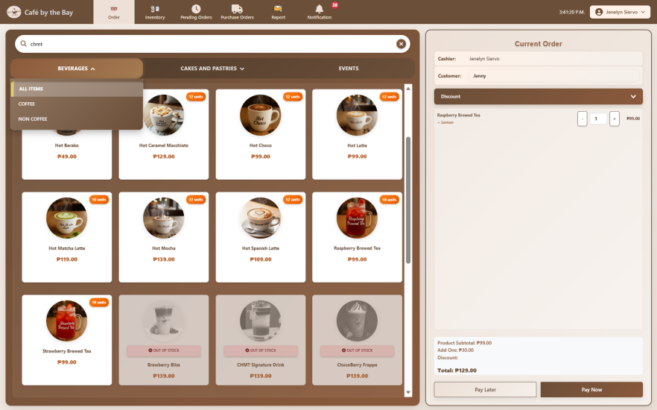
Figure 15. Order Management Interface for Staff
Figure 15 shows the main interface of the POS system, specifically the ordering interface that handles daily customer transactions. The products are organized into three (3) categories – Beverages, Cakes and Pastries, and Events – designed to makes it easier for the staff to locate and navigate items. A search bar is also integrated into the interface that allows the staff to quickly find specific products by entering keywords or characters, which eliminates the need to manually browse through all categories. Each product card contains the product image, name, price, and current stock level, which helps the staff to determine if the item need restocking. While products that are out of stock are labeled and automatically disabled to prevent selection. The interface also includes an order summary panel located on the right side of the screen. This panel displays the selected items by staff, along with the other details such as applicable discounts, quantities that can be modified, and review the total amount due for confirmation. Over all, this layout provides a simple and organized way to process orders, which reduces manual errors and speeds up the transaction process.
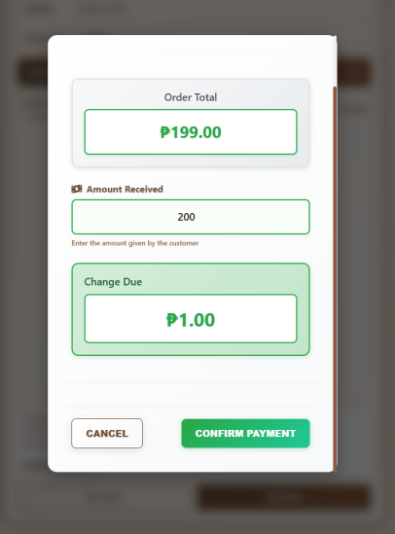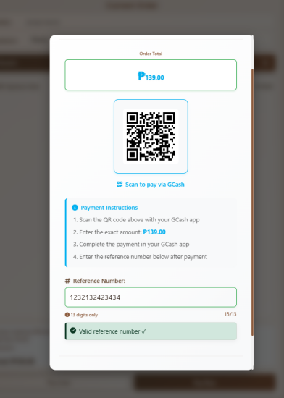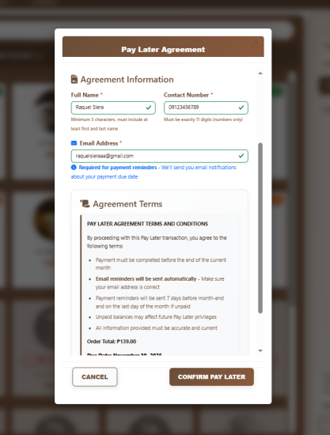
- (b) (c)
Figure 15.1. Payment Option and Process Feature: (a) Cash Payment, (b) GCash Payment, (c) Pay Later
Figure 15.1 shows the payment options and workflow in the ordering interface. The system provides two payment methods: Pay Now, which is available to all customers, and Pay Later, which is offered exclusively to faculty members. The “Pay Now” option require customers to settle the payment immediately after taking their order, either cash or GCash. For cash transactions (a), the system displays the computed total amount, allows the staff to input the cash received, and automatically calculates the change, eliminating manual calculations and errors. For GCash payments (b), the system displays the café’s QR code and allows the staff to input the reference number from the GCash receipt showed by the customer. After the transaction is successfully verified. The system displays a confirmation screen showing the transaction details including the order number, list of items, and total amount.
If a faculty proceeds to pay later, the system will display a Pay Later Agreement form (c). The form collects the faculty’s details such as department, full name, contact number, and an active email address. It also presents the agreement terms and payment due date to ensure proper documentation of the transaction. Before confirming, the faculty member must agree to the stated terms and conditions to proceed. This process is implemented to maintain accountability and ensures that all Pay Later transactions are properly tracked by the system.
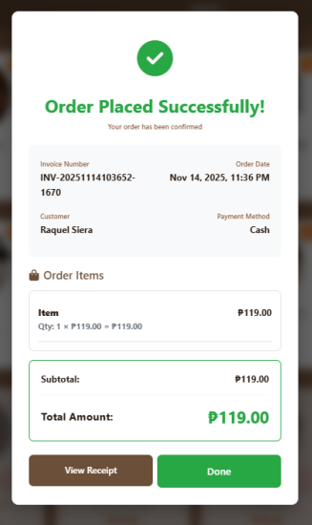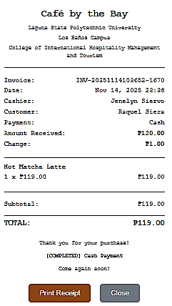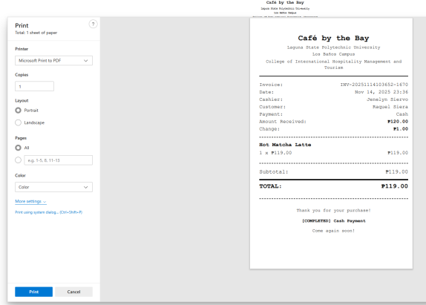
(a) (b) (c)
Figure 15.2. Generated Printable Receipt Feature: (a) Order Confirmation,
(b) Generated receipt, (c) Printable receipt
Figure 15.2 Shows the generated receipt of the system, once the payment is processed, a confirmation appears (a) with two options “View Receipt” and “Done.” When the staff clicks “View Receipt,” the detailed receipt is displayed (b), such as the invoice number, date and time, staff name, customer type, mode of payment, and the list of purchased items with their corresponding prices. The system automatically computes the subtotal, any additional charges, and the total amount. It also shows the amount received and the change for cash transactions. At the bottom, the staff has the option to print the receipt to open the print dialog (c). This automated process helps lessen the manual computation errors and provides an organized printed receipt for both the business and customer.
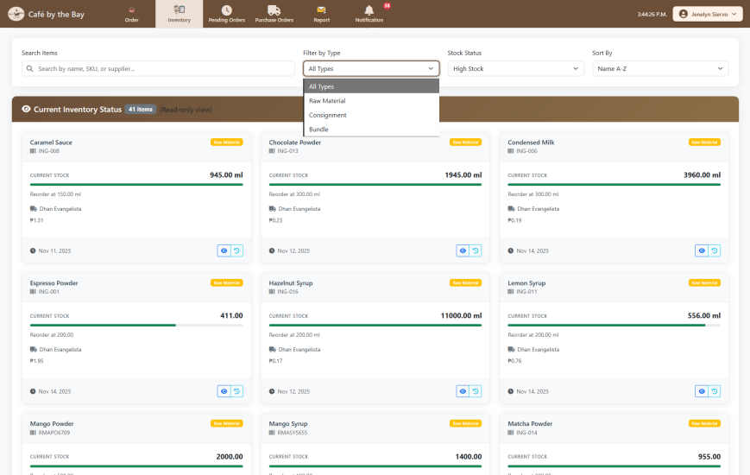
Figure 16. Inventory Management Interface for Staff
Figure 16 shows the inventory page in staff interface, where the integration of the Point-of-Sales (POS) and inventory module is demonstrated. The staff can only view the inventory to check the stock availability but cannot modify any details.
This page provides a comprehensive overview of the current stock levels for all items used in the café. It offers a search bar to quickly locate specific item; a filter dropdown that organize inventory according to item types and stock status; a sorting option according to item name, stock level, cost, and time it was updated. Each item is displayed in an individual card that shows key details such as the item name, remaining stock quantity, unit of measurement, supplier, and the most recent date it was restocked. A color-indicator bar also represents the current stock level, which allows users to immediately identify items that are low, adequate, or high in quantity. Whenever an order is processed in the POS, the system automatically updates the inventory by deducting the items or ingredients used for orders. This integration helps both the staff and the admin to monitor product quantities in real time and avoid manual errors.
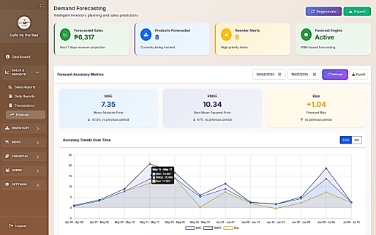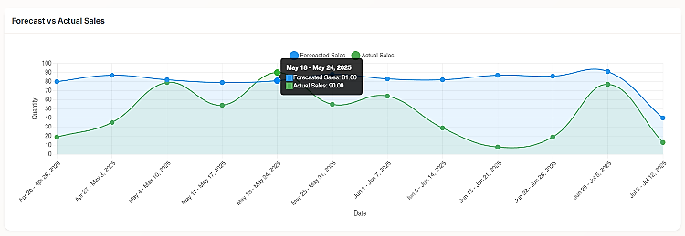
(a) (b)
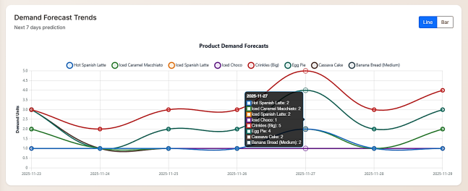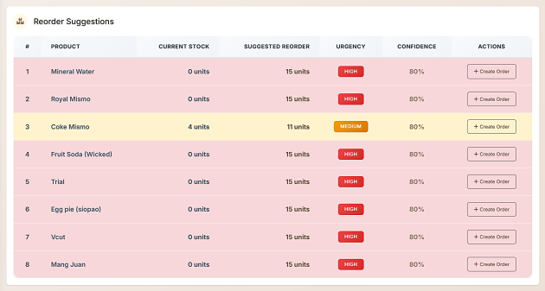
(c) (d)
Figure 17. Forecasting Feature for Admin: (a) Forecast Accuracy Metrics, (b) Forecasted Sales vs Actual Sales (c) Demand Forecast Trends, (d) Reorder Suggestions
Figure 17 shows the integration of the analytics module within the Forecasting page, where the system uses the KNN algorithm to generate sales forecasts. The Forecasted Sales and Products Forecasted tiles shows how many items are currently being forecasted by the model, according to the date range set by the admin. The Reorder Alerts tile identifies items that require inventory attention based on the forecasted demand patterns. While, the Forecast Engine status indicates whether the KNN forecasting module is active, which indicates whether the displayed results are generated from the recent analysis.
The Forecast Accuracy Metrics (a) summarizes how the KNN model performed during the selected date range by presenting key indicators such as MAE (Mean Absolute Error), RMSE (Root Mean Squared Error), and Bias, which shows the accuracy and directional tendencies of the forecasts. These metrics help the administrator to assess whether the model’s predictions align closely with historical data patterns. The Accuracy Trends Over Time chart further illustrates how these indicators vary across different periods, which provides insights into the stability and consistency of the model’s performance.
Other features of the page include the Forecasted Sales vs Actual Sales chart (b), which provides an estimate of how product demand may change in the coming days by visually comparing the system’s forecasted sales with the café’s actual sales. This allows the administrator to assess how closely the model’s predictions align with the café’s real performance. The weekly comparison of predicted and actual sales from April 20 to July 12, 2025, shows that the KNN model closely follows the actual sales pattern throughout the assessment period. It consistently captures changes in demand direction, as seen during low-demand periods in late April, mid-May, and early June, where forecasted and actual values remain very close. While actual sales demonstrates sharper fluctuations that drops below 20 units several times in June and rising above 70 units in early July, which shows the forecasted values remain smoother and slightly higher on average that reflects the model’s tendency to avoid underestimating demand. Overall, the chart demonstrates that the KNN model provides accurate, stable, and dependable weekly predictions, making it suitable for practical café-level inventory and production planning.
Demand Forecast Trend chart (c) visualizes the forecasted demand of forecasted products for the next seven (7) days through a chart. This panels help the admin to understand the café’s future product needs and monitor whether the system’s predictions are reliable. Even though the historically collected data that went into the training and testing of the model is only until July 10, 2025, the system is designed to constantly generate forecasts of the future starting from the current date, thus enabling it to act as a real-time prediction tool. Therefore, it is able to deliver valid short-term forecasts that go beyond the dataset's range, thereby demonstrating its capability to assist with the ongoing inventory and production planning. This feature shows that it is a great tool for the café to anticipate product demand very soon, and helps them to allocate resources in the best way possible and at the same time avoid stock outs or wastage. It allows administrators to take actions in terms of restocking and preparation that are in line with the customer demand for each specific product as per the projection.
Lastly, the page also provides a Reorder Suggestion section (d), which shows a list of products that needs restocking along with their urgency levels and recommended quantities. This helps to prevent stockouts and ensures that important items remain available. Altogether, these features support better inventory planning, improve decision-making, and help the business maintain smooth daily operations.
Project Testing and Debugging
A. Unit Testing
The unit testing for the Web-Based Point-of-Sales System for Café by the Bay was carefully conducted to each important functionalities of each module of the system. This is to ensure the system’s reliability, usability, and system integrity for both administrator and staff.
Table 12. Unit Testing for Account Management Module
Tested Case | Expected Result | Actual Output | Response Time | Remarks
User Registration | User account record created with active status. | User inserted successfully, status= ‘Active’ | 1.16 s | PASSED
User Login Success | Valid credentials accepted | Password verified, session data set | 0.50 s | PASSED
User Login Failure | Invalid password rejected | Password mismatch detected. | 0.51 s | PASSED
Admin Role Permissions | Admin role recognized and permissions granted | Role comparison succeeds, access granted. | 0.30 s | PASSED
Session Management | Session values persisted correctly | Session data stored and retrieved | 0.33 s | PASSED

Table 12 presents the results of unit testing conducted on the Account Management Module, where critical user account functionalities are tested. The user registration process successfully created account records with an active status, with the system responding in 1.16 seconds, confirming that new users can be registered efficiently. User login functionality was also verified, with both successful and failed login attempts and produce the expected outcomes. Valid credentials were correctly accepted and successfully establish session data within 0.50 seconds, while invalid passwords were appropriately rejected. The module’s role-based access was tested for administrative privileges, and results showed that admin users were correctly identified and granted the appropriate permissions within 0.30 seconds. While the session management was validated, with the session data accurately stored and retrieved in 0.33 seconds. Overall, all tested cases are remarked passed, which indicates that the Account Management Module operates as intended with satisfactory response times.
Table 13. Unit Testing for Inventory Management Module
Tested Case | Expected Result | Actual Output | Response Time |  | Remarks
Add Inventory Item | New inventory item stored in database | Item inserted with stock and cost values |  | 1.38 s | PASSED
Update Inventory Stock | Stock quantity updated correctly | Current-stock field updated to new value |  | 1.17 s | PASSED
Restock Inventory | Stock increases by specified quantity | Stock incremented successfully |  | 1.05 s | PASSED
Deduct Inventory Stock | Stock decreases when items sold | Stock decremented correctly |  | 0.64 s | PASSED
Low Stock Alerts | Low stock items identified and returned | Array contains items below threshold |  | 0.56 s | PASSED

Table 13 presents the results of unit testing conducted on the Inventory Management Module, where core inventory operations functioned as expected. Adding new inventory items was successful, with stock and cost values correctly stored in the database, and the system responded in 1.38 seconds. Stock updates and restocking processes accurately adjusted item quantities, while stock deductions reflected sales transactions correctly, with response times ranging from 0.64 to 1.17 seconds. The module also successfully identified items with low stock levels with .56 seconds response time. Overall, all tested cases were remarked as passed, which confirms the module’s reliability and efficiency in managing inventory data.
Table 14. Unit Testing for Order Module
Tested Case | Expected Result | Actual Output | Response Time | Remarks
Create Order | New order/sale record created | Sale record inserted with status=‘paid’ | 1.15 s | PASSED
Add Items to Order | Items added to order successfully | Sale items inserted with quantities and prices | 0.46 s | PASSED
Update Order Status | Order status changed from pending to paid | Status field updated correctly | 0.28 s | PASSED
Calculate Order Total | Total amount calculated from items | Total matches sum of item prices | 0.63 s | PASSED

Table 14 summarizes the unit testing of the Order Module, where its ability to manage sales and order-related processes accurately were verified. New orders were created and recorded with the correct status, while items were successfully added with correct quantities and prices. The module correctly updated order statuses from pending to paid and accurately calculated order totals by summing the prices of all items. Response times for these operations ranged from 0.28 to 1.15 seconds, demonstrating the prompt processing. The successful completion of all test cases indicates that the Order Module reliably supports transaction management and ensures data accuracy within the system with passed remarks.
Table 15. Unit Testing for Supplier Module
Tested Case | Expected Result | Actual Output | Response Time |  | Remarks
Create Supplier | New supplier record created | Supplier inserted with all details |  | 1.48 s |  | PASSED
Update Supplier | Supplier information updated | Fields updated successfully |  | 0.55 s |  | PASSED
Delete Supplier | Supplier removed from database | Supplier record deleted |  | 0.46 s |  | PASSED
Create Purchase Order | Purchase order created with items | PO created with supplier link and items |  | 1.39 s |  | PASSED

Table 15 presents the unit testing results for the Supplier Module, confirming that supplier management and purchase order functionalities operate correctly. The creation of new supplier records was successful, with all details accurately stored in the database, and the system responded in 1.48 seconds. Updates to supplier information were reflected correctly in the respective fields, while deletion of supplier records successfully removed the entries from the database, with response times of 0.55 and 0.46 seconds, respectively. Additionally, the module effectively created purchase orders, linking them to suppliers and including the relevant items, with a response time of 1.39 seconds. All tested cases passed, demonstrating the module’s reliability in handling supplier data and supporting procurement processes efficiently.
Table 16. Unit Testing for Product Module
Tested Case | Expected Result | Actual Output | Response Time | Remarks
Create Product | New menu item/product created | Product inserted with price and category | 1.49 s | PASSED
Update Product | Product details updated | Name, price, category updated correctly | 0.25 s | PASSED
Update Product Price | Product price modified | Price field updated successfully | 0.13 s | PASSED
Hide Product | Product status set to hidden | Status changed to ‘Hidden’ | 0.13 s | PASSED
Get Products by Category | Products filtered by category | Array returned with category filter | 0.24 s | PASSED

Table 16 presents the unit testing results for the Product Module, showing that all product management functionalities were executed correctly. The creation of new products or menu items was successful, with the system accurately storing the product’s price and category, responding in 1.49 seconds. Updates the product details, including name, price, and category, were reflected correctly, while individual price modifications were applied successfully, with minimal response times of 0.25 and 0.13 seconds, respectively.
The module also correctly implemented the functionality to hide products by changing their status to “Hidden,” this is to ensure that items could be temporarily removed from menu display. Products were also effectively filtered by category, and the expected results displays in 0.24 seconds. All tested cases passed, which confirms the module’s reliability in managing product information and supporting efficient menu or product management.
Table 17. Unit Testing for Notification & Alert Module
Tested Case | Expected Result | Actual Output | Response Time | Remarks
Get Low Stock Alerts | Low stock items identified | Array contains items below threshold | 0.54 s | PASSED
Low Stock Threshold | Only items below threshold returned | Filtering working correctly | 0.34 s | PASSED
Get Pending Orders | Pending pay-later orders retrieved | Array contains pending orders | 0.65 s | PASSED
Zero Stock Notification | Items with zero stock flagged | Zero stock items in alerts | 0.44 s | PASSED

Table 17 presents the unit testing results for the Notification and Alert Module, which is responsible for detecting low-stock items, identifying zero-stock conditions, and retrieving pending pay-later orders. The results show that the module performed all of its functions efficiently and accurately, which demonstrates its reliability for real-time operational use.
The system correctly identified and successfully alerts Low stock items below the specified reorder level quantity, with response times of 0.54 and 0.34 seconds. It also accurately retrieved pending pay-later orders in the correct priority order, from the most overdue to the least overdue, with a response time of 0.65 seconds. Meanwhile, the Zero Stock Notification test verified that the module accurately flag all items with zero inventory within 0.44 seconds, which ensures that inventory stocks in critical condition are detected immediately. Overall, all test cases passed, which indicated that the module is stable, responsive, and fully capable of supporting real-time inventory monitoring and order management for the café’s daily operations.
Table 18. Unit Testing for Transaction Module
Tested Case | Expected Result | Actual Output | Response Time |  | Remarks
Process Cash Payment | Cash transaction recorded | Sale created with payment_method=‘cash’ |  | 0.25 s | PASSED
Process GCash Payment | GCash transaction with reference recorded | Sale created with reference number |  | 0.26 s | PASSED
Process Pay Later | Pay later transaction created as pending | Sale created with status=‘pending’ |  | 0.37 s | PASSED
Transaction with Inventory Deduction | Inventory reduced when transaction processed | Stock decreased correctly |  | 0.55 s | PASSED
Receipt Generation | Receipt data retrieved correctly | All receipt fields returned |  | 0.34 s | PASSED

Table 18 presents the unit testing results for the Transaction Module, showing its capability to accurately handle Cash and GCash payment methods and manage inventory adjustments. Cash transactions were successfully recorded, creates sales entries with the payment method set to “cash,” while GCash payments were processed with reference numbers correctly recorded, with response times of 0.25 and 0.26 seconds, respectively. While “Pay-later” transactions were also correctly created with a pending status in 0.37 seconds. The module accurately deducted inventory according to processed transactions, which ensures that stock levels are reflected in sales in 0.55 seconds. The receipt generation retrieved all necessary fields correctly in 0.34 seconds, and enables the proper documentation of sales. All tested cases passed, which confirms that the module reliably manages transactions, updates inventory, and provides accurate sales records.
Table 19. Unit Testing for Reports Module
Tested Case | Expected Result | Actual Output | Response Time | Remarks
Daily Sales Report | Daily sales aggregated correctly | Report shows date, orders, and totals | 0.35 s |  | PASSED
Weekly Sales Report | Weekly sales data aggregated | Weekly summaries returned | 0.43 s |  | PASSED
Monthly Sales Report | Monthly sales aggregated | Monthly summaries with totals | 0.55 s |  | PASSED
Top Selling Products | Best-selling products identified | Products sorted by sales quantity | 0.35 s |  | PASSED
Transaction Logs Report | Transaction history retrieved | Logs with staff information returned | 0.74 s |  | PASSED

Table 19 presents the unit testing results for the Reports Module, where its ability to generate accurate and timely summaries of sales and transaction data were validated. The module successfully produced daily, weekly, and monthly sales reports, and filters orders and totals correctly with response times ranging from 0.35 to 0.55 seconds. Top-selling products were accurately identified and sorted based on sales quantities, which provides valuable insights into product performance in 0.35 seconds. The module also effectively retrieved transaction logs, including staff and transaction details, in 0.74 seconds that supports the proper record-keeping and auditing. All tested cases passed, which confirms the module’s reliability in generating comprehensive and accurate reports to facilitate effective decision-making and operational monitoring.
Table 20. Unit Testing for Analytics Module
Tested Case | Expected Result | Actual Output | Response Time | Remarks
Store Forecast Prediction | Single prediction stored in database | Prediction inserted with date and demand value | 1.00 s | PASSED
Calculate MAE (Mean Absolute Error) | MAE calculated correctly from predictions vs actuals | MAE value returned as float | 1.59 s | PASSED
Get Accuracy Metrics for Product | Product-specific accuracy metrics retrieved | Metrics array with MAE, RMSE, Bias returned | 1.17 s | PASSED
Forecast Cache Storage | Forecast data cached in database | Cache entry created with expiration time | 0.82 s | PASSED
Historical Trends Analytics | Weekly accuracy trends retrieved | Historical data array with period metrics | 1.02 s | PASSED

Table 20 presents the unit testing results for the Analytics Module, where its ability to generate, store, and evaluate sales forecasts accurately were validated and tested thoroughly. The module successfully stored single forecast predictions in the database, including the prediction date and demand value, with a response time of 1.00 second. It correctly calculated the Mean Absolute Error (MAE) between predicted and actual values, returns the result as a float in 1.59 seconds, and retrieve product-specific accuracy metrics, including MAE, RMSE, and bias, in 1.17 seconds.
Forecast data was also properly cached with expiration times to optimize the system’s performance, and was completed in 0.82 seconds. The module also retrieved historical weekly trends for accuracy assessment in 1.02 seconds that allows analysis of forecast performance over the time. All test cases were remarked passed, which confirms that the Analytics Module reliably supports forecasting, performance evaluation, and trend analysis for informed decision-making.
B. Integration Testing
The integration testing of the Web-Based Point-of-Sales System for Café by the Bay tested all system modules: Account Management Module, Inventory Management Module, Order Module, Supplier Module, Product Module, Notification & Alert Module, Transaction Module, Reports Module, and Analytics Module. This testing proves that modules perform well individually, as well as when integrated together, ensuring that data is passed accurately between the administrator, staff, and database. The successful results indicate that inter-module interactions function as intended without data loss or processing errors.

Table 21. Integration Testing
Tested Case | Expected Result | Actual Output | Response Time | Remarks
Account Management Module | Admin and staff users can access appropriate modules based on roles, authentication controls access to all system modules | Admin successfully accesses all admin modules, staff restricted to staff modules only, role-based access control working | 1.12s | PASSED
Inventory Management Module | Inventory stock deducted when orders processed, restocked from purchase orders, triggers low stock notifications, data flows to reports and forecast modules | Inventory automatically deducted on order processing, restocked from PO receive, notifications generated, reports and forecasts updated | 1.48s | PASSED
Order Module | Orders process payments (cash/gcash/pay later), deduct inventory, update reports, and trigger notifications | Orders successfully process all payment types, inventory deducted, reports updated, notifications generated | 1.65s | PASSED
Supplier Module | Supplier data used in purchase orders, purchase orders restock inventory, supplier information appears in reports | Purchase orders created with supplier data, inventory restocked on PO receive, supplier reports generated | 1.35s | PASSED
Product Module | Products linked to inventory items, used in orders, appear in sales reports, and included in forecast predictions | Products correctly linked to inventory, used in order processing, included in sales reports and forecasts | 1.22s | PASSED
Notification & Alert Module | Notifications triggered by low inventory stock, pending orders, and other system events | Low stock alerts generated, pending order notifications created, all event-driven notifications working | 1.14s | PASSED
Transaction Module | Transactions process payments, deduct inventory, update sales records, and flow data to reports | All payment methods processed, inventory deducted, sales records updated, data flows to reports correctly | 1.23s | PASSED
Reports Module | Reports aggregate data from transactions, inventory movements, sales, and product performance | Daily, weekly, and monthly reports show accurate data from all source modules | 1.36s | PASSED
Analytics Module | Forecast module uses historical sales data, compares predictions with actual sales, and integrates with inventory for demand planning | Forecasts generated from sales data, accuracy metrics calculated, inventory planning data provided | 1.72s | PASSED

Table 21 presents the results of integration testing, which verified that all system modules interact correctly and data flows smoothly across the system. The Account Management Module correctly employed role-based access that allows administrators full module access and restricts the staff access, with authentication functioning as expected in 1.12 seconds. The Inventory Management Module successfully deducted stock during order processing, restocked items from purchase orders, triggered the low stock notifications, and updated reports and forecast data, which responded in 1.48 seconds. The Order Module accurately processed payments through cash, GCash, and pay-later options, updated inventory, generated reports, and triggered notifications in 1.65 seconds. Supplier data was correctly linked to purchase orders, inventory replenishment, and reporting in 1.35 seconds, while the Product Module ensured products were connected to inventory items, used in orders, reflected in sales reports, and included in the forecast predictions with response time of 1.22 seconds.
The Notification & Alert Module generated appropriate alerts for low stock and pending orders within 1.14 seconds. The Transaction Module processed all payment types, updated sales records, and synchronized the data with reports in 1.23 seconds. Reports accurately combines data from transactions, inventory movements, and product performance in 1.36 seconds. Lastly, the Analytics Module generated comprehensive forecasts based on historical sales, calculated accuracy metrics, and provided inventory planning data in 1.72 seconds. All integration test cases passed, which confirms that the system modules work together all together, ensuring the accurate flow of data, reliable processing, and effective communication between different modules.
- System Testing
The system testing served as the final phase of evaluation of the Web-Based Point-of-Sales System for Café by the Bay. The researchers conducted Browser Compatibility Testing to test the system’s compatibility to seamlessly perform its functionalities on different browsers, ensuring its adaptability before deployment.
Table 22. Browser Compatibility Testing Results
Tested Case | Chrome  Response Time | Firefox  Response Time | Microsoft Edge  Response Time
- User Login and Authentication | 1.25s | 1.30s | 1.28s
- Admin Dashboard Access | 1.26s | 1.37s | 1.25s
- Staff Dashboard Access | 1.25s | 1.38s | 1.26s
- Complete Sales Transaction | 1.50s | 1.65s | 1.22s
- Payment Processing | 0.90s | 0.72s | 0.88s
- Inventory Management | 0.95s | 0.68s | 0.66s
- Reports Generation | 0.85s | 1.38s | 0.86s
- Forecast Generation | 6.30s | 6.68s | 6.65s
- Data Export | 1.23s | 1.58s | 0.76s

Table 22 presents the response times of key functions of the web-based point-of-sales (POS) system when executed from three major web browsers: Google Chrome, Mozilla Firefox, and Microsoft Edge. The results show that the system performs consistently across all browsers, with only slight difference in speed depending on the function executed. Basic operations such as User Login and Authentication, Dashboard Access, and Inventory Management show response times ranging between 0.66s and 1.38s, which indicates that these functions loaded efficiently regardless of the browser used. Chrome and Edge generally provides slightly faster response times, while Firefox shows minor delays in some operations such as Reports Generation and Dashboard Access. The feature Forecast Generation, expectedly record higher response times across all browsers that ranges from 6.30s to 6.68s, demonstrating that the system still behaves consistently, with no significant performance drop on any specific browser, despite a heavy computation involved.
Among the three browsers, Microsoft Edge demonstrates the most optimized performance with the fastest response times in most critical functions such as Complete Sales Transaction, Inventory Management, and Data Export, followed by Chrome. While Firefox shows comparatively slower performance in a few tasks but remains within the acceptable operational limits. Overall, the results indicate that the system is highly compatible across Chrome, Firefox, and Edge, with performance differences being minor and not detrimental to usability. The consistent response times across browsers demonstrate that the system functions reliably regardless of the user’s chosen platform.
2. Develop a web-based system that automates stock monitoring, generates sales reports, and inventory stock levels alerts.
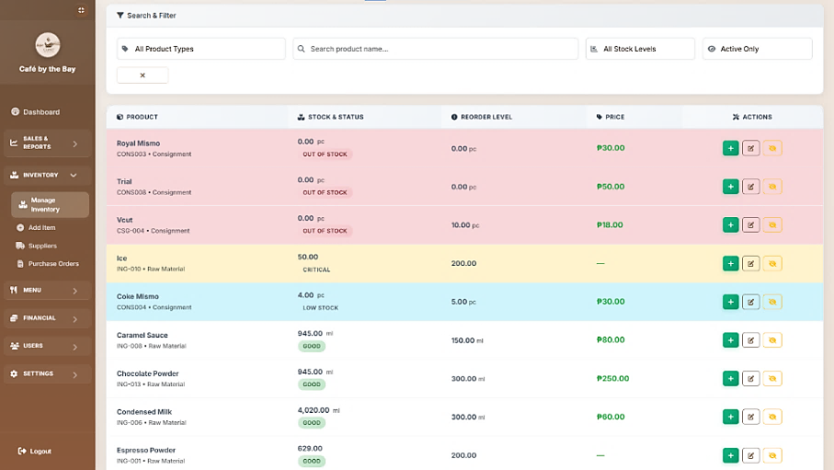
Figure 18. Inventory Management Interface for Administrator
Figure 18 shows the Inventory Management for the admin interface of the Café by the Bay POS system, which demonstrates how the system automates the stock monitoring and reduces the manual workload that is associated with traditional way of checking inventory. Instead of manually inspecting shelves or updating handwritten records, administrators can view real-time product information directly through the interface, such as item name, type, stock quantity, price, and status. This automation allows the system to instantly update stock changes whenever admin users restock, edit details, or adjust quantities using the interactive action buttons.
The use of color-coded indicators serves as an automated alert mechanism that identifies which items requires immediate attention, where red is for out of stock, yellow for critical, and blue for low stock levels. This feature eliminates the need for manual tracking, improves the accuracy, and supports better inventory control by ensuring the timely stock replenishment and prevent unexpected stockouts.
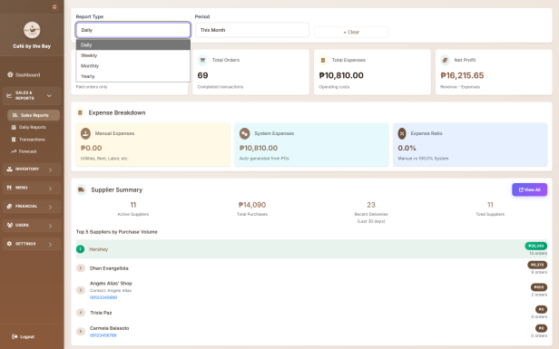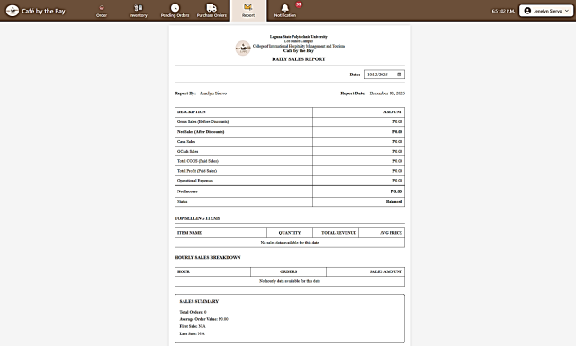
- (b)
Figure 19. Sales Report: (a) Administrator Sales Reports Interface, (b) Staff
Sales Report Interface
Figure 19 presents the sales reporting feature of the Café by the Bay POS system, which demonstrate how automated report generation improves transparency in monitoring the overall business performance and transactions handles by staff individually. The Sales Report interface for administrators (a) automatically collects data from all recorded transactions submitted by staff and organizes them into summaries for various time periods such as daily, weekly, monthly, and yearly. The feature’s key financial indicators are generated immediately, such as total orders, expenses, net profit, expense breakdowns, and supplier summaries.
Connected to this is the Staff Sales Report interface (b), which provides a comprehensive and automated summary of all sales activities handled by each staff member during their shift. The interface also presents supporting details of staff hourly sales breakdown that shows the distribution of orders throughout the shift. By automatically collecting, organizing, and summarizing this information, the system significantly reduces the staff’s manual counting of sales and minimizes reporting errors that usually arise from handwritten logs or manual computations. This automated reporting ensures that all sales data is accurate, monitored, and consistent across all staff.
Overall, these reporting features enhance the café’s sales transparency by giving administrators a clear and real-time view of both overall business performance and sales activity of each staff member. This promotes accountability, as individual performance and anomalies can be easily identified and evaluated, supporting a more responsible and performance-driven learning environment.
3. Evaluate the efficiency and effectiveness of the developed system using ISO 25010 and Technology Acceptance Model (TAM).
A. System Evaluation Results Based on ISO/IEC 25010 Software Quality Characteristics
Table 23. Results of ISO 25010 Functional Suitability Evaluation
SUBCATEGORY/ITEM | MEAN | SD | INTERPRETATION
- Functional Completeness - The system meets its intended purpose effectively. | 4.5 | ±0.58 | Excellent
- Functional Appropriateness - The system’s functions are appropriate and effectively support the user’s business operations. | 4.75 | ±0.50 | Excellent
- Functional Correctness - The system performs all the required functions accurately. | 4.25 | ±0.96 | Excellent
Composite Score | 4.5 | ±0.24 | Excellent
n=4, Legend: Excellent (4.21–5.00), Good (3.41–4.20), Fair (2.61–3.40), Needs Improvement (1.81–2.60), Poor (1.00–1.80).
Table 23 presents the results of the system evaluation in terms of Functional Suitability based on the ISO/IEC 25010 software quality standard. The indicator Functional Completeness got a mean score of 4.5, which means that the system meets all its intended functions effectively. The Functional Appropriateness received the highest mean of 4.75, showing that the features of the system are appropriate and help support the users’ tasks and business operations. The Functional Correctness obtained a mean of 4.25, which still falls under the Excellent interpretation, proving that the system performs all required functions accurately.
The composite mean of 4.5 with a verbal interpretation of Excellent indicates that the system successfully meets the functional needs of the users and performs its tasks efficiently and accurately.
The standard deviation (SD) values, which range from 0.24 to 0.96, show that the respondents had slight differences in their answers but still mostly agreed with each other. This means that most users consistently rated the system as excellent in terms of its functionality.
Table 24. Results of ISO 25010 Performance Efficiency Evaluation
SUBCATEGORY/ITEM | MEAN | SD | INTERPRETATION
- Time Behavior - The system loads and responds quickly during operation. | 4.75 | ±0.50 | Excellent
- Resource Utilization - The system utilizes computer resources efficiently. | 4.75 | ±0.50 | Excellent
- Capacity - The system maintains stable performance even under heavy usage. | 4.75 | ±0.50 | Excellent
Composite Score | 4.75 | ±0.00 | Excellent
n=4, Legend: Excellent (4.21–5.00), Good (3.41–4.20), Fair (2.61–3.40), Needs Improvement (1.81–2.60), Poor (1.00–1.80).
Table 24 illustrates the results of the system evaluation in terms of Performance Efficiency. The indicator Time Behavior received a mean score of 4.75, which means the respondents strongly agreed that the system loads fast and responds quickly during use. The same mean score of 4.75 was also obtained by Resource Utilization and Capacity, indicating that the system efficiently uses computer resources and maintains stable performance even when handling heavy processes.
The overall composite mean of 4.75 with a verbal interpretation of Excellent implies that the system performs very well in terms of speed, resource management, and stability. The standard deviation (SD) values, which range from 0.00 to 0.50, show that the responses of the participants were consistent and had very little variation, meaning most of them gave similar ratings. This indicates that users had a common positive experience when using the system.
Table 25. Results of ISO 25010 System Compatibility Evaluation
SUBCATEGORY/ITEM | MEAN | SD | INTERPRETATION
- Co-existence - The system operates properly across different devices or platforms. | 4.25 | ±0.50 | Excellent
- Interoperability - The system integrates smoothly with other software or hardware components. | 4.75 | ±0.50 | Excellent
Composite Score | 4.5 | ±0.00 | Excellent
n=4, Legend: Excellent (4.21–5.00), Good (3.41–4.20), Fair (2.61–3.40), Needs Improvement (1.81–2.60), Poor (1.00–1.80).
Table 25 shows the results of system compatibility, which include co-existence and interoperability. The system obtained a mean score of 4.25 for co-existence and 4.75 for interoperability, both interpreted as “Excellent.” The standard deviations indicate that the responses of the participants were consistent, showing similar opinions regarding the system’s performance.
The composite mean of 4.5, with a verbal interpretation of “Excellent,” shows that the system is highly compatible and functions efficiently. The standard deviation (SD) values of 0.50 show that the responses of the participants were consistent and had little variation. These results confirm that the developed system meets user expectations in terms of performance, integration capability, and overall reliability, which makes it suitable and dependable for its intended operational use. These findings suggest that the system can operate reliably across different platforms and work seamlessly with other software or hardware components.
Table 26. Results of ISO 25010 Interaction Capability Evaluation
SUBCATEGORY/ITEM | MEAN | SD | INTERPRETATION
- Appropriateness Recognizability - The system’s purpose and functions are easy to recognize and understand. | 4.75 | ±0.50 | Excellent
- Learnability - It is easy to learn how to use the system, even for first-time users. | 4.5 | ±0.58 | Excellent
- Operability - The system is easy to operate and navigate when performing task | 5 | 0.00 | Excellent
- User Error Protection - The system helps prevent and correct user errors effectively. | 4.75 | ±0.50 | Excellent
- User Engagement - The system provides an engaging and enjoyable experience for users. | 4.25 | ±0.96 | Excellent
- Inclusivity - The system can be used comfortably by users with different abilities or needs. | 4.25 | ±0.50 | Excellent
- User Assistance - The system provides useful help features and guidance when needed. | 4.5 | ±1.00 | Excellent
- Self-descriptiveness - The system displays clear instructions, icons, and labels that guide users easily. | 4.5 | ±1.00 | Excellent
Composite Score | 4.56 | ±0.34 | Excellent
n=4, Legend: Excellent (4.21–5.00), Good (3.41–4.20), Fair (2.61–3.40), Needs Improvement (1.81–2.60), Poor (1.00–1.80).
Table 26 shows the results of the system’s Interaction Capability, with the composite mean of 4.56, and standard deviation (SD) of 0.34, which has a verbal interpretation of Excellent. This means that most of the respondents agreed that the system performs well in terms of its interaction features. Operability got the highest mean score of 5.00, means users has no difficulty in navigating and performing task. Other subcategories like Appropriateness Recognizability and User Error Protection also received high ratings shows that the users can easily understand what the system is for and easily learned how to use it even if it's their first time. On the other hand, User Engagement and Inclusivity got the lowest mean of 4.25 though they still fall under the “Excellent” range, these suggest that while the system is already a user-friendly there still room to make the experience more engaging and accessible for all types of users.
Overall, these results show that the system is user-friendly and easy to navigate. Respondents found it appropriate, learnable, and operable, especially for first-time users. The system also helps users from errors and provides an engaging experience. The excellent composite mean reflects that the developed system meets users’ expectations and provides a positive interaction experience.
Table 27. Results of ISO 25010 Reliability Evaluation
SUBCATEGORY/ITEM | MEAN | SD | INTERPRETATION
- Faultlessness - The system performs its functions consistently without unexpected errors or failures. | 4.5 | ±1.00 | Excellent
- Availability - The system is available and accessible whenever it is needed. | 5 | 0.00 | Excellent
- Fault Tolerance - The system continues to operate correctly even when minor errors occur. | 5 | 0.00 | Excellent
- Recoverability - The system can quickly recover and restore data after an unexpected failure. | 5 | 0.00 | Excellent
Composite Score | 4.88 | ±0.50 | Excellent
n=4, Legend: Excellent (4.21–5.00), Good (3.41–4.20), Fair (2.61–3.40), Needs Improvement (1.81–2.60), Poor (1.00–1.80).
Table 27 presents the results of the system’s reliability. The composite mean of 4.88 with a standard deviation (SD) of 0.50 means it was rated Excellent by the respondents. Sub categories such as Faultlessness, Availability, Fault Tolerance, and Recoverability got a perfect mean of 5.00, shows that the users strongly agreed that the system works well, is available when needed, and can handle errors properly. In the other hand Faultlessness got the lowest mean of 4.5 still falls under the interpretation of excellent this means that the users find the system work overall, though they might have noticed a few issues that can still improve.
Table 28. Results of ISO 25010 Security Evaluation
SUBCATEGORY/ITEM | MEAN | SD | INTERPRETATION
- Confidentiality - The system ensures that only authorized users can access confidential data. | 4.75 | ±0.50 | Excellent
- Integrity - The system protects information from unauthorized changes or tampering. | 4.75 | 0.00 | Excellent
- Non-Repudiation - The system records all transactions to prevent users from denying their actions. | 5 | 0.00 | Excellent
- Accountability - The system tracks user activities to identify responsibility for specific actions. | 4.5 | ±1.00 | Excellent
- Authenticity - The system verifies the identity of users before granting access. | 4.75 | ±0.50 | Excellent
- Resistance - The system is capable of resisting unauthorized access and malicious attacks. | 3.75 | ±0.96 | Good
Composite Score | 4.58 | ±0.37 | Excellent
n=4, Legend: Excellent (4.21–5.00), Good (3.41–4.20), Fair (2.61–3.40), Needs Improvement (1.81–2.60), Poor (1.00–1.80).
Table 28 presents the results of the system’s security. The composite mean of 4.58 with a standard deviation (SD) of 0.37 means it was rated Excellent by the respondents. The indicator Resistance got the lowest mean of 3.75 (SD = 0.96) with a verbal interpretation of Good, which means the system can still be improved in resisting unauthorized access or malicious attacks. Overall, these results show that the system has strong security features and effectively protects user information from unauthorized access and data tampering, the respondents are confident in the system’s ability to keep data safe and maintain integrity while performing transactions.
Table 29. Results of ISO 25010 Maintainability Evaluation
SUBCATEGORY/ITEM | MEAN | SD | INTERPRETATION
- Modularity - The system is designed with separate modules that make it easier to manage and update. | 4.75 | ±0.50 | Excellent
- Reusability - The system’s components can be reused for other similar applications or functions. | 5 | 0.00 | Excellent
- Analyzability - The system allows easy identification of issues and understanding of its internal structure. | 5 | 0.00 | Excellent
- Modifiability - The system can be easily modified or updated without affecting its overall functionality. | 4.75 | ±0.50 | Excellent
- Testability - The system can be easily tested to ensure its functions work correctly after updates or changes. | 4.75 | ±0.50 | Excellent
Composite Score | 4.85 | ±0.27 | Excellent
n=4, Legend: Excellent (4.21–5.00), Good (3.41–4.20), Fair (2.61–3.40), Needs Improvement (1.81–2.60), Poor (1.00–1.80).
Table 29 illustrate the results of the system’s maintainability. The composite mean of 4.85 with a verbal interpretation of Excellent shows that the respondents strongly agree that the system is easy to maintain. The indicators with the highest mean of 5.00, which are Reusability and Analyzability, indicate that the system’s components can be reused for other similar functions and that issues can be easily identified and understood. Meanwhile, Modularity, Modifiability, and Testability all obtained a mean of 4.75, still interpreted as Excellent. This means the system is well-organized and can be easily modified or tested whenever updates are needed. Overall, the results imply that the system is efficiently designed for long-term use and maintenance.
Table 30. Results of ISO 25010 Flexibility Evaluation
SUBCATEGORY/ITEM | MEAN | SD | INTERPRETATION
- Adaptability - The system can easily adjust to different environments, devices, or user needs. | 4.75 | ±0.50 | Excellent
- Scalability - The system can handle an increasing number of users or transactions without performance issues. | 4.75 | ±0.50 | Excellent
- Installability - The system can be easily installed, set up, and configured without technical difficulties. | 5 | ±0.00 | Excellent
- Replaceability - The system can be replaced or upgraded with minimal disruption to operations. | 5 | ±0.00 | Excellent
Composite Score | 4.88 | ±0.29 | Excellent
n=4, Legend: Excellent (4.21–5.00), Good (3.41–4.20), Fair (2.61–3.40), Needs Improvement (1.81–2.60), Poor (1.00–1.80).
Table 30 presents the results of the system’s flexibility. The composite mean of 4.88, interpreted as Excellent, shows that the respondents strongly agree that the system can easily adapt and function well in different conditions. The indicators with the highest mean of 5.00, which are Installability and Replaceability, imply that the system can be easily installed, configured, and updated without causing any problems or interruptions. Meanwhile, Adaptability and Scalability both obtained a mean of 4.75, still interpreted as Excellent. This indicates that the system can adjust to various environments or devices and can manage an increasing number of users without performance issues. Overall, these results suggest that the system is highly flexible and reliable when it comes to adapting, scaling, and upgrading to meet user needs.
Table 31. Results of ISO 25010 Safety Evaluation
SUBCATEGORY/ITEM | MEAN | SD | INTERPRETATION
- Operational Constraint - The system operates within safe limits to prevent damage or unsafe conditions. | 5 | ±0.00 | Excellent
- Risk Identification - The system helps identify potential risks or safety issues during operation. | 4.25 | ±0.96 | Excellent
- Fail Safe - The system automatically activates safety measures in case of malfunction or failure. | 4 | ±0.00 | Good
- Hazard Warning - The system provides clear warnings or alerts when unsafe conditions are detected. | 4.5 | ±0.58 | Excellent
- Safe Integration - The system can be safely integrated with other components or equipment without causing hazards. | 4.75 | ±0.50 | Excellent
Composite Score | 4.5 | ±0.41 | Excellent
n=4, Legend: Excellent (4.21–5.00), Good (3.41–4.20), Fair (2.61–3.40), Needs Improvement (1.81–2.60), Poor (1.00–1.80).
Table 31 shows the results of the system’s safety. The composite mean of 4.5, interpreted as Excellent, means that the respondents agree that the system is safe to use and operates within proper limits. The highest mean of 5.00 for Operational Constraint indicates that the system performs safely and prevents any damage or unsafe conditions during use. Other indicators such as Safe Integration and Hazard Warning also received high ratings, which shows that the system can integrate safely with other components. On the other hand, Risk Identification obtained a mean of 4.25, and Fail Safe received the lowest mean of 4.00, interpreted as Good. This suggests that while the system can identify risks and activate safety measures, there is still room for improvement in automatic safety responses. Overall, the results imply that the system is secure and dependable, which ensures user safety while maintaining efficient operation.
Table 32. Results of System Quality Evaluation (ISO 25010)
CATEGORY | MEAN | SD | INTERPRETATION
Functional Suitability | 4.5 | ±0.24 | Excellent
Performance Efficiency | 4.75 | ±0.00 | Excellent
Compatibility | 4.5 | ±0.00 | Excellent
Interaction Capability | 4.56 | ±0.34 | Excellent
Reliability | 4.88 | ±0.50 | Excellent
Security | 4.58 | ±0.37 | Excellent
Maintainability | 4.85 | ±0.27 | Excellent
Flexibility | 4.88 | ±0.29 | Excellent
Safety | 4.5 | ±0.41 | Excellent
Composite Score | 4.67 | ±0.17 | Excellent
n=4, Legend: Excellent (4.21–5.00), Good (3.41–4.20), Fair (2.61–3.40), Needs Improvement (1.81–2.60), Poor (1.00–1.80).
Table 32 presents the results of the system quality evaluation based on ISO 25010 Standard. With a composite mean of 4.67, with standard deviation (SD) of 0.17, and verbally interpreted as Excellent. It can be concluded that the system has high quality and reliability. The results show that all aspects of system quality such as Functional Suitability, Performance Efficiency, Compatibility, Interaction Capability, Reliability, Security, Maintainability, Flexibility, and Safety received excellent ratings. This means that the respondents were highly satisfied with the overall performance of the system, particularly in terms of its speed, stability, and security. The high mean score further indicates that the system meets the expected quality standard defined by ISO 25010 framework.
B. System Acceptability Evaluation Results Based on the Technology Acceptance Model (TAM)
Table 33. Results of Perceived Usefulness
ITEM | MEAN | SD | INTERPRETATION
- The system helps speed up transaction and order processing. | 3.97 | ±0.17 | Strongly Agree
- The system reduces human error in sales and inventory records. | 3.94 | ±0.28 | Strongly Agree
- The system improves the accuracy and reliability of sales reports. | 3.96 | ±0.20 | Strongly Agree
- The system makes monitoring of sales and inventory more efficient for the café. | 3.96 | ±0.20 | Strongly Agree
- The system enhances business decision-making and financial management. | 3.93 | ±0.26 | Strongly Agree
Composite | 3.95 | ±0.04 | Strongly Agree
n=100, Legend: highest to lowest as follows: four (4) – Strongly Agree (3.26 – 4.00), three (3) – Agree (2.51 – 3.25), two (2) – Disagree (1.76 – 2.50), one (1) – Strongly Disagree (1.00 – 1.75).
Table 33 shows the results of the perceived usefulness of the developed system. The composite mean of 3.95 indicates that respondents strongly agreed on its usefulness in the café’s daily operations. The highest mean (3.97) shows that the system helps speed up transaction and order processing. The lowest mean of 3.93 corresponds to enhancing business decision-making and financial management still falls under Strongly Agree, which means respondents still believe the system supports better financial and management decisions. The standard deviation (SD) values, ranging from 0.17 to 0.28, indicate that the responses of the participants are close to one another, showing consistency in their evaluation. Overall, the findings reveal that the developed web-based point-of-sale system is highly useful for the café, as it improves speed, accuracy, and efficiency in daily operations.
Table 34. Results of Perceived Ease of Use
ITEM | MEAN | SD | INTERPRETATION
- The system interface is user-friendly and easy to navigate. | 3.9 | ±0.30 | Strongly Agree
- I find it easy to learn how to operate the system and interpret the data it provides. | 3.85 | ±0.36 | Strongly Agree
- It requires minimal effort or technical knowledge when using the system. | 3.83 | ±0.38 | Strongly Agree
- The application and dashboard make it convenient to monitor sales and inventory in real time. | 3.92 | ±0.27 | Strongly Agree
- I am comfortable with the overall setup and functionality of the point-of-sales system. | 3.86 | ±0.38 | Strongly Agree
Composite Score | 3.87 | ±0.05 | Strongly Agree
n=100, Legend: highest to lowest as follows: four (4) – Strongly Agree (3.26 – 4.00), three (3) – Agree (2.51 – 3.25), two (2) – Disagree (1.76 – 2.50), one (1) – Strongly Disagree (1.00 – 1.75).
Table 34 shows the results of the respondents’ assessment on the perceived ease of use of the developed system. The overall composite mean of 3.87, interpreted as Strongly Agree, indicates that the respondents find the system highly user-friendly and easy to operate. The highest mean (3.92) obtained for the indicator stating that the application and dashboard make it convenient to monitor sales and inventory in real time shows that users appreciate how the system helps them manage daily transactions efficiently.
The standard deviation (SD) values, which range from 0.27 to 0.38, show that the participants’ responses are consistent. Overall, the findings suggest that the system provides a simple, accessible, and efficient user experience, allowing users to perform sales and inventory tasks with ease and confidence.
Table 35. Results of Attitude Towards Using the System
ITEM | MEAN | SD | INTERPRETATION
- I feel positive about using the system for managing sales and inventory. | 3.9 | ±0.33 | Strongly Agree
- The system fits well with my business operations and inventory management practices. | 3.9 | ±0.30 | Strongly Agree
- I believe this technology can greatly benefit the coffee shop business. | 3.93 | ±0.26 | Strongly Agree
- Using this system is an enjoyable and beneficial experience. | 3.9 | ±0.30 | Strongly Agree
- I would recommend implementing this kind of system to other business owners or coffee shop operators. | 3.89 | ±0.35 | Strongly Agree
Composite Score | 3.90 | ±0.03 | Strongly Agree
n=100, Legend: highest to lowest as follows: four (4) – Strongly Agree (3.26 – 4.00), three (3) – Agree (2.51 – 3.25), two (2) – Disagree (1.76 – 2.50), one (1) – Strongly Disagree (1.00 – 1.75).
Table 35 presents the results of the respondents’ attitude towards using the developed system based on the Technology Acceptance Model (TAM). The 3.90 composite mean, which is interpreted as Strongly Agree, indicates that users have a highly positive attitude toward the system. All indicators under this construct obtained mean scores ranging from 3.89 to 3.93, with relatively low standard deviation values, which indicates a minimal variation in responses. Respondents strongly agreed that the system fits well with the café’s business operations, enhances sales and inventory management, and provides meaningful insights. These findings align with TAM principles, which states that a positive attitude toward technology is influenced by its usefulness and the system’s ability to improve work performance and efficiency.
Table 36. Results of Intention to Use the System
ITEM | MEAN | SD | INTERPRETATION
- I intend to use this system regularly for managing sales and inventory. | 3.93 | ±0.26 | Strongly Agree
- I am likely to rely on this system to help manage my business operations in the future. | 3.85 | ±0.36 | Strongly Agree
- I am willing to adopt other digital solutions for my business operations based on my experience with this system. | 3.91 | ±0.29 | Strongly Agree
- I am likely to recommend this system to colleagues in the business or retail industry. | 3.9 | ±0.33 | Strongly Agree
- I am committed to using this system as part of my daily sales and inventory routine. | 3.91 | ±0.32 | Strongly Agree
Composite Score | 3.90 | ±0.04 | Strongly Agree
n=100, Legend: highest to lowest as follows: four (4) – Strongly Agree (3.26 – 4.00), three (3) – Agree (2.51 – 3.25), two (2) – Disagree (1.76 – 2.50), one (1) – Strongly Disagree (1.00 – 1.75).
Table 36 illustrates the results of the respondents’ intention to use the developed system. The composite mean of 3.90, interpreted as Strongly Agree, shows that the respondents are highly willing to use the system regularly for managing sales and inventory. The highest mean of 3.93 indicates that they intend to continue using the system as part of their business operations, which reflects a strong level of acceptance and trust in its reliability. The lowest mean of 3.85, which still falls under Strongly Agree, implies that respondents are likely to rely on the system for future management tasks. The standard deviation (SD) values, ranging from 0.26 to 0.36, show that their responses are consistent. Overall, the findings indicate that the respondents have a strong intention to continue using the system, showing confidence in its usefulness, reliability, and contribution to smoother business operations.
Table 37. Results of the Technology Acceptance Model (TAM) Evaluation
ITEM | MEAN | SD | INTERPRETATION
- Perceived Usefulness | 3.95 | ±0.04 | Strongly Agree
- Perceived Ease of Use | 3.87 | ±0.05 | Strongly Agree
- Attitude (Towards Using the System) | 3.90 | ±0.03 | Strongly Agree
- Behavior (Intention to Use the System) | 3.90 | ±0.04 | Strongly Agree
Composite Score | 3.91 | ±0.01 | Strongly Agree
n=100, Legend: highest to lowest as follows: four (4) – Strongly Agree (3.26 – 4.00), three (3) – Agree (2.51 – 3.25), two (2) – Disagree (1.76 – 2.50), one (1) – Strongly Disagree (1.00 – 1.75).
Table 37 shows the results of the Technology Acceptance Model (TAM) evaluation. The Perceived Usefulness gained the highest mean of 3.95, which means that most of the respondents strongly agreed that the system is useful and helps them accomplish their tasks more efficiently. The Perceived Ease of Use with a mean of 3.87, indicating that users found the system easy to navigate and operate. The Attitude (Towards Using the System) and Behavior (Intention to Use the System) both obtained a mean of 3.90, showing that users have a positive attitude toward the system and are willing to continue using it. The overall composite mean of 3.91 with a verbal interpretation of Strongly Agree implies that the respondents generally accepted the system and were satisfied with its performance and usability. The standard deviation (SD) values, which range from 0.01 to 0.05, indicate that the respondents’ answers were highly consistent and had very minimal variation. This means that most users shared the same positive opinion toward the system’s usefulness, ease of use, and overall acceptability.
In conclusion on ISO 25010 evaluation, the system obtained excellent ratings across all quality characteristics, including Functional Suitability, Performance Efficiency, Compatibility, Interaction Capability, Reliability, Security, Maintainability, Flexibility, and Safety, with a composite mean of 4.67. The results indicate that the system performs its intended functions accurately, efficiently, and reliably while providing a user-friendly interface and ensuring secure, safe, and maintainable operations. Small discrepancies in standard deviation suggest consistent agreement among respondents regarding the system’s high quality.
Overall, the findings suggest that the developed system is both efficient and effective in meeting functional, operational, and user requirements, and it is widely accepted by its intended users. The consistent high results from both the TAM and ISO 25010 evaluations further validate that the system successfully integrates technical quality with user acceptance, which supports its readiness for real-world deployment. These results also indicate the system’s strong potential for sustained use in café operations and similar business environments.
Acceptance Testing
The evaluation of this phase was determined using the Technology Acceptance Model (TAM), which was discussed in the previous section. The overall results of construct – Perceived Usefulness, Perceived Ease of Use, Attitude Toward Using the System, and Behavioral Intention – reveal a consistently high levels of user acceptance with mean scores ranging from 3.87 to 3.95. Perceived Usefulness obtained the highest mean of 3.95 with ± 0.04 standard deviation, which indicates that users believe that the system significantly enhances the efficiency and task performance. Attitude Toward Using the System and Behavioral Intention both with the mean result of 3.90, suggests that users not only view the system positively but also show a strong willingness to adopt it in long-term. Perceived Ease of Use with the mean of 3.87 (± 0.05) also received a “Strongly Agree” evaluation, which indicates that users find the system easy to understand, intuitive, and convenient to operate. With a composite mean score of 3.91 ± 0.01, the results demonstrate that the system is highly acceptable to its intended users, demonstrating the positive insights of respondents and reflects users’ confidence in the system’s practicality and value.
Overall, the TAM results confirm that users have a high level of acceptance for the system, highlighting its usefulness, ease of use, and the positive intention of users to implementing and using it. This reflects strong user confidence in the system’s functionality.
CHAPTER V
SUMMARY, CONCLUSIONS AND RECOMMENDATIONS
This chapter presents the summary of the study’s results and key findings. It provides an overview of the system’s development, functionality, and user acceptance, highlights the main outcomes, draws conclusions, and offers recommendations for further system improvement.
Summary
The capstone project entitled “Café by the Bay: Integration of Point-of-Sales (POS) System” was developed to address the challenges of manual transaction processing. Traditionally, the operations at Café by the Bay relied heavily on manual transaction recording, sales revenue tracking, and inventory monitoring using Microsoft Excel, which often resulted to human errors, inefficiencies, and delayed process. To address these issues, the researchers aimed to design, develop, and implement a user-centered Point-of-Sales (POS) system that would streamline the sales operations, reduce errors, and improve overall management efficiency of the retail business.
The project employed the Agile Scrum Methodology throughout the developments phase for continuous feedback and improvements. Technologies utilized for development of the system include HTML as the foundation of platform’s front-end interface, CSS for designing and make the system visually appealing along with Bootstrap for responsiveness, Javascript for back-end functionalities, PHP for database management and establishing communication with MySQL database. These software tools make the development of a user-friendly web-based system possible, that is scalable, efficient, and provides real-time data.
The proposed web-based system’s user-friendly interface allows the staff to manage and process orders efficiently, monitor inventory in real-time, and create and send reports easily. This reduces the need for manual input of orders, which eliminates the need for long waiting period and increases productivity. The automated notification feature ensures that the staff are updated and aware of low-inventory stock levels and overdue payments, which reduces stockout and overstock situations, and loss in sales. While the system’s analytics and reports feature allows the administrator to create strategies based on data-driven insights. These features help in efficient business management and increases the customers’ satisfaction.
The system’s effectiveness is assed using the ISO 25010 Software Quality Product and Technology Acceptance Model (TAM). The system was presented to 104 respondents, where 100 of them answered the TAM survey comprising of shop’s administrators, staffs, and customers, while the remaining 4 are IT professionals who assessed the overall performance and functionalities of the POS system using ISO 25010. Most responses in ISO survey ranges from 4.21 – 5.00 mean, with the interpretation of Excellent, while most responses in TAM ranges from 3.26 – 4.00 mean, interpreted as Strongly Agree. These results indicates that most users recognize the efficiency of integrating POS system to the Café by the Bay’s daily business operations, with the intention to recommend and implement the system. This demonstrates the system’s overall reliability and suitability for practical use.
In summary, the developed Point-of-Sales (POS) system for Café by the Bay successfully addressed the challenges of manual transaction processing, which often caused errors and inefficiencies. The system provides an efficient, user-friendly, reliable, and secure platform for administrators and staff to manage sales, monitor inventory, and generate reports. By automating business processes and offering data-driven insights, the system enhances the overall operational efficiency, reduces human error, and supports the informed decision-making for the café.
Conclusion
In conclusion, the web-based point-of-sales (POS) system successfully achieved the following objectives:
1. To design and develop a web-based point-of-sales system integrated with inventory management designed to the needs of Café by the Bay to streamline sales transactions and improve order management.
The design and development of the web-based Point-of-Sales (POS) system integrated with inventory management successfully meets the business operational needs of Café by the Bay by streamlining sales transactions and improving the overall order management process. The system provides a structured and user-friendly interface that allows staff to quickly process orders, manage item selections, and complete sales with reduced manual process. By automating the transaction flow, the POS eliminates common errors related to manual recording and processing, and ensures that every order is recorded accurately in real time. The system’s integration with inventory management further supports the café’s smoother operations by automatically reflecting item usage every transaction that enables a more organized order handling without requiring the staff to manually adjust the records. Through this design, the POS system enhances the efficiency, accuracy, and consistency in the café’s daily sales operations.
2. To develop a web-based system that automates stock monitoring, generates sales reports, and inventory stock levels alerts.
The web-based system effectively meets the objective of automating stock monitoring, generating sales reports, and providing inventory stock level alerts, which offers administrators a better visibility and control over the café’s product availability. The automated stock monitoring keeps inventory levels updated automatically whenever sales or orders are made, which eliminates the need for the repetitive and error-prone manual tracking that was previously done using Microsoft Excel. The system’s reporting features provides clear summaries of sales trends, top-selling items, and stocks movement that enables administrators to make informed decisions based on actual data. The stock level alert function effectively notifies administrators and staff when inventory items drop below the set reorder level quantity, which helps them restock on time and avoid disruptions in service. These features, all together, provides a reliable and easy to navigate system for monitoring inventory that supports a better and more efficient management of the café’s supplies.
3. To evaluate the efficiency and effectiveness of the developed system using ISO 25010 and Technology Acceptance Model (TAM).
The evaluation of the developed system using ISO 25010 and the Technology Acceptance Model (TAM) confirmed its overall efficiency and effectiveness. Based on the ISO 25010 criteria, the system met key software quality attributes such as functionality, reliability, usability, and performance that demonstrates efficient operations and a user-friendly interface that is suitable for the café’s daily transactions. The TAM results further showed the strong acceptance from users, which indicates that they found the system easy to use and navigate, useful in improving tasks, and beneficial to the business workflow. The positive feedback from both models greatly supports that the system not only performs its intended functions effectively but is also accepted by its users, which validates and verify its readiness for real-world application within the Café by the Bay.
Recommendation
The following recommendations are derived from the results of the study. The researchers identified several opportunities where technology can further enhance the system user experience and performance, through the project’s key findings. Based on these insights, the suggestions below highlight the potential improvements that may strengthen the functionality and overall effectiveness of the web-based point-of-sales (POS) system.
1. Administrators
a. Improve the system’s responsiveness and compatibility across different devices such as smartphones and tablets to ensure a smoother monitoring of café’s performance.
b. Add features such as automated data backup and recovery options to protect data related to sales, inventory, or customer records. This is primarily to ensure the business’ continuity and minimize risks in case of unexpected technical failures.
c. Enhance security measures by implementing data encryption for sensitive information, enforcing strong password and authentication policies, activating a detailed audit logs to track system activities, establishing clear data retention procedures, and incorporating anti-fraud or misuse prevention mechanisms to protect business data and maintain the system’s integrity.
2. Staff
a. To consider integrating online ordering system into the POS to minimize manual input and help staff to manage orders more efficiently. As this would also benefit staff by streamlining order processing and inventory updates, as orders will automatically appear in the POS interface.
b. Integrate café’s loyalty program within the POS system to streamline customer order points tracking, without relying on physical cards. This will simplify transactions for staff and improves record accuracy for the admin.
c. Integrate the POS system directly with supplier platforms to automate purchase orders and track deliveries. This integration would reduce the manual communication, helps to ensure timely restocking, and maintain optimal inventory levels for smoother café operations.
d. Incorporate an automated cash and coin counting feature into the POS system to support more accurate and efficient payment processing. This would minimize the manual counting errors, speed up auditing, and ensure the transparency in handling physical payments. It can provide real-time verification of the cash received and reduce the workload of staff during closing operations.
3. Customers
a. Consider the integration of online ordering system as this feature would allow customers to place orders remotely without needing to physically visit the café. Given the significant distance between various college departments inside the campus, this is especially beneficial for all customers.
b. Add support for multiple payment methods, such as credit/debit cards and other e-payments, as this will provide convenience for customers and simplify the checkout process.
c. Integrate a fully automated loyalty system, as this will enhance convenience, reduce waiting time of confirming order points, improve the overall service quality and customer satisfaction.
4. System developers, IT students and future researchers.
a. Enhance Confidence-Level Interpretation and UI Indicators. Since the system already assigns confidence scores to every product, an improvement in the interface with the addition of tooltips that explain the meaning of the confidence value is suggested. This will allow a quicker interpretation of the predictions by the users and hence will lower the probability of errors in decision-making.
b. Refine the Cake and Pastry Forecast to be More Accurate. The results from the forecast indicate that cakes and pastries are the products that never miss out on the forecast with a confidence level that is moderate and variability that is higher all the time. It is advisable that the future versions of the system take separate modeling parameters or additional features (seasonality factors, day-of-week patterns) specifically for this category to improve the accuracy of the forecasting.
c. Improve Validation of Data and Monitoring Data Quality. The Cakes and pastries, according to the forecast results, are products that not only produce more variable predictions but also suffer from the issue of inconsistent or incomplete sales data likely being the cause. Enhancement of the system with tighter data validation, missing-data alerts, and data completeness indicators is suggested in order to achieve more accurate forecasting in the future.
d. Expand Forecast Horizon and Scenario Simulation. The system provides a forecast of the next seven days but one of the suggested improvements is to offer the option of 14-day or 30-day forecasts as well as "What-if" scenarios like anticipated sales during promotions, holidays, or peak days.
e. Create an Analytics Dashboard Specific to Category. The difference between beverages and pastries in terms of demand is so significant that they can be treated separately in the existing dashboard which is currently catered for by historical trends, error metrics, and confidence evolution over time.

REFERENCES
AAPPL, O. M., Ercilla, L. ., Garcia, J. ., Gonzales, A. ., & Relano, K. . (2024). A Research Proposal of Inventory and POS System for Bida Mart in the City of San Jose Del Monte, Bulacan: Vol.4, No.1. Ascendens Asia Singapore – Bestlink College of the Philippines Journal of Multidisciplinary Research, 4(1).
Adewumi, A., Misra, S., & Omoregbe, N. (2015). Evaluating open source software quality models against ISO 25010. In 2015 IEEE International Conference on Computer and Information Technology; Ubiquitous Computing and Communications; Dependable, Autonomic and Secure Computing; Pervasive Intelligence and Computing (pp. 872–877). IEEE. https://doi.org/10.1109/CIT/IUCC/DASC/PICOM.2015.130
Adi Kurniawan, Rayuwati Rayuwati, & Ira Zulfa. (2024). Prediction Of Laptop Sales Using The K-Nearest Neighbor Method At The MVP Computer Mawar Store, In Takengon. International Journal of Economics and Management Sciences, 1(2), 39–48. https://doi.org/10.61132/ijems.v1i2.33
Alifadillah, A., & Supriatna, H. (2023). Web-Based coffee inventory Application. Majalah Bisnis & IPTEK, 16(2).
Alt, R. (2021). Digital transformation in the restaurant industry: current developments and implications. Deleted Journal, 1(1), 69–74.
Amardeep, A.R. (2023). Sales Prediction and Inventory Restocking Using Machine Learning. Int. J. Sci. Eng. Technol. 11, 629.
Andarwati, Mardiana & Amrullah, Fikri & Thamrin, Elfirahmi & Muslikh, Ahmad. (2020). An Analysis of Point of Sales (POS) Information Systems in SMEswith The Black Box Testing and PIECES Method. IOSR Journal of Business and Management. 22. 20-25. 10.9790/487X-2209052025.
Arago, A. M., De Chavez, M. J. E., Mercado, R. D., Benlot, J. B. L. R., Magbilang, E. D., & Felicen, S. S. (2019). Hospitality management students’ academic and internship performance in Asian and Western cuisine. Asia Pacific Journal of Education, Arts and Sciences, 6(3), 17–29.
Bashini, M., & Akilan, S. S. (2022). Integration of Point of Sale (POS) with Inventory Management System. International Journal of Scientific Research in Engineering and Management (IJSREM).​
Bhatia, N., & Vandana. (2010). Survey of nearest neighbor techniques. International Journal of Computer Science and Information Security (IJCSIS), 8(2).
Braglia, M., Grassi, A. and Montanari, R. (2004), "Multi‐attribute classification method for spare parts inventory management", Journal of Quality in Maintenance Engineering, Vol. 10 No. 1, pp. 55-65.
Chicano, A. A. and Huervana, E. G. (2009). Computerized restaurant sales and stock monitoring system (Unpublished thesis). Central Philippine University, Jaro, Iloilo City.
Cote, M. (2015). The power of point of sale: Improving growth, profit, and customer service in a retail business (Honors thesis, Bryant University). Bryant Digital Commons.
Danny, M., Muhidin, A., & Jamal, A. (2024). Application of the K-Nearest Neighbor machine learning algorithm to predict sales of best-selling products. Informatics Engineering Study Program, Faculty of Engineering, Pelita Bangsa University, 4(1). https://doi.org/10.47709/brilliance.v4il.4063
Davis, F. D. (1987). User acceptance of information systems: The technology acceptance model (TAM) (Working Paper No. 529). University of Michigan, School of Business Administration.
Dela Cruz, G. M. T., Dumaplin, T. B., Gaerlan, P. V. T., & Junio, O. M. (2019). Inventory Management System with POS. International Journal of Advanced Research in Science, Engineering and Technology, 6(4).
Deloitte. (n.d.). The future of higher education business models. Deloitte Insights.
Dewi, I. A., Miftahuddin, Y., Fattah, M. A., Palenda, C. B., & Erawan, S. F. (2021). Point of Sales System in InHome Café Website using Agile Methodology. Journal of Innovation and Community Engagement, 1(1), 01–19.
Digitalhill. (2024, December 10). The role of predictive analytics in shaping the future of inventory management. Digital Hill Multimedia, Inc.
Estdale, J., & Georgiadou, E. (2018). Applying the ISO/IEC 25010 quality models to software product. In X. Larrucea, I. Santamaria, R. O'Connor, & R. Messnarz (Eds.), Systems, software and services process improvement. EuroSPI 2018 (Vol. 896, pp. 409–419). Springer. https://doi.org/10.1007/978-3-319-97925-0_42
Felicen, Sevillia & Rasa, Lhea & Sumanga, Jourell & Buted, Dexter. (2014). Internship Performance of Tourism and Hospitality Students: Inputs to Improve Internship Program. International Journal of Academic Research in Business and Social Sciences. 4. 10.6007/IJARBSS/v4-i6/923
German, V. K., Gerardo, B., & Tanguilig, B. (2016). Mobile of Point of Sales (POS) Application with Cloud Computing Inventory Management System for Micro and Small Enterprises. Proceedings of the 6th International Workshop on Computer Science and Engineering (WCSE 2016), Tokyo, Japan.​
Gill, A. (2021). OPTIMIZING RESTAURANT INVENTORY MANAGEMENT USING REAL-TIME DATA. International Journal of Core Engineering & Management, 6(12), 312–314.
Gordieiev, O., Kharchenko, V., Fominykh, N., & Sklyar, V. (2014). Evolution of software quality models in context of the standard ISO 25010. In W. Zamojski, J. Mazurkiewicz, J. Sugier, T. Walkowiak, & J. Kacprzyk (Eds.), Proceedings of the Ninth International Conference on Dependability and Complex Systems DepCoS-RELCOMEX, June 30 – July 4, 2014, Brunów, Poland (Vol. 286, pp. 213–222). Springer. https://doi.org/10.1007/978-3-319-07013-1_21
Govindarajan, R., Balaji, V., Arumugam, J., Assegie, T. A., & Mothukuri, R. (2024). Evaluation of sequential feature selection in improving the K-nearest neighbor classifier for diabetes prediction. IAES International Journal of Artificial Intelligence (IJ-AI), 13(2), 1567–1573. https://doi.org/10.11591/ijai.v13.i2.pp1567-1573
Hartzel, K. S., & Wood, C. A. (2017). Factors that affect the improvement of demand forecast accuracy through point-of-sale reporting. European Journal of Operational Research, 260(1), 171–182. https://doi.org/10.1016/j.ejor.2016.12.016
Hidayati, Irma & Sudarmiatin, Sudarmiatin & Hermawan, Agus. (2023). Analysis of Point of Sale System Implementation in Coffee Shop. Jurnal Pendidikan dan Kewirausahaan. 11. 932-947. 10.47668/pkwu.v11i3.881.
Hu, B., Xie, H., Ma, Y., Wang, J., & Zhang, L. (2018b). A robust retail POS system based on blockchain and edge computing. In Lecture notes in computer science (pp. 99–110).
Ibrahim, R., Leng, N. S., Yusoff, R. C. M., Samy, G. N., Masrom, S., & Rizman, Z. I. (2017). E-learning acceptance based on technology acceptance model (TAM). Journal of Fundamental and Applied Sciences, 9(6), 1341-1357.
Indra Nasution, Rezkinah Rambe, Khairil Putra, Muhammad Dafa, & Muhammad Syahputra Novelan. (2025). Application of the K-Nearest Neighbor Algorithm in the Data Mining Process to Predict Drug Sales at Pratama Haji Medan-Pancing Clinic. Jurnal Publikasi Ilmu Komputer Dan Multimedia, 4(2), 136–147. https://doi.org/10.55606/jupikom.v4i2.4081
Jan, Saeed Ullah and Shah, Khalid and Mand, Niaz, Point of Sale System (February 24, 2023). http://dx.doi.org/10.2139/ssrn.4368998
Khorasani, G., & Zeyun, L. (2014). Implementation of Technology Acceptance Model (TAM) in Business Research on Web-Based Learning System. International Journal of Innovative Technology and Exploring Engineering (IJITEE), 3(11).
Laguna State Polytechnic University. (n.d.). Historical development.
Laguna State Polytechnic University. (2024). CHMT Designs Curriculum for Glocal Industry-Responsive Students.
Lewis, E. C., Harper, K. M., Poirier, L. K., & Gittelsohn, J. (2021). Feasibility of using mobile point-of-sale technology in Baltimore City corner stores tracking sales: A brief report. Journal of public health research, 11(1), 2607.
Liu, Y., Zhang, Y., Wang, X., & Qu, X. (2025). Evidential K-Nearest Neighbors with Cognitive-Inspired Feature Selection for High-Dimensional Data. Big Data and Cognitive Computing, 9(8), 202. https://doi.org/10.3390/bdcc9080202
LSPU. (2023, October 18). CHMT launches Cafe by the Bay. Laguna State Polytechnic University.
Madamidola O. A., Daramola O.A., Akintola K .G. (2017). WEB BASED INTELLIGENT INVENTORY MANAGEMENT SYSTEM. International Journal of Trend in Scientific Research and Development (ijtsrd), ISSN: 2456-6470, Volume-1 | Issue-4, June
Melvin, M., Wiratama, J., Sutomo, R., & Sanjaya, S. A. (2023). A Web-based Point of Sales for Automotive Component Industry using Rapid Application Development model. JOINS (Journal of Information System), 8(2), 167–176.
Miha Djami, A. S., Utami, N. W., & Paramitha, A. A. I. I. (2023). The Prediction Of Product Sales Level Using K-Nearest Neighbor and Naive Bayes Algorithms (Case Study : PT Kotamas Bali). Jurnal Pilar Nusa Mandiri, 19(2), 77–84. https://doi.org/10.33480/pilar.v19i2.4420
Napitupulu, D., Ibrahim, M., & Purwandari, M. (2018). Analysis of Technology Acceptance Model (TAM) on E-Learning System. In 2017 International Conference on Education and Technology (2017 ICEduTech) (pp. 264-268). Atlantis Press.
Oladele, Tinuke & Ogundokun, Roseline & Adegun, Adekanmi & Adeniyi, Emmanuel & Ajanaku, Ayobami. (2021). Development of an inventory management system using association rule. Indonesian Journal of Electrical Engineering and Computer Science. 21. 1868. 10.11591/ijeecs.v21.i3.pp1868-1876
Onasanya, Abosede & Okonkwo, Roy & Aroyewun, Olajumoke. (2022). Inventory Optimization Using Machine Learning: Creating A System That Utilizes Machine Learning Algorithms to Analyze Sales Data, Predict Future Demand, And Optimize Inventory Levels, Reducing Costs and Improving Efficiency for Small Businesses. 10.13140/RG.2.2.33112.88325.
Panganiban, E. B., & Bermusa, J. P. (2020). Simplified Barcode-Based Point of Sales and Inventory Management System with replenishment decision. In International Journal of Scientific & Technology Research, International Journal of Scientific & Technology Research (Vol. 9, Issue 03, pp. 597–598)
Peters, E., & Aggrey, G. K. (2020). An ISO 25010 based quality model for ERP systems. Advances in Science, Technology and Engineering Systems Journal, 5(2), 578–583. https://www.astesj.com
Rajan, R., Sulthana, S., & Sowndhariya, S. (2022). Inventory Management System in Mobile-Based Point of Sale. Central Asian Journal of Theoretical and Applied Sciences, 3(5).
S. Zhang, X. Li, M. Zong, X. Zhu and R. Wang, "Efficient kNN Classification With Different Numbers of Nearest Neighbors," in IEEE Transactions on Neural Networks and Learning Systems, vol. 29, no. 5, pp. 1774-1785, May 2018, doi: 10.1109/TNNLS.2017.2673241.
Salesforce Staff. (2024, May 15). What is sales reporting? Steps and tips for success. Salesforce Asia.
Sihombing, D. J. C. (2024, May 6). Innovating restaurant inventory management application enhancing quality and efficiency through extreme programming approach.
Suchacka, G., Skolimowska, M., & Potempa, A. (2015). A k-nearest neighbors method for classifying user sessions in e-commerce scenario. Journal of Telecommunications and Information Technology, 2015, 64–69. https://doi.org/10.26636/jtit.2015.3.971
Susanto, J., & Fenriana, I. (2024). Web-Based POS with Apriori Market Basket Analysis. bit-Tech, 6(3), 271–280.
Tanaman, M. T., Baylosis, J. L. A., Abiles, B. J. A., Catungal, M. L. P., & Encarnacion, P. C. (2023). Web-based Inventory Management System. International Journal of Science and Applied Information Technology, 12(5), 44–48.
University of Minnesota. (2023). The benefits of collaboration between universities and industries. College of Continuing & Professional Studies.
Venkatesh, V., & Bala, H. (2008). Technology Acceptance Model 3 and a research agenda on interventions. Decision Sciences, 39(2), 273-315.
Verma, S., Bhattacharyya, S. S., & Kumar, S. (2018). An extension of the technology acceptance model in the big data analytics system implementation environment. Information Processing & Management, 54(5), 791–806.
Villanueva, J. (2023). Development of a Web-Based POS and Inventory Management System for Yannie Computer Store.
Zhang, Q., Wang, L., & Huang, J. (2023). KNN-enabled blockchain consensus algorithm for enhanced SLA handling in BaaS systems. Electronics, 12(1429), 1–20. https://www.mdpi.com/2079-9292/12/6/1429

APPENDICES

Appendix A.
Letter of Approval


Republic of the Philippines
Laguna State Polytechnic University
Province of Laguna
CERTIFICATE OF APPROVAL
This is to certify that after having satisfactorily completed all the requirements of the capstone project entitled:
"CAFÉ BY THE BAY: INTEGRATION OF A WEB-BASED POINT-OF-SALE (POS) WITH INVENTORY MANAGEMENT SYSTEM"
JENELYN C. SIERVO, MARIA RAQUEL GRACE A. TUISA, and SHERLYN I. BANASIHAN have been granted permission to proceed with their proposal presentation.
As their Research Adviser, I confirm that the proponents have met the academic standards and requirements set forth by the department, and therefore, I approve their request to conduct the proposal presentation.

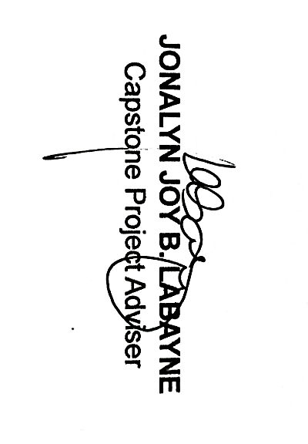

Appendix B.
Relevant Source Code

<?php
// Start database transaction
$db->beginTransaction();

try {
// Generate invoice number
$invoice_no = 'INV-' . date('Y-m-d') . '-' . str_pad($invoice_counter, 5, '0', STR_PAD_LEFT);

// Insert sale record
$sale_stmt = $db->query(
"INSERT INTO sales (
invoice_no, sale_date, customer_name, total_amount,
payment_method, reference_number, users_id, status,
agreement_data, due_date, discount_id
) VALUES (?, ?, ?, ?, ?, ?, ?, ?, ?, ?, ?)",
[
$invoice_no, $sale_date, $customer_name, $total_amount,
$payment_method, $reference_number, $userId, $status,
$agreement_json, $due_date, $overall_discount_id
]
);

if (!$sale_stmt) throw new Exception('Insert sale failed');

$saleId = $db->lastInsertId();
$total_cogs = 0;

// Process each item in the sale
foreach ($items as $it) {
$menu_item_id = !empty($it['menu_item_id']) ? intval($it['menu_item_id']) : null;
$quantity = intval($it['quantity'] ?? 0);
$unit_price = (float)($it['unit_price'] ?? 0);
$total_price = $quantity * $unit_price;

// Insert sale item
$item_stmt = $db->query(
"INSERT INTO sale_items (sale_id, menu_item_id, quantity, unit_price, total_price)
VALUES (?, ?, ?, ?, ?)",
[$saleId, $menu_item_id, $quantity, $unit_price, $total_price]
);

$sale_item_id = $db->lastInsertId();

// Deduct inventory and calculate COGS
if ($menu_item_id) {
$deduction_result = $inventoryService->deductMenuInventory($menu_item_id, $quantity, $saleId, $sale_item_id);
if ($deduction_result['success']) {
$item_cogs = $deduction_result['total_cogs'];
$total_cogs += $item_cogs;
}
}
}

// Update sale with total COGS and profit margin
$profit_margin = $total_amount - $total_cogs;
$db->query("UPDATE sales SET total_cogs = ?, profit_margin = ? WHERE id = ?", [$total_cogs, $profit_margin, $saleId]);

// Commit transaction
$db->commit();

echo json_encode(['success' => true, 'sale_id' => $saleId, 'invoice_no' => $invoice_no]);

} catch (Exception $e) {
$db->rollback();
error_log("Sale processing error: " . $e->getMessage());
echo json_encode(['success' => false, 'error' => $e->getMessage()]);
}

// Get today's inventory cost - use COGS from sales table (most accurate)
$today_inventory_cost = 0;
$sql = "SELECT COALESCE(SUM(total_cogs), 0) as total_cost FROM sales WHERE DATE(sale_date) = ? AND status = 'paid'";
if ($stmt = $mysqli->prepare($sql)) {
$stmt->bind_param('s', $today_date);
$stmt->execute();
$result = $stmt->get_result();
if ($row = $result->fetch_assoc()) $today_inventory_cost = $row['total_cost'];
$stmt->close();
}

// Fallbacks for inventory cost computation
if ($today_inventory_cost == 0) {
$sql = "SELECT COALESCE(SUM(si.total_cogs), 0) as total_cost
FROM sale_items si JOIN sales s ON s.id = si.sale_id
WHERE DATE(s.sale_date) = ? AND s.status = 'paid'";
if ($stmt = $mysqli->prepare($sql)) {
$stmt->bind_param('s', $today_date);
$stmt->execute();
$result = $stmt->get_result();
if ($row = $result->fetch_assoc()) $today_inventory_cost = $row['total_cost'];
$stmt->close();
}
}

if ($today_inventory_cost == 0) {
$sql = "SELECT COALESCE(SUM(cogs.total_cost), 0) as total_cost
FROM cost_of_goods_sold cogs JOIN sales s ON s.id = cogs.sale_id
WHERE DATE(s.sale_date) = ? AND s.status = 'paid'";
if ($stmt = $mysqli->prepare($sql)) {
$stmt->bind_param('s', $today_date);
$stmt->execute();
$result = $stmt->get_result();
if ($row = $result->fetch_assoc()) $today_inventory_cost = $row['total_cost'];
$stmt->close();
}
}

if ($today_inventory_cost == 0 && $today_sales > 0) $today_inventory_cost = $today_sales * 0.30;

// Calculate gross profit and profit margin
$today_gross_profit = $today_sales - $today_inventory_cost;
$today_profit_margin = $today_sales > 0 ? ($today_gross_profit / $today_sales) * 100 : 0;

public function deductMenuInventory($menu_item_id, $quantity, $sale_id = null, $sale_item_id = null) {
try {
$total_cogs = 0;
$cogs_details = [];

// Get menu item details
$menu_item = $this->db->fetchOne(
"SELECT id, name, uses_raw, inventory_id, packaging_cost, machine_use FROM menu_items WHERE id = ?",
[$menu_item_id]
);

if (!$menu_item) {
return ['success' => false, 'total_cogs' => 0, 'error' => 'Menu item not found'];
}

if ($menu_item['uses_raw']) {
$ingredients = $this->db->fetchAll(
"SELECT mi.inventory_id, mi.quantity, i.cost as unit_cost, i.track_stock
FROM menu_ingredients mi
LEFT JOIN inventory i ON mi.inventory_id = i.id
WHERE mi.menu_item_id = ?",
[$menu_item_id]
);

foreach ($ingredients as $ingredient) {
$total_quantity_needed = $ingredient['quantity'] * $quantity;

$inventory_item = $this->db->fetchOne(
"SELECT id, current_stock FROM inventory WHERE id = ?",
[$ingredient['inventory_id']]
);

if ($inventory_item && $inventory_item['track_stock']) {
if ($inventory_item['current_stock'] < $total_quantity_needed) continue;

$this->deductDirectInventory($ingredient['inventory_id'], $total_quantity_needed);

$ingredient_cost = $total_quantity_needed * ($ingredient['unit_cost'] ?? 0);
$total_cogs += $ingredient_cost;

if ($sale_id && $ingredient_cost > 0) {
$this->recordCOGS(
$sale_id, $sale_item_id, $menu_item_id,
$ingredient['inventory_id'], $total_quantity_needed,
$ingredient['unit_cost'] ?? 0, $ingredient_cost, 'ingredient'
);
}
}
}

$packaging_cost = ($menu_item['packaging_cost'] ?? 0) * $quantity;
$machine_cost = ($menu_item['machine_use'] ?? 0) * $quantity;
$total_cogs += $packaging_cost + $machine_cost;

} else if ($menu_item['inventory_id']) {
$total_cogs = $this->calculateDirectInventoryCOGS($menu_item_id, $menu_item['inventory_id'], $quantity, $sale_id, $sale_item_id);
}

return ['success' => true, 'total_cogs' => $total_cogs, 'cogs_details' => $cogs_details];

} catch (Exception $e) {
error_log("Inventory deduction error: " . $e->getMessage());
return ['success' => false, 'total_cogs' => 0, 'error' => $e->getMessage()];
}
}

private function recordCOGS($sale_id, $sale_item_id, $menu_item_id, $inventory_id,
$quantity_used, $unit_cost, $total_cost, $cost_type = 'ingredient') {
try {
$this->db->query(
"INSERT INTO cost_of_goods_sold
(sale_id, sale_item_id, menu_item_id, inventory_id, quantity_used,
unit_cost, total_cost, cost_type)
VALUES (?, ?, ?, ?, ?, ?, ?, ?)",
[$sale_id, $sale_item_id, $menu_item_id, $inventory_id,
$quantity_used, $unit_cost, $total_cost, $cost_type]
);
} catch (Exception $e) {
error_log("Error recording COGS: " . $e->getMessage());
}
}
$top_items = [];
$last_30_days = date('Y-m-d', strtotime('-30 days'));

$sql = "SELECT item_name AS name, SUM(sold_qty) AS sold
FROM (
SELECT COALESCE(mi.name, inv.name) AS item_name, si.quantity AS sold_qty
FROM sale_items si
JOIN sales s ON s.id = si.sale_id
LEFT JOIN menu_items mi ON si.menu_item_id = mi.id
LEFT JOIN inventory inv ON si.product_id = inv.id
WHERE DATE(s.sale_date) >= ? AND s.status = 'paid'
) AS combined
WHERE item_name IS NOT NULL
GROUP BY item_name
ORDER BY sold DESC
LIMIT 5";

if ($stmt = $mysqli->prepare($sql)) {
$stmt->bind_param('s', $last_30_days);
$stmt->execute();
$result = $stmt->get_result();
while ($row = $result->fetch_assoc()) {
$top_items[] = ['name' => $row['name'], 'sold' => (int)$row['sold']];
}
$stmt->close();
}

Appendix C.
Evaluation Tool & Statistical Computation



Republic of the Philippines
Laguna State Polytechnic University – Los Baños Campus
College of Computer Studies

ISO/IEC 25010 Software Quality Evaluation Rubric
Project Title: Café by the Bay: Integration of a Web-Based Point-of-Sales System
Good day! We are students of the Laguna State Polytechnic University – Los Baños Campus, under the College of Computer Studies, conducting the development of a project entitled “Café by the Bay: Integration of a Web-based Point-of-Sales.”
We would like to seek your professional evaluation of the system based on the ISO 25010 Software Quality Model. Please evaluate each statement by checking the appropriate number that best represents your assessment of the system’s quality characteristics, wherein 1 = Poor; 2 = Needs Improvement; 3 = Fair; 4 = Good; and 5 = Excellent.
Rest assured that all information you provide will be treated with the utmost confidentiality in accordance with RA 10173 (Data Privacy Act of 2012) and will be used solely for academic and research purposes. Thank you for your cooperation!
Maria Raquel Grace A. Tuisa
Sherlyn I. Banasihan
Jenelyn C. Siervo
Name of Respondent: ________________________________________
Characteristics | Excellent (5) | Good (4) | Fair (3) | Needs Improvement (2) | Poor (1)
Functional Suitability | Fully meets all required and intended functions with complete accuracy and reliability. | Meets most functional needs; minor issues not affecting key functions. | Meets core functions; some limitations in accuracy or scope. | Partially meets requirements; noticeable inaccuracies or missing features. | Fails to meet core functions; major gaps or errors.
Performance Efficiency | Consistently fast and resource-efficient under all conditions. | Generally responsive; minor delays under heavy load. | Average performance; occasional lag or resource strain. | Frequent lag or inefficiency under normal load. | Very slow, high resource consumption, poor responsiveness.
Compatibility | Works seamlessly with all target systems and environments. | Minor integration issues that don’t affect main functions. | Compatible with main systems but not all platforms. | Limited interoperability; noticeable integration problems. | Incompatible with key systems; frequent conflicts.
Interaction Capability (formerly Usability) | Extremely intuitive, accessible, and engaging user experience; supports diverse users. | User-friendly; minor interface or accessibility issues. | Usable but requires some learning or adjustment. | Difficult navigation and limited accessibility. | Very poor UX; confusing design and barriers to use.
Reliability
  Fully stable and dependable under all conditions; quick recovery from faults.
  Generally stable; rare minor failures.
  Some stability issues under moderate load.
  Frequent non-critical errors or recoverability issues.
  Very unstable; frequent crashes or data loss.
Security | Comprehensive protection (confidentiality, integrity, authenticity); minimal vulnerabilities. | Strong protection; few minor vulnerabilities. | Adequate protection; some known weaknesses. | Weak safeguards; several vulnerabilities exist. | Major security flaws; data or user privacy at high risk.
Maintainability | Highly modular, readable, and easily modifiable; supports efficient debugging and updates. | Mostly maintainable; some complex sections. | Manageable but requires extra effort to update or debug. | Hard to maintain; code difficult to modify. | Nearly impossible to maintain without major rewriting.
Flexibility | Fully adaptable and scalable; easy to install and replace across environments. | Adaptable with minor configuration changes. | Some portability issues; moderate setup effort needed. | Limited adaptability; significant reconfiguration needed. | Not flexible; fails to function in new environments.
Safety | System operates with full risk controls; automatically prevents and warns of hazards. | Proper safeguards in place; rare risk events. | Basic risk controls exist; some unaddressed risks. | Inconsistent or weak safety features. | Unsafe operation; high risk of failure or hazards.

______________________________
Signature of Respondent

Republic of the Philippines
Laguna State Polytechnic University – Los Baños Campus
College of Computer Studies

TECHNOLOGY ACCEPTANCE MODEL QUESTIONNAIRE
Dear respondent,
We are students of the Laguna State Polytechnic University – Los Baños Campus under the College of Computer Studies conducting development on the project entitled “Café by the Bay: Integration of a Web-Based Point-of-Sales System”.
We would like to seek your opinion on the acceptability of the said project by scoring the statements below by checking the appropriate numbers, wherein 1 = Strongly Agree; 2 = Agree; 3 = Disagree; and 4 = Strongly Disagree.
Rest assured that any information that you provide will be treated with utmost confidentiality (RA 10173. Data Privacy Act) and will be used for research purposes only. Thank you for your cooperation!
Maria Raquel Grace A. Tuisa
Sherlyn I. Banasihan
Jenelyn C. Siervo
Name of Respondent: ________________________________
Perceived Usefulness | 4 | 3 | 2 | 1
1. The system helps speed up transaction and order processing.
Ang sistema ay nakatutulong upang mapabilis ang proseso ng transaksyon at pag-order.
2. The system reduces human error in sales and inventory records.
Nababawasan ng sistema ang pagkakamali sa mga tala ng benta at imbentaryo.
3. The system improves the accuracy and reliability of sales reports.
Pinapahusay ng sistema ang katumpakan at pagiging maaasahan ng mga ulat sa benta.
4. The system makes monitoring of sales and inventory more efficient for the café.
Ginagawang mas mahusay ng sistema ang pagmamanman ng benta at imbentaryo ng café.
5. The system enhances business decision-making and financial management.
Pinabubuti ng sistema ang paggawa ng desisyon at pamamahalang pinansyal.
Perceived Ease of Use
1. The system interface is user-friendly and easy to navigate.
Ang interface ng sistema ay madaling gamitin at madaling i-navigate.
2. I find it easy to learn how to operate the system and interpret the data it provides.
Madali kong natutunan kung paano gamitin ang sistema at intindihin ang datos na ibinibigay nito.
3. It requires minimal effort or technical knowledge when using the system.
Ang paggamit ng sistema ay nangangailangan ng kaunting pagsisikap o teknikal na kaalaman.
4. The application and dashboard make it convenient to monitor sales and inventory in real time.
Ginagawang maginhawa ng application at dashboard ang pagsubaybay sa mga benta at imbentaryo sa real time.
5. I am comfortable with the overall setup and functionality of the point-of-sales system.
Komportable ako sa kabuuang setup at functionality ng point-of-sales system.
Attitude (Towards Using the System)
1. I feel positive about using the system for managing sales and inventory.
Positibo ang aking pakiramdam sa paggamit ng sistema para sa pamamahala ng benta at imbentaryo.
2. The system fits well with my business operations and inventory management practices.
Ang sistema ay angkop sa aking mga gawain sa operasyon ng negosyo at pamamahala ng imbentaryo.
3. I believe this technology can greatly benefit the coffee shop business.
Naniniwala ako na ang teknolohiyang ito ay malaking maitutulong sa negosyo ng coffee shop.
4. Using this system is an enjoyable and beneficial experience.
Ang paggamit ng sistemang ito ay isang kasiya-siya at kapaki-pakinabang na karanasan.
5. I would recommend implementing this kind of system to other business owners or coffee shop operators.
Irekomenda ko ang implementasiyon ng ganitong uri ng sistema sa iba pang mga may-ari ng negosyo o tagapamahala ng coffee shop.
Behavior (Intention to Use the System)
1. I intend to use this system regularly for managing sales and inventory.
Balak kong gamitin ang sistemang ito nang regular para sa pamamahala ng benta at imbentaryo.
2. I am likely to rely on this system to help manage my business operations in the future.
Malamang na aasa ako sa sistemang ito upang makatulong sa pamamahala ng aking negosyo sa hinaharap.
3. I am willing to adopt other digital solutions for my business operations based on my experience with this system.
Handa akong gumamit ng iba pang digital na solusyon para sa aking negosyo batay sa aking karanasan sa sistemang ito.
4. I am likely to recommend this system to colleagues in the business or retail industry.
Malamang na irekomenda ko ang sistemang ito sa mga kasamahan ko sa industriya ng negosyo o retail.
5. I am committed to using this system as part of my daily sales and inventory routine.
Nais kong gamitin ang sistemang ito bilang bahagi ng aking araw-araw na gawain sa benta at imbentaryo.

____________________________________
Signature of the Respondent

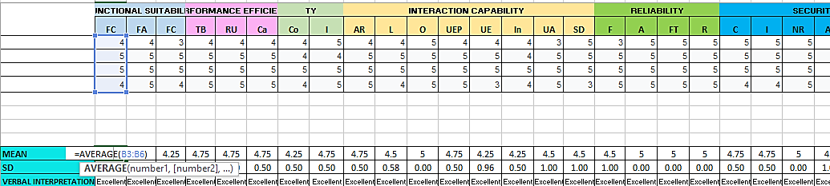
This figure shows the summary of computed Mean for the questionnaire items under the ISO 25010 criteria.
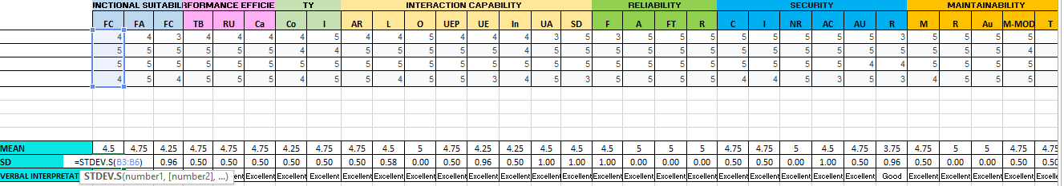
This figure shows the summary of computed Standard Deviation for the questionnaire items under the ISO 25010 criteria.
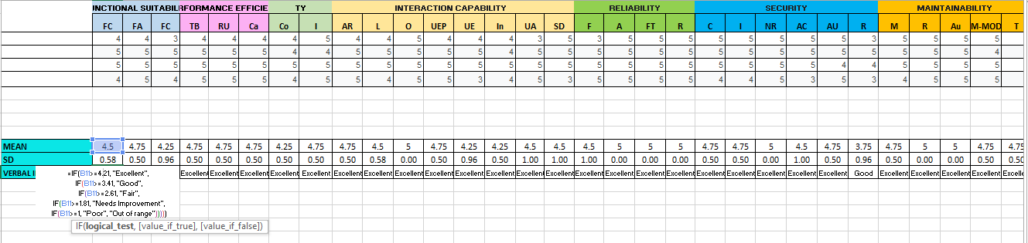
This figure shows the Verbal Interpretation for the questionnaire items under the ISO 25010 criteria.
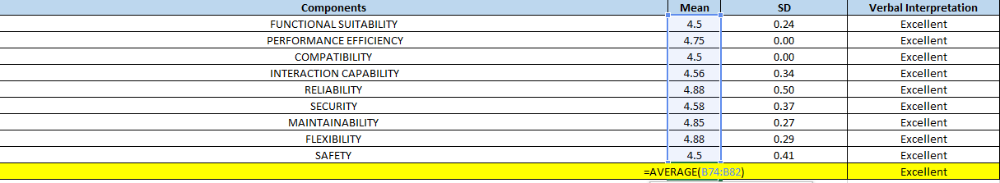
This figure shows the Excel computation of the Composite Mean for the system’s evaluation components based on the ISO 25010 criteria.
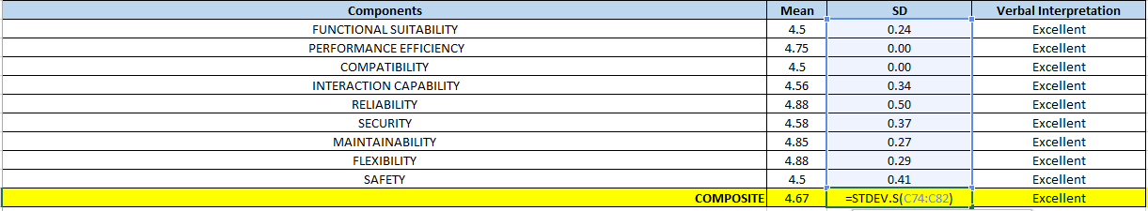
This figure shows the Excel computation of the Composite Standard Deviation for the system’s evaluation components based on the ISO 25010 criteria.
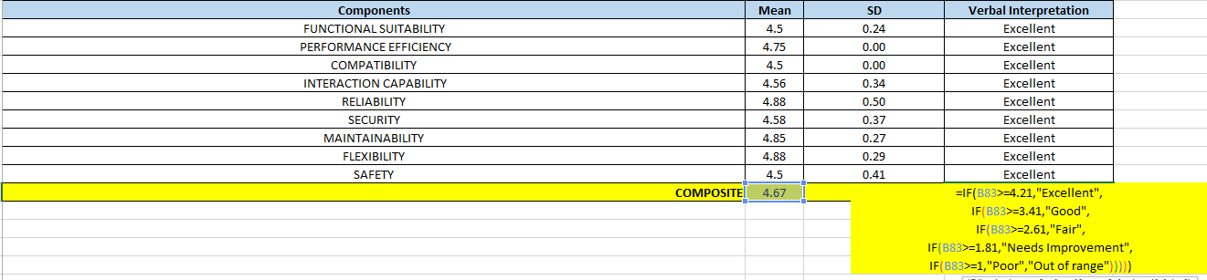
This figure shows the Verbal Interpretation for the system’s evaluation components based on the ISO 25010 criteria.
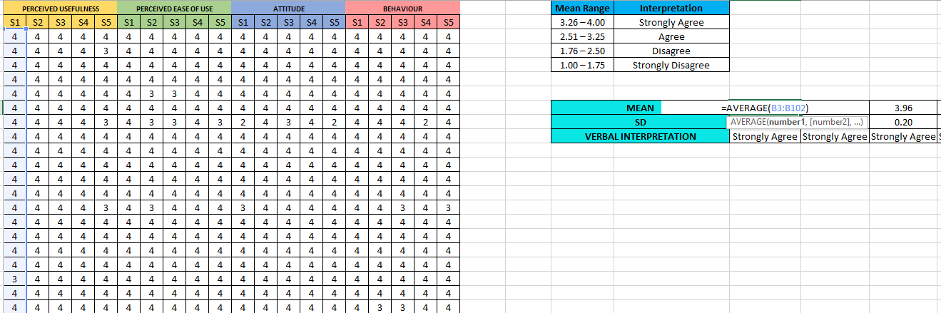
This figure shows the summary of computed Mean for the questionnaire items under the TAM criteria.
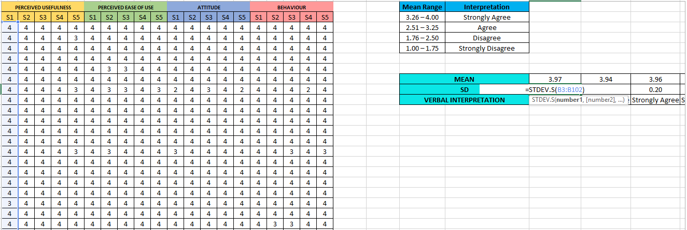
This figure shows the summary of computed Standard Deviation for the questionnaire items under the TAM criteria.

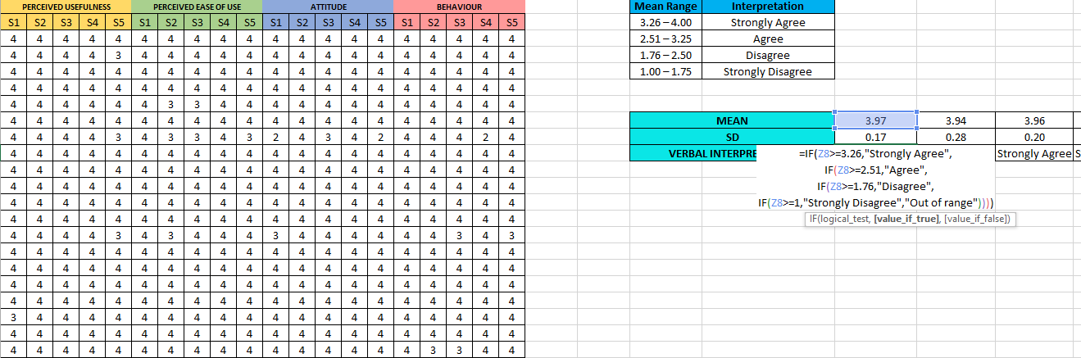
This figure shows the Verbal Interpretation for the questionnaire items under the TAM criteria.
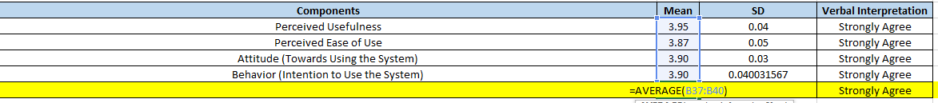
This figure shows the Excel computation of the Composite Mean for the system’s evaluation components based on the TAM criteria.
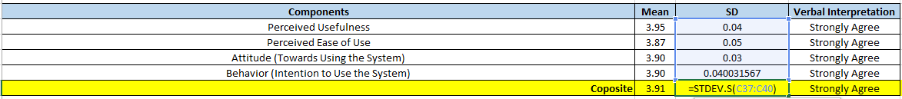
This figure shows the Excel computation of the Composite Standard Deviation for the system’s evaluation components based on the TAM criteria.
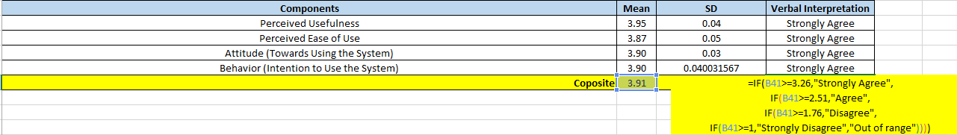
This figure shows the Verbal Interpretation for the system’s evaluation components based on the TAM criteria.

Appendix D.
Sample Input / Output

Staff Interface
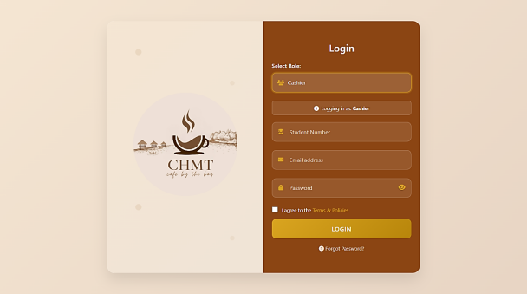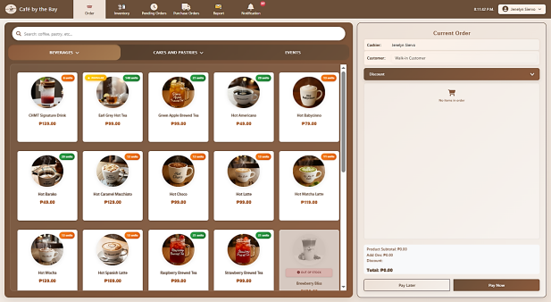
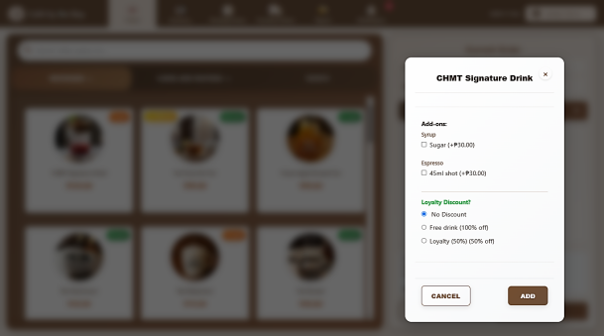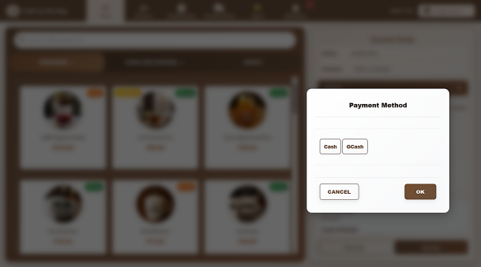
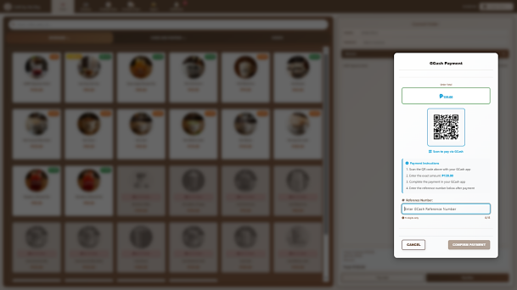
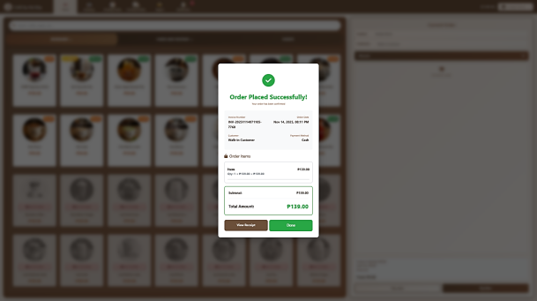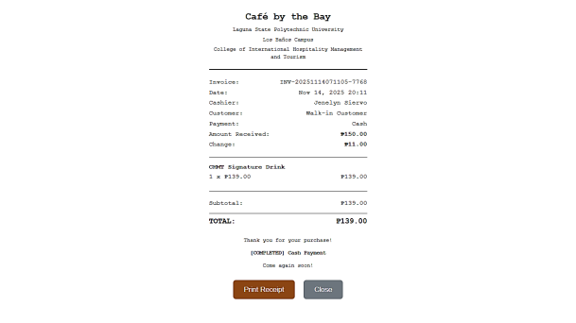
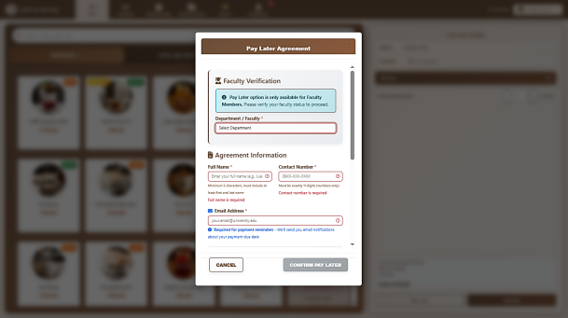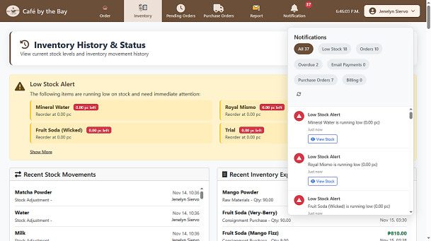

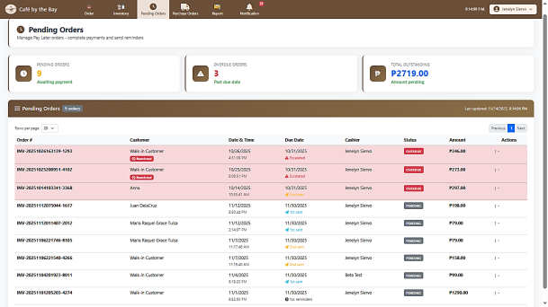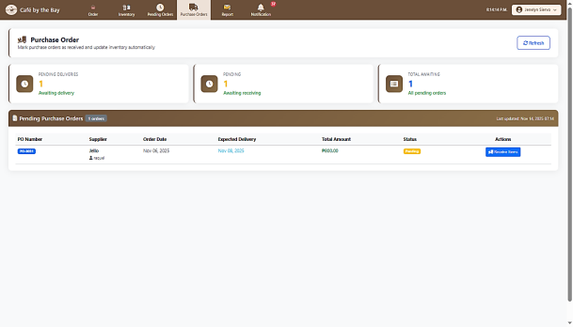
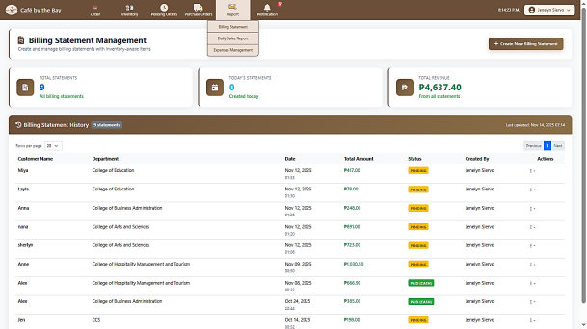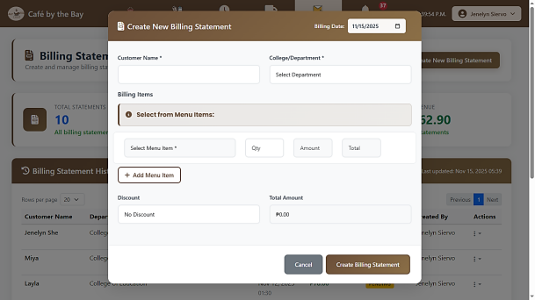
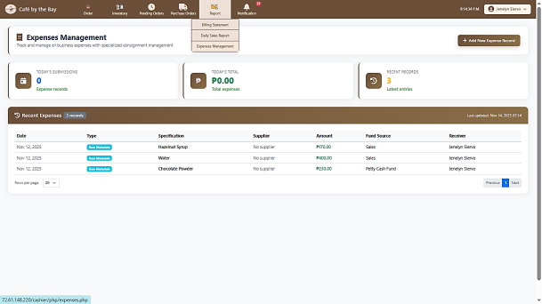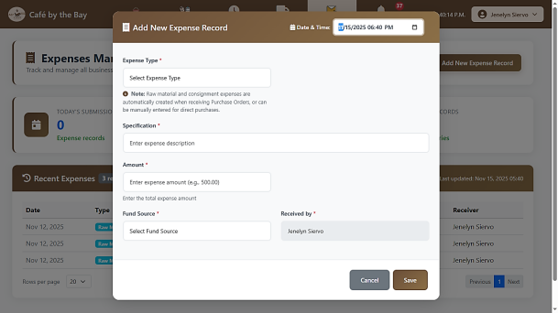
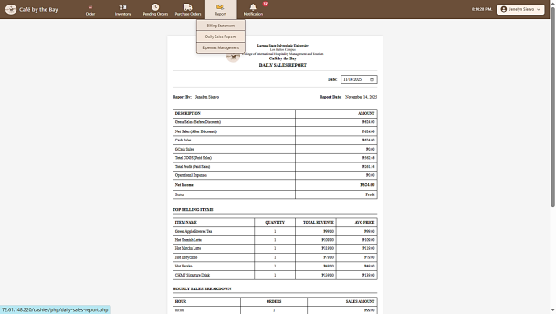

Administrator Interface
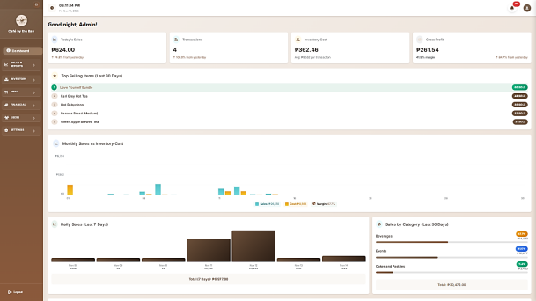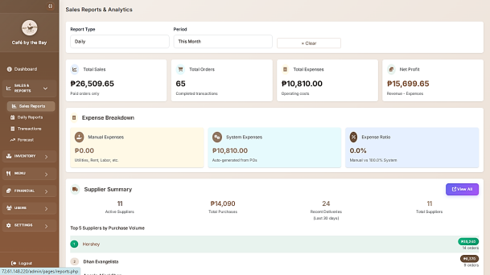
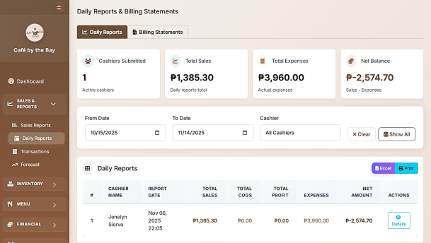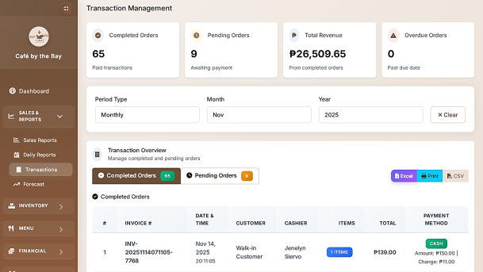
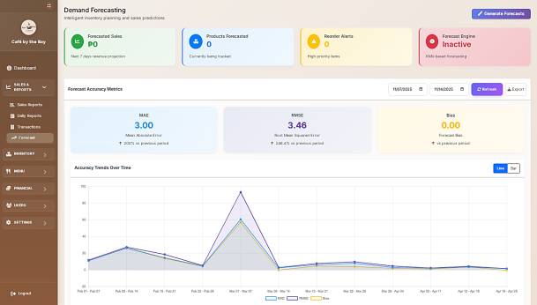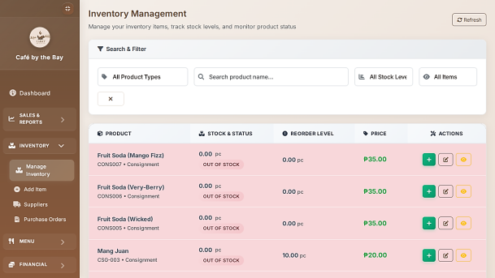
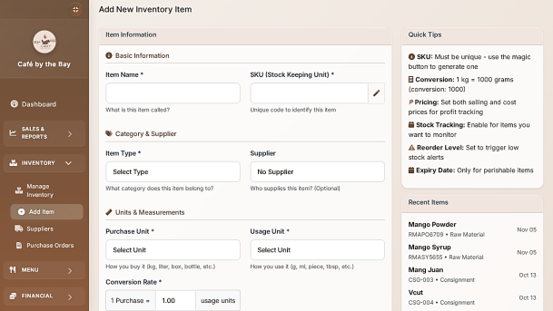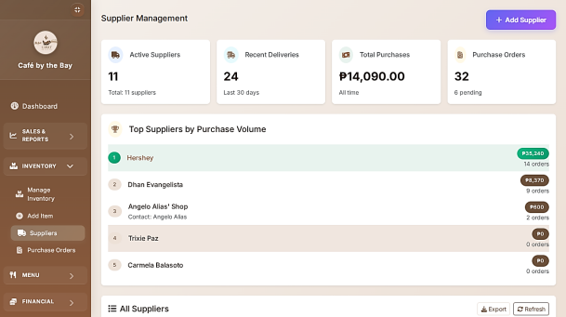
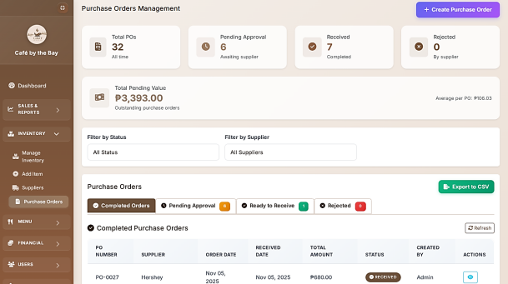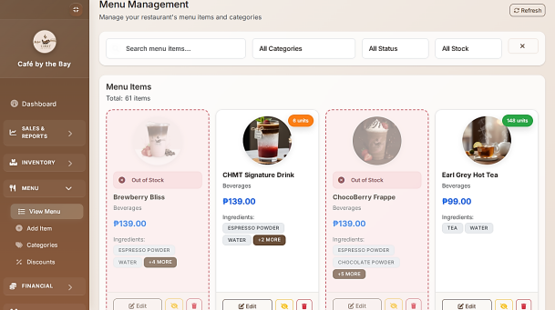

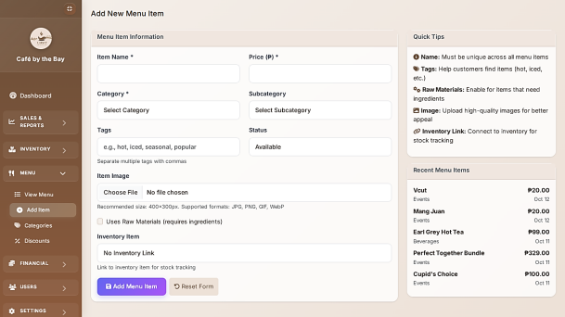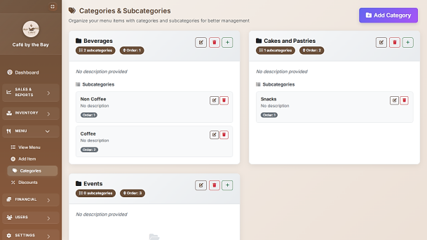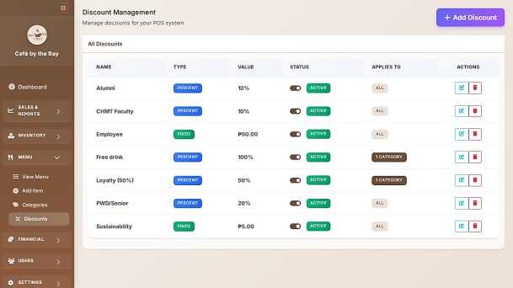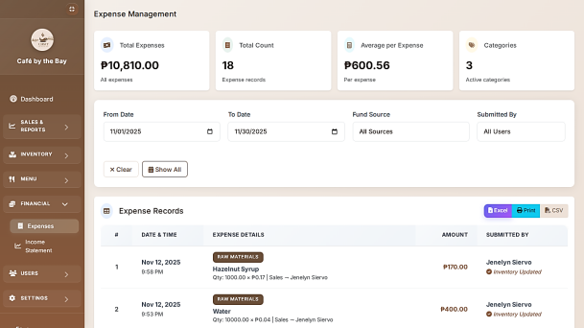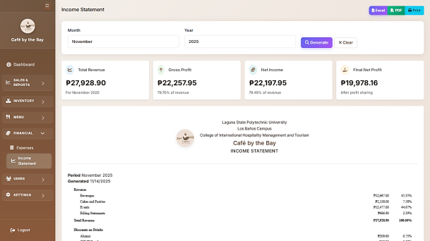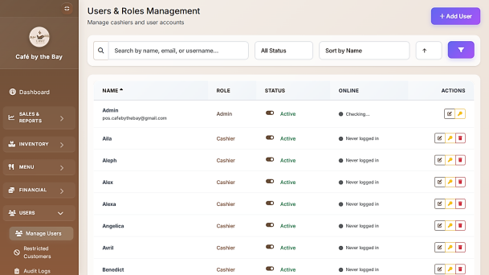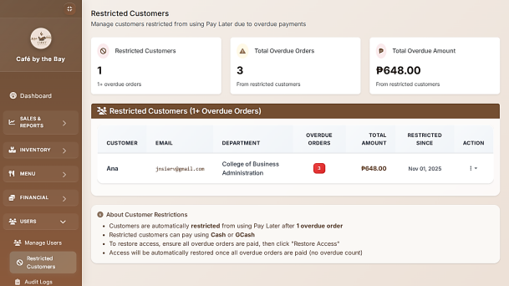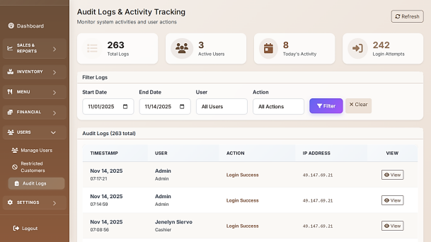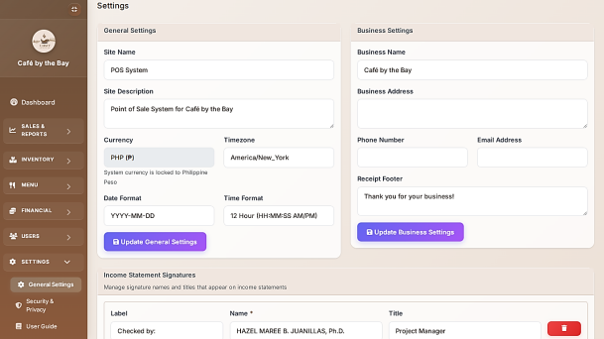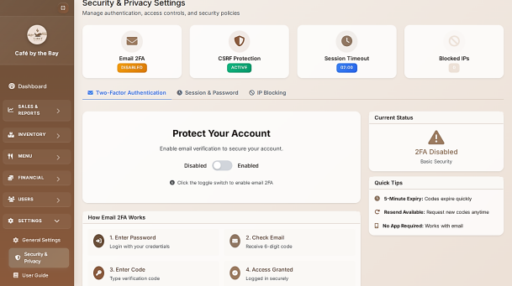

Appendix E.
User’s Guide

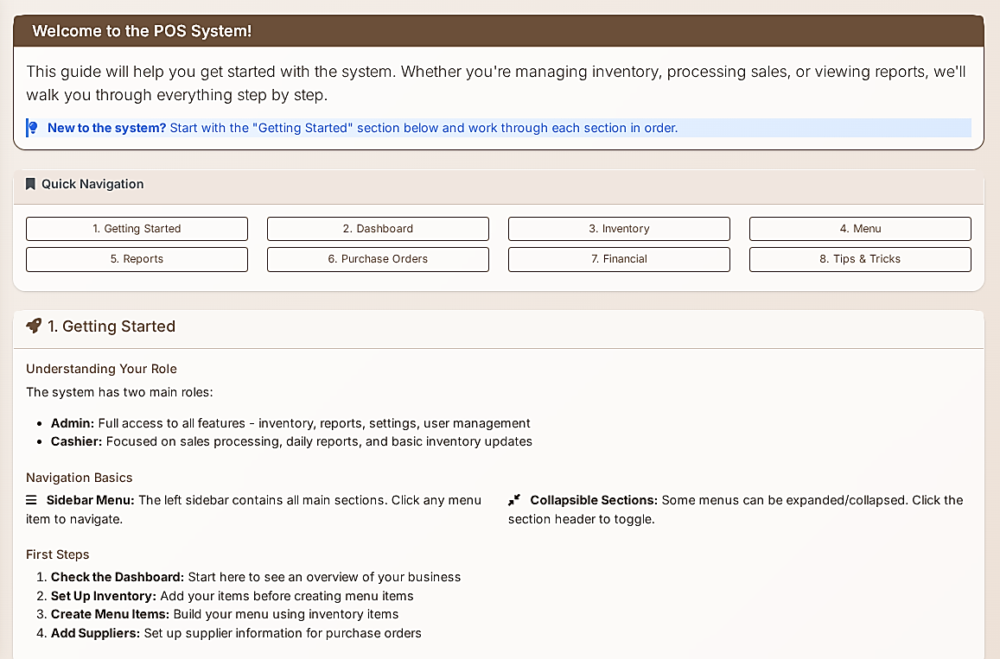
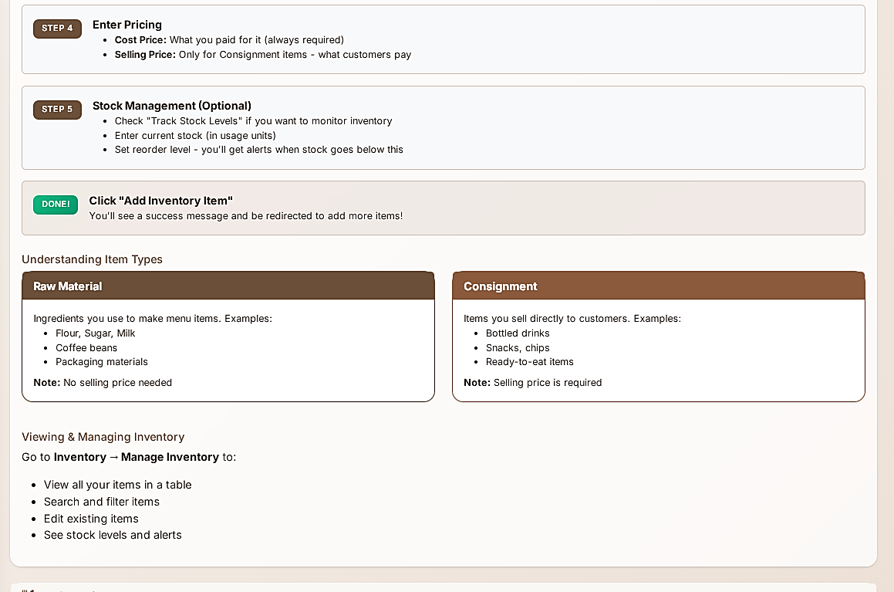
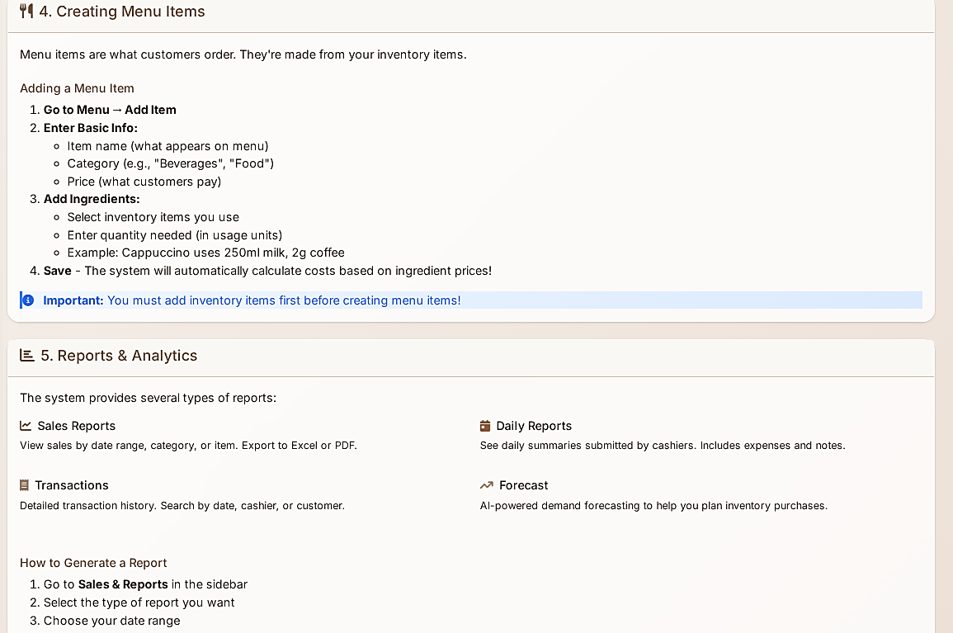
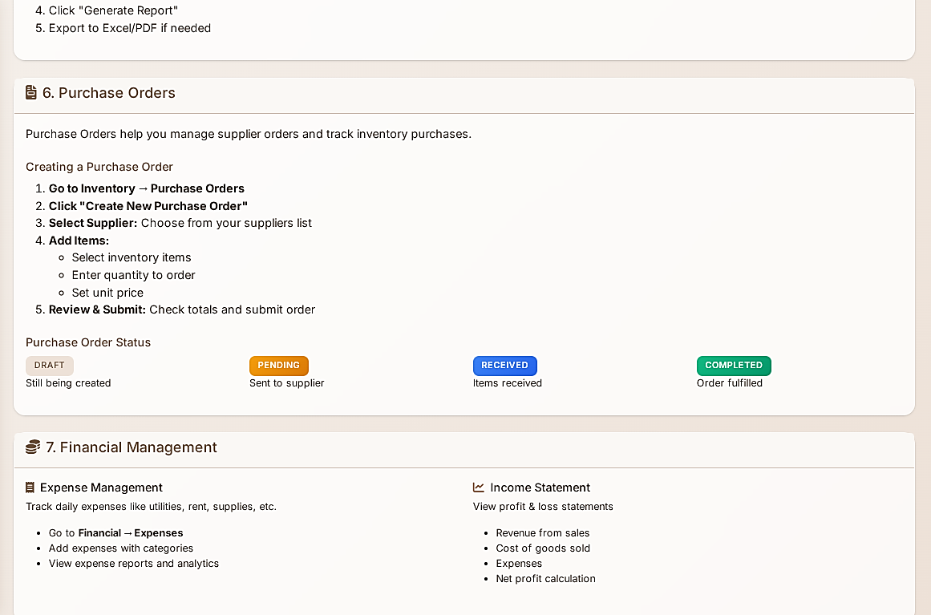
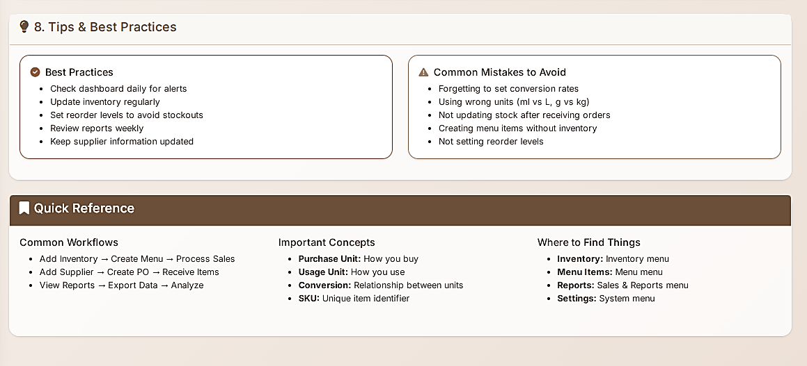

Appendix F.
Curriculum Vitae

 | MARIA RAQUEL GRACE A. TUISA  0991 429 7426  tuisamariaraquelgrace@gmail.com  Purok 5, Brgy. Sucol, Calamba City, Laguna
PERSONAL DETAILS  Date of Birth: May 28, 2004  Birth Place: Tadlac, Los Baños, Laguna  Sex: Female  Height: 5'2  Weight: 40kg  Citizenship: Filipino  Civil Status: Single  Religion: Catholic  Language: Filipino, English  SKILLS  - Basic Microsoft Office (Word, PowerPoint, Excel)  - Basic HMTL & CSS  - Data Management  - UI Graphic Design (Canva, Figma, Photoshop)  - Basic Photoshop Editing | EDUCATION  Tertiary  LAGUNA STATE POLYTECHNIC UNIVERSITY  Mayondon – Malinta, Los Baños, Laguna  Bachelor of Science in Information Technology – Major in Service Management Program (SMP)  2022 – Present  Secondary – Senior High School  SAINTS JOHN AND PAUL FOUNDATION, INC.  Halang, Calamba City, Laguna  General Academic Strand (GAS)  2020 – 2022  Junior High School  CASTOR ALVIAR NATIONAL HIGH SCHOOL  Masili, Calamba City, Laguna  2016 – 2020  Primary  TIYANI ELEMENTARY SCHOOL  Sucol, Calamba City, Laguna  2010 – 2016  SEMINARS  - Securing the Future: Understanding the Fundamentals of Cyber Security – December 12, 2023  - Role of Technology in Sustainable Development – February 28, 2025  DIGITAL CREDENTIAL – IBM SkillBuild  - Web Development Fundamentals  - AI-Enabled Applications for Customer Service  - Cyber Security Fundamentals  - Customer Engagement Fundamentals  - Cloud Computing Fundamentals  - Digital Literacy
ACADEMIC PROJECT
- Interactive Website for Barangay Sampiruhan, Calamba Laguna (2024)
- Ordering System (2024)
- Point of Sale System with Inventory Management (2025)

  PERSONAL DETAILS  Date of Birth: August 19, 1997  Pace of Birth: San Pablo Laguna  Sex: Female  Height: 5'0  Weight: 45kgs  Civil Status: Single  Nationality: Filipino  Religion: Christian  SKILLS  - Basic Microsoft Word, PowerPoint, Excel  - Front-end Development (HTML, CSS, basic JavaScript)  - Data Management  - Basic Graphic Design (Canva, Photoshop – basic editing) and basic UI/UX Layout Design (Figma)  - Database Usage: MySQL, phpMyAdmin, SQL(CRUD), ERD, XAMPP Server Setup  SEMINARS  - Securing the Future: Understanding the Fundamentals of Cybersecurity – December 12, 2023  - Role of Technology in Sustainable Development – February 28, 2025 | SHERLYN I. BANASIHAN  0967 399 0599  Sto. Domingo Bay Laguna  sherlynbanasihan019@gmail.com  EDUCATION  Tertiary  LAGUNA STATE POLYTECHNIC UNIVERSITY  Bgry. Mayondon-Malinta, Los Banos, Laguna  2022-Present  Bachelor of Science in Information Technology – Major in Service Management Program (SMP)  Secondary  LOS BAÑOS NATIONAL HIGH SCHOOL  Pearl St. Batong Malake, Los Banos, Laguna  2013-2014  Primary  STO. DOMINGO ELEMENTARY SCHOOL  Sto. Domingo Bay, Laguna  2009-2010  CERTIFICATES & TRAININGS  - Certificate of Appreciation  Barangay Lamot II, Calauan, Laguna – April 21, 2024. Recognized for contributing to the development of a Web System for Monthly Committee Accomplishment Reports, improving barangay documentation and reporting efficiency.  - Certificate of Participation  Digital Character Painting  Laguna State Polytechnic University Los Baños Campus - July 29, 2015  IBM SkillBuild Digital Credentials  - Hardware Components and Troubleshooting (2025)  - Information Technology Fundamentals (2025)  - Working in a Digital World – Professional skills (2025)  - Lifelong Professional Skills (2025)

  PERSONAL DETAILS  Date of Birth: August 31, 2003  Birthplace: Pambujan, Northern Samar  Gender: Female  Citizenship: Filipino  SKILLS  - Microsoft Office (Word, Excel, PowerPoint)  - HTML & CSS  - Networking basics  - Computer troubleshooting  - Figma – Basic UI design  ACADEMIC PROJECTS  - Ordering System – Contributed to the overall development of the system.  - Point of Sale System with Inventory Management - Contributed to the overall development of the system.  LANGUAGE  - Filipino – Native  - English – Basic proficiency | JENELYN C. SIERVO  0909 116 0954  siervojenelyn6@gmail.com  Brgy. Maahas, Los Banos, Laguna  EDUCATION  College  LAGUNA STATE POLYTECHNIC UNIVERSITY  Bgry. Mayondon-Malinta, Los Banos, Laguna  2022 – Present  Bachelor of Science in Information Technology – Major in Service Management Program (SMP)  Senior High School  PAMBUJAN NATIONAL HIGH SCHOOL  Brgy. 8, Pambujan, Northern Samar  2020-2022  Technical-Vocational-Livelihood track with a specialization in Information and Communication Technology (TVL-ICT) Strand  Junior High School  PAMBUJAN NATIONAL HIGH SCHOOL  Brgy. 8, Pambujan, Northern Samar  2016-2020  Elementary School  CAMPARANGA ELEMENTARY SCHOOL  Brgy. Camparanga, Pambujan, Northern Samar  2009-2016  ACHIEVEMENTS / CERTIFICATES  - National Certicate II in Computer Sytems Servicing - June 2022  - IBM SkillBuild Badge – Web Development Fundamentals  - IBM SkillBuild Badge - Customer Engagement Fundamentals  - IBM SkillBuild Badge - AI Literacy  SEMINARS  - Securing the Future: Understanding the Fundamentals of Cybersecurity – December 12, 2023  - Role of Technology in Sustainable Development – February 28, 2025

Appendix G.
Publishable Paper (IEE Format)

CAFÉ BY THE BAY: INTEGRATION OF A WEB-BASED POINT-OF-SALES SYSTEM

Maria Raquel Grace A. Tuisa¹, Sherlyn I. Banasihan ², Jenelyn C. Siervo³
College of Computer Studies, Laguna State Polytechnic University
Malinta Los Banos, Laguna, Philippines
¹tuisamrgayson@gmail.com, ²sherlynbanasihan019@gmail.com, ³jenelyn.siervo@lspu.edu.ph

Abstract— Manual transaction processing, inventory mismanagement, and the absence of real-time data continue to pose challenges for small cafés and academic business facilities that affects the operational efficiency and decision-making. Despite efforts to improve these processes, many existing systems lack integrated solutions that combine sales tracking, inventory monitoring, and data-driven forecasting. Therefore, this study addresses these gaps by developing a web-based Point-of-Sales (POS) system with integrated inventory management specifically designed for Café by the Bay. While previous studies have shown that digital systems greatly enhance business operations, most of it have not incorporated predictive analytics designed to small-scale café environments. The study integrates a K-Nearest Neighbor (KNN) forecasting module to support sales prediction and inventory planning. Using the Agile Scrum methodology for system development, the platform was evaluated through ISO 25010 software quality standards and the Technology Acceptance Model (TAM). Results from system testing showed that all modules met the required quality attributes, demonstrating the system’s efficiency, usability, reliability, and strong user acceptance. This study provides evidence that the developed system is a practical and innovative solution that strengthens the café’s operational accuracy, enhances their data-driven decision-making, and improves the overall business performance within training-based café environments.
Keywords— point-of-sales (POS), Inventory Management, ISO 25010, TAM, Agile Scrum, KNN Algorithm, Forecasting, Retail Business
- INTRODUCTION
Small retail businesses like cafes and restaurants indeed need a very strong online-offline compatible point-of-sales (POS) system to keep their operations continuously alive [1]. System availability can be maximized when complementary technologies such as blockchain or edge computing are integrated into POS systems, that allows them to be functional even there is no internet service. In such cases, resiliency in these systems becomes very important for small businesses, to think that most of them do not have reliable connectivity.
Café by the Bay is more than just a café; it is a strategic initiative by the College of Hospitality Management and Tourism (CHMT) at Laguna State Polytechnic University–Los Baños Campus (LSPU-LBC) that blends business practice with academic learning [2].
Modern day point-of-sale systems can also be referred to as the tools used to execute the financial transactions of a restaurant. These platforms used to query sales tracking during the busy management periods in a restaurant, such as inventory management and analytics, which is complemented with friendly web interfaces for easier data input and analysis [3]. Another study also supports putting the inventory management system into the POS since real-time input of data reduces waste, adds profitability, and boosts customer satisfaction with the better decision-making of restaurants through the information [4]. Similarly, real-time inventory tracking not only reduces waste but also ensures the availability of product for customers, which demonstrates the importance of timely and accurate inventory sales data [5]. Another case study revealed that the implementation of the POS system significantly improved operational efficiency and financial management within the coffee shop businesses [6].
Inefficiencies that traditional inventory systems had for a small Philippine business with four branches and a mobile store. PHP, MySQL, HTML5, Bootstrap, and JavaScript were used to address the inventory challenges of a small enterprise in Pagadian City, Philippines [7]. Data-driven inventory systems can address the limitations of traditional manual methods by providing accurate, timely, and strategic information for operational and business planning by developing of an inventory management system with the incorporation of association rule mining, particularly the Apriori algorithm [8].
Sales reporting is an essential aspect of data gathering, analysis, and presentation in sales processes. It tells the business about sales trends, customer behavioral trends, and whether their sales strategies are working [9]. KNN algorithm to predict which products at PT LG Innotek Indonesia would sell well. They analyzed sales data from 2020 to 2023 and categorized items as “Selling” or “Not Selling.” The model achieved 94.74% accuracy and only 5.26% error, which means KNN performed effectively when data was properly cleaned and processed [10].
Practical training facilities, including Café by the Bay, encounter several challenges even when designed to simulate real-world operations. Hands-on training for students has not eliminated operational difficulties, particularly in the areas of sales tracking, inventory management, and data-driven decision-making. Manual processes have sometimes resulted in inefficiencies such as stock mismanagement, slow transactions, and a lack of real-time financial understanding.
To address these operational issues, the researchers integrate a point-of-sale (POS) system with an inventory management platform specifically designed for Café by the Bay. The system addresses the prevalent issues of manual errors, stock discrepancies, and inefficient resource management by incorporating streamlined order processing, real-time sales monitoring, stock control, and streamlined financial reporting. This approach not only enhances operational efficiency but also provides a user-friendly interface tailored to the dynamic needs of café management that offers a comprehensive solution to elevate both business performance and customer service.
- Methodology
Figure 1 illustrates the development of the point-of-sales (pos) with inventory system using the Supplier – Input – Process – Output – Customer Feedback (SIPOCF) model. It is composed of five main components: Supplier, Input, Process, Output, and Customer. The Supplier represents the primary provider of the necessary resources, materials, and data needed. The Inputs consists of essential data that is needed for the system operations to work and support its functions. The Process section covers the core functions performed by the POS system. From these processes generates the Outputs that include the configured POS system, active modules, updated user accounts, sales records, inventory updates, reports, real-time data access, and the return of investment (ROI) of the business from sales. Finally, the Customers are identified as the system owner, admin, and staff, who will benefit directly utilize these outputs.
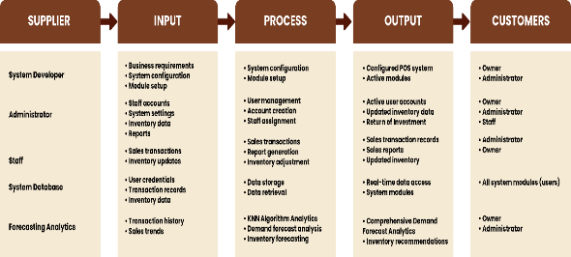
Figure 1. Conceptual Framework

- Project Design
The figure 2, context diagram, illustrates the overall interaction between the Point-of-Sales (POS) system, the staff, and the admin, whereas the system serves as the central process. The staff primarily uses the system to input customer order details by which the POS processes and displays order invoice and receipts. The admin interacts with the POS system on a broader management level. The system provides the admin with sales records, various reports, and sales trend analysis, along with the low stock-level notifications, to support their decision-making. The admin also provides the menu product details and supplier information, which ensures that the POS remains updated with accurate inventory and product data.

Figure 2. Context Diagram
- Data Source and Algorithm
In this capstone project, sales data from Cafe by the Bay were collected to create and validate forecasting systems. The dataset, which spans from October 10, 2024 to July 10, 2025, was extracted from the café’s Microsoft Excel file where all transactions are recorded and consists of comprehensive daily sales data.
The data preprocessing stage included the removal of inappropriate records, daily demand aggregation at the product level, the creation of temporal and statistical features, and normalization of the values to make the dataset compatible with the K-Nearest Neighbors (KNN) algorithm. K-Nearest Neighbors (KNN) was selected as the forecasting algorithm for this study due to its simplicity, interpretability, and suitability for environments with limited historical data.
To evaluate the forecasting performance of the model, three widely used error metrics were employed: Mean Absolute Error (MAE), Root Mean Squared Error (RMSE), and Forecast Bias. These metrics quantify the magnitude, variability, and direction of prediction errors during the testing period.
- Materials
PhpMyAdmin is used by developers to specify, store, manage and organize the database of the Point of Sale with Inventory System. It stores important data such as product details, user accounts, sales transactions, and inventory records.
Cascading Style Sheets (CSS) is what is used to design the visual appearance of the system for a neat, modern, user-friendly experience. Layouts, color schemes, fonts, spacing, and all other stylistic features that make the interface appealing and easy to navigate are defined here.
Hypertext Markup Language (HTML) is responsible for building the initial structure and layout of the POS user interface. It is responsible for putting all those buttons, forms, and tables and navigation menus in the framework to be displayed.
Bootstrap is utilized as part of the system’s front-end design and user interface development. It is responsible for ensuring that the system’s interface is not only user-friendly but also adaptive.
JavaScript has been applied to the making of the system dynamic and responsive. It renders the system more interactive to real-time updates, form validations, product searches, and all other essential user actions.
Visual Studio Code serves as the primary integrated development environment (IDE) to create and manage the system codebase.
XAMPP is used to create a local development environment for testing POS implementations before deployment.
Python is a multi-purpose programming language with a lot of different applications such as data analysis, machine learning, and database interaction. Various libraries are incorporated to make the system more versatile.
Pandas allows data manipulation or data handling, which makes it capable of reading data from SQL databases and performing extensive DataFrame operations. This function is very important for the analysis of historical sales data to be done properly and easily.
NumPy provides the necessary support for numerical computing through its fast and easy-to-use array structures and mathematical operations; thus, the demand forecasting algorithms are able to take the required computation done easily.
Scikit-learn for machine learning model implementation especially for the algorithm of K-Nearest Neighbors (KNN). It provides support for the process of data scaling, cross-validation, and hyperparameter tuning, which makes it very easy for the system to find patterns in sales data and thus provide predictions of demand that are reliable and accurate.
Mysql-connector-python library as the communication between the MySQL database and Python. It makes it possible for the data to be retrieved and updated efficiently thus, making database connectivity a crucial part of the system.

D. Project Development
Figure 3 illustrates the life cycle of the system from the initial idea to the final output, which is the point-of-sale (POS) system. The researchers adopted Agile Scrum methodology by dividing the tasks into multiple phases with one to four (1-4) weeks iterations. Key procedures include product backlog, sprint planning, daily scrum, scrum review, and delivering of the finished product.

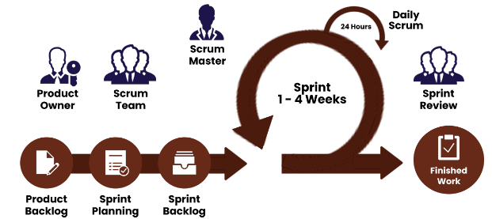
Figure 3. Agile Scrum Methodology

The figure 4 illustrates the system flowchart of the system, which presents the overall operational process of the Café by the Bay Point-of-Sales (POS) system. It shows how both administrator and staff interact with the system from login to logout.

Figure 4. System Flowchart

Figure 5 illustrated the different functions that both the Administrator and Staff can perform in the system. It shows how each user role interacts with various features based on the level of their access to the system. Both the Administrator and Staff can perform basic operations such as logging in, viewing of notifications, and logging out.
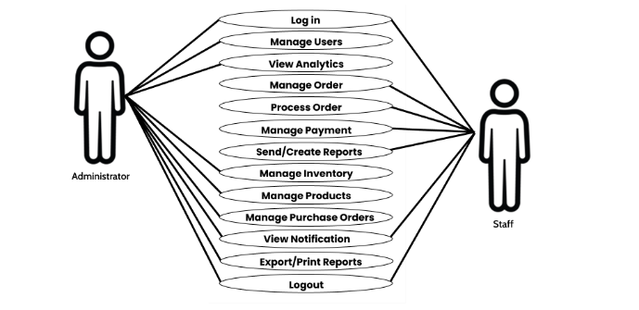
Figure 5. Use Case Diagram

Figure 6 illustrates the business model canvas of the project. The POS System serves as the core of the business framework, smoothly connecting Management, Staff, and Developers. The staff use the system to handle transactions, inventory, and customer interactions, while every recorded transaction delivers real-time data to Management for strategic decision-making.

Figure 6. Business Model
2.4 Evaluation Procedure
The evaluation of the system was conducted using the ISO 25010 Software Quality Model and the Technology Acceptance Model (TAM). Theses standard and models were employed to guide the assessment, which focuses on the system’s performance and user experience.
The system’s quality was evaluated across multiple software characteristics based on the ISO 25010 software quality model. Functional suitability examines how effectively the system performs its intended functions and meets user requirements.
Figure 7. Quality Characteristic of ISO 25010

The Technology Acceptance Model (TAM) was employed to evaluate the system’s user satisfaction and the perceived usefulness. TAM includes four key constructs: perceived usefulness, perceived ease of use, attitude toward use, and behavioral intention to use.

Figure 8. Technology Acceptance Model (TAM)

- RESULT AND DISCUSSION
The results are organized and discussed in relation to the research objectives and insights drawn from the collected data.
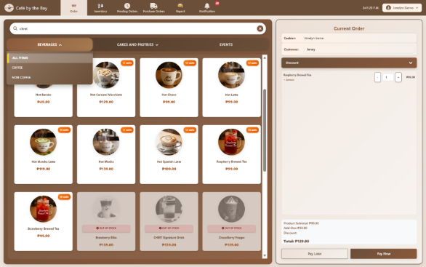
Figure 9. Order Management Interface for Staff
Figure 9 shows the main interface of the POS system, specifically the ordering interface that handles daily customer transactions. This layout provides a simple and organized way to process orders, which reduces manual errors and speeds up the transaction process.
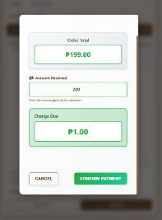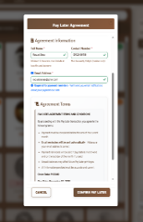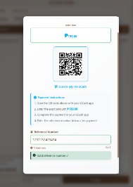
Figure 10. Payment Option and Process Feature: (a) Cash Payment, (b) GCash Payment, (c) Pay Later
Figure 10 shows the payment options and workflow in the ordering interface. The system provides two payment methods: Pay Now, which is available to all customers, and Pay Later, which is offered exclusively to faculty members.
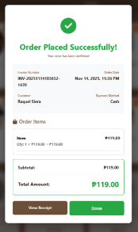
Figure 11 Generated Printable Receipt Feature: (a) Order Confirmation, (b) Generated receipt
Figure 11 shows the generated receipt of the system, once the payment is processed, a confirmation appears (a) with two options “View Receipt” and “Done.” When the staff clicks “View Receipt,” the detailed receipt is displayed (b), such as the invoice number, date and time, staff name, customer type, mode of payment, and the list of purchased items with their corresponding prices.
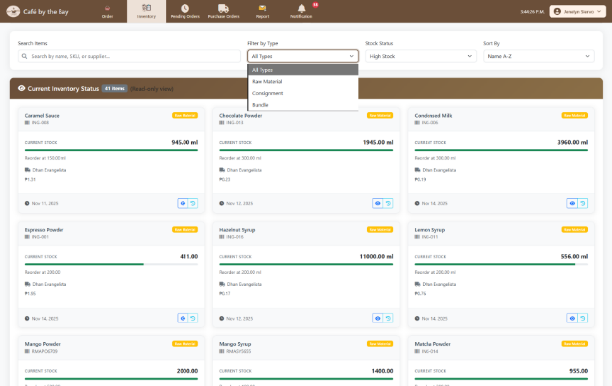
Figure 12. Inventory Management Interface for Staff
Figure 12 shows the inventory page in staff interface, where the integration of the Point-of-Sales (POS) and inventory module is demonstrated. The staff can only view the inventory to check the stock availability but cannot modify any details.
Figure 13. Forecasting Feature for Admin
Figure 13 shows the integration of the analytics module within the Forecasting page, where the system uses the KNN algorithm to generate sales forecasts. The Forecasted Sales and Products Forecasted tiles shows how many items are currently being forecasted by the model, according to the date range set by the admin.
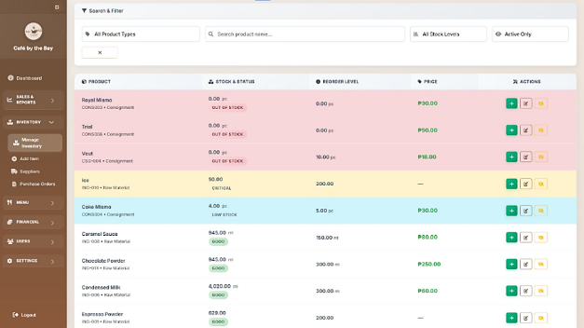
Figure 14. Inventory Management Interface for Administrator
Figure 14 shows the Inventory Management for the admin interface of the Café by the Bay POS system, which demonstrates how the system automates the stock monitoring and reduces the manual workload that is associated with traditional way of checking inventory.
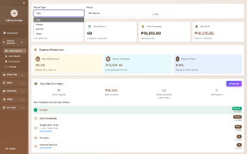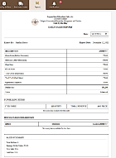
Figure 15. Sales Report: (a) Administrator Sales Reports Interface, (b) Staff Sales Report Interface
Figure 15 presents the sales reporting feature of the Café by the Bay POS system, which demonstrate how automated report generation improves transparency in monitoring the overall business performance and transactions handles by staff individually.

Evaluate the efficiency and effectiveness of the developed system using ISO 25010 and Technology Acceptance Model (TAM)
Table 1. Results of System Quality Evaluation (ISO 25010)
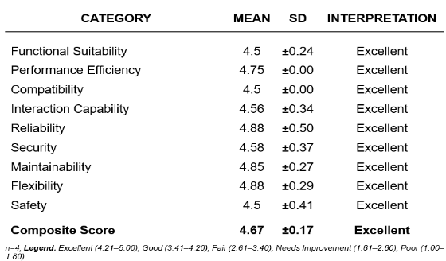
Table 1 presents the results of the system quality evaluation based on ISO 25010 Standard. With a composite mean of 4.67, with standard deviation (SD) of 0.17, and verbally interpreted as Excellent. It can be concluded that the system has high quality and reliability. The results show that all aspects of system quality such as Functional Suitability, Performance Efficiency, Compatibility, Interaction Capability, Reliability, Security, Maintainability, Flexibility, and Safety received excellent ratings. This means that the respondents were highly satisfied with the overall performance of the system, particularly in terms of its speed, stability, and security. The high mean score further indicates that the system meets the expected quality standard defined by ISO 25010 framework.
Table 2. Results of the Technology Acceptance Model (TAM) Evaluation
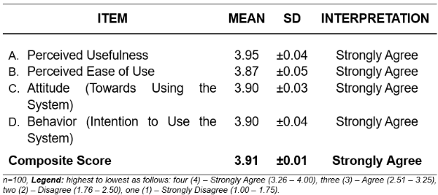
Table 2 shows the results of the Technology Acceptance Model (TAM) evaluation. The Perceived Usefulness gained the highest mean of 3.95, which means that most of the respondents strongly agreed that the system is useful and helps them accomplish their tasks more efficiently. The Perceived Ease of Use with a mean of 3.87, indicating that users found the system easy to navigate and operate. The Attitude (Towards Using the System) and Behavior (Intention to Use the System) both obtained a mean of 3.90, showing that users have a positive attitude toward the system and are willing to continue using it. The overall composite mean of 3.91 with a verbal interpretation of Strongly Agree implies that the respondents generally accepted the system and were satisfied with its performance and usability. The standard deviation (SD) values, which range from 0.01 to 0.05, indicate that the respondents’ answers were highly consistent and had very minimal variation. This means that most users shared the same positive opinion toward the system’s usefulness, ease of use, and overall acceptability.
- CONCLUSION AND RECOMMENDATION
Conclusion
In conclusion, the developed web-based Point-of-Sales (POS) system for Café by the Bay successfully met the objectives of streamlining sales transactions, improving order management, and enhancing inventory control. The system provided a user-friendly interface that enabled staff to process orders efficiently while minimizing errors associated with manual recording. Its integration with inventory management ensured accurate, real-time tracking of item usage, contributing to more organized and consistent daily operations.
The system effectively automated stock monitoring, sales reporting, and inventory level alerts. These features improved administrative visibility over sales performance and inventory status, reduced reliance on manual tracking methods, and supported timely restocking decisions to prevent service disruptions.
The evaluation using ISO 25010 and the Technology Acceptance Model (TAM) confirmed that the system is efficient, reliable, and user-accepted. The results demonstrated that the system met essential software quality standards and was perceived by users as both useful and easy to use, validating its readiness for real-world implementation at Café by the Bay.
Recommendation
Based on the findings of the study, several recommendations are proposed to further enhance the functionality, usability, and overall performance of the web-based Point-of-Sales (POS) system for Café by the Bay. For administrators, improvements such as better cross-device compatibility, automated data backup and recovery, and strengthened security measures are recommended to ensure system reliability, data protection, and business continuity.
For staff, integrating online ordering, automated loyalty tracking, supplier system integration, and cash and coin counting features may further streamline operations, reduce manual workload, and improve transaction accuracy. These enhancements can support more efficient order processing, inventory management, and payment handling.
From the customer’s perspective, the inclusion of online ordering, multiple digital payment options, and a fully automated loyalty system is recommended to improve convenience, reduce waiting time, and enhance overall customer satisfaction, especially within a campus setting.
For system developers, IT students, and future researchers, enhancements in forecasting accuracy, data validation, confidence-level interpretation, and analytics are recommended. Expanding forecast horizons, refining category-specific models, and developing dedicated analytics dashboards may improve decision support capabilities and contribute to more accurate demand forecasting and system scalability in future implementations.
Acknowledgement
The researchers are deeply grateful to Almighty God for His wisdom, guidance, and protection throughout this academic journey. Sincere appreciation is extended to the University President, Campus Director, Dean, adviser, Research Coordinator, and the approval committee for their leadership, valuable insights, and continuous support. Their guidance played a significant role in the successful development and completion of the project. This capstone project reflects not only the researchers’ efforts but also the collective support of everyone who contributed along the way.
REFERENCES
- Hu, B., Xie, H., Ma, Y., Wang, J., & Zhang, L. (2018b). A robust retail POS system based on blockchain and edge computing. In Lecture notes in computer science (pp. 99–110).
- Laguna State Polytechnic University. (2024). CHMT Designs Curriculum for Glocal Industry-Responsive Students.
- Alt, R. (2021). Digital transformation in the restaurant industry: current developments and implications. Deleted Journal, 1(1), 69–74.
- Gill, A. (2021). OPTIMIZING RESTAURANT INVENTORY MANAGEMENT USING REAL-TIME DATA. International Journal of Core Engineering & Management, 6(12), 312–314.
- Sihombing, D. J. C. (2024, May 6). Innovating restaurant inventory management application enhancing quality and efficiency through extreme programming approach.
- Hidayati, Irma & Sudarmiatin, Sudarmiatin & Hermawan, Agus. (2023). Analysis of Point of Sale System Implementation in Coffee Shop. Jurnal Pendidikan dan Kewirausahaan. 11. 932-947. 10.47668/pkwu.v11i3.881.
- Tanaman, M. T., Baylosis, J. L. A., Abiles, B. J. A., Catungal, M. L. P., & Encarnacion, P. C. (2023). Web-based Inventory Management System. International Journal of Science and Applied Information Technology, 12(5), 44–48.
- Oladele, Tinuke & Ogundokun, Roseline & Adegun, Adekanmi & Adeniyi, Emmanuel & Ajanaku, Ayobami. (2021). Development of an inventory management system using association rule. Indonesian Journal of Electrical Engineering and Computer Science. 21. 1868. 10.11591/ijeecs.v21.i3.pp1868-1876
- Salesforce Staff. (2024, May 15). What is sales reporting? Steps and tips for success. Salesforce Asia.
- Danny, M., Muhidin, A., & Jamal, A. (2024). Application of the K-Nearest Neighbor machine learning algorithm to predict sales of best-selling products. Informatics Engineering Study Program, Faculty of Engineering, Pelita Bangsa University, 4(1). https://doi.org/10.47709/brilliance.v

Appendix H.
Plagiarism Result

